MOQ Website Faith Formation

Faith Formation
- Children
  - Toddler Community
  - Catechesis of the Good Shepherd
- Sacrament
  - First Eucharist
- Adult
  - CGS Catechist Formation

Children:
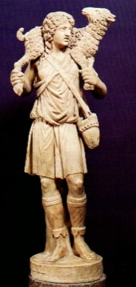
Welcome to Mary Our Queen a growing community with a big heart.
Formation for children begins with our toddler community which represents children ages 1 year to 3 years old. This group meets in the Trinity Building in room 101 from 10:45 am drop off to 12:15pm pick up. The toddler program at Mary Our Queen takes the place of a nursery for these children.

As the children grow and develop the faith formation at MOQ grows and develops. The children in pre-Kindergarten age 3 to 5th Grade are in the Catechesis of the Good Shepherd Program. This program is a hands on approach to faith formation where the catechist is a co listener to the word with the child. The child makes their own choice as to the presentations they receive discovering their faith at their pace. They are guided in this process by the adult or teen catechist. Each Level meets the developmental needs of the Child.

Video Link: https://www.youtube.com/watch?v=hfg9RfBk-fY Or
3 min https://www.youtube.com/watch?v=MwO_CWLKwOE

To Register your child for Children’s Faith Formation: https://goo.gl/forms/LrHvt122GmmwUyRy2
Tuition payment Link: https://www.eservicepayments.com/cgi-bin/Vanco_ver3.vps?appver3=0id-wTxmu9JJ9y0I_TO97--6YHdOL0cwOvgrcfK79xUACGhPJ3OmuQuwu1o4rF_n8cHdqUTsA0MoQVoDjiTXjYPqkHL78SwvNlnXAGZ85smQCgJDnwleJ52cwgiRRI6EvrhMLQQzizPb3vJfPz_WfRwCsL-_quPsiLt5BuPSzXQ=&ver=3
With any questions about our children’s programs please contact:

Elizabeth Piper
Children, Youth and Catechist
Epiper@maryourqueen.com
Phone: 770-373-7847

Toddler Community: Coming Soon
Catechesis of the Good Shepherd

ENDORSEMENTS
"The Catechesis of the Good Shepherd is an amazing approach to a contemplative
catechesis for children, as developed through the work of Sofia Cavalletti and
Gianna Gobbi. "CGS" is more than a catechesis for children. I believe that it
is one of the new renewal movements for the Church, given to us by the
Lord... allowing us a new way to receive and experience the gifts of the
Lord through a contemplative listening of the Word and an active participation
in the Sacraments of His Presence. I was introduced to this work while pastor
at Saint John Neumann and it has affected my own spirituality in a powerful way.
Please allow me this personal request... to come and see how the
Catechesis of the Good Shepherd may be a blessing in the lives of your people...
the children and the teens and the adults of your parish community."
Bishop Talley completed CGS training Levels I and II
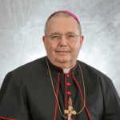
The Most Reverend David P. Talley, M.S.W., J.C.D.
Bishop of Alexandria, LA

Video Link: https://www.youtube.com/watch?v=3F3jP0cf0nA
What is the Catechesis of the Good Shepherd?
The Catechesis of the Good Shepherd (CGS) is a Catholic formation program grounded in scriptural and liturgical study using tangible, self-teaching materials based on study by Maria Montessori in 1915 then developed into what we know now as CGS by Gianna Gobbi and Sophia Cavalletti. The catechesis is based on the principle that the child desires to draw near to God. The Relationship is assisted by the Catechist but is directed by the Spirit of God within the child. Themes are offered in such a way as to develop the religious potential present in every child: “the capacity to love and be loved”.
What is the curriculum?
The curriculum of the CGS is rooted in the Bible and the liturgy of the church. It is developmentally age appropriate and specific in the method in which is presented, followed by the liturgical calendar of the church. It is divided into three levels, Level I for 3-6, Level II for 6 to 9, and Level III for 9 to 12 year olds. Each level explores the fundamental theme of covenant as lived in the liturgy and reflected in the Bible
There presentations in each level that is first presented to the child by the catechists then is chosen . Each level builds on the knowledge gained from the previous one. All classes are organized around a similar time frame: twenty to thirty minutes for lesson presentation, work time and a prayer service designed by the children to end the Atrium. Once the children experience a particular lesson, they can choose the presentation materials during work time or choose other lesson materials in the classroom according to their own interests
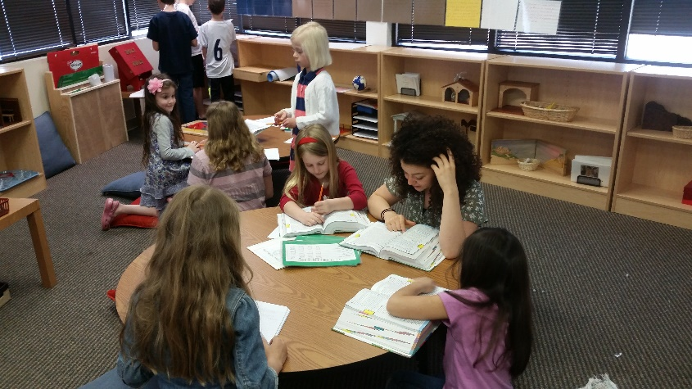
Schedule for 2018 – 2019 School year:
Catechesis of the Good Shepherd Faith Formation Groups will be held on Sunday morning from 9:30 to 11:00am and on Monday afternoon from 4:30 pm to 6:00 pm. Groups will meet from September 9, 2018 to May 5, 2019. Please check the on line calendar for updates. Registration requests are based on first come first serve. Registration Opens May 15, 2018

To Register your child for Children’s Faith Formation: https://goo.gl/forms/LrHvt122GmmwUyRy2
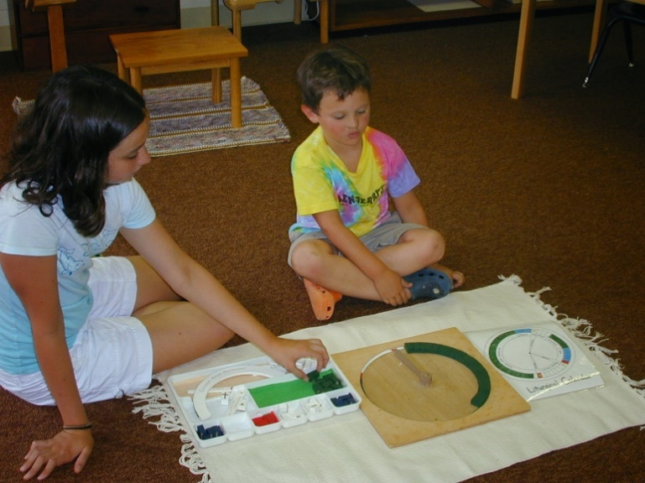
Tuition payment Link: https://www.eservicepayments.com/cgi-bin/Vanco_ver3.vps?appver3=0id-wTxmu9JJ9y0I_TO97--6YHdOL0cwOvgrcfK79xUACGhPJ3OmuQuwu1o4rF_n8cHdqUTsA0MoQVoDjiTXjYPqkHL78SwvNlnXAGZ85smQCgJDnwleJ52cwgiRRI6EvrhMLQQzizPb3vJfPz_WfRwCsL-_quPsiLt5BuPSzXQ=&ver=3
With any questions about our children’s programs please contact:
Elizabeth Piper
Epiper@maryourqueen.com
Phone: 770-373-7847

First Eucharist
Welcome to Mary Our Queen’s preparation for First Eucharist.
Eucharist is a gift that is given to the child as they grow in their faith. The Catechesis of the Good Shephard program prepares the child to receive this gift though faith formation groups and retreats. The children that are preparing for first Eucharist should be 7 years old and in 2nd grade. The child needs to have completed a minimum of 1 year of faith formation before their 2nd grade year. There is not a separate registration for this group but you do need to express your interest on the faith formation registration.
For the 2018 – 2019 school year First Eucharist is scheduled for Sunday May 5, 2019 at the 11:00 am mass. There are two retreats that are held in preparation, one on Saturday, March 16, 2019 from 9:30 to 11:30 am focusing on Reconciliation the other on Saturday, April 6, 2019 from 9:30 to 11:30 am focusing on Eucharist. First Eucharist Rehearsal is from 9:30 to 10:30 am Saturday, May 4, 2019
The Sacrament of reconciliation may be received through the Saturday Parish Reconciliation time from 4:00 to 4:30pm, Reconciliation service at Advent or Lent, or by appointment with Father Darragh. The children will be prepared to receive this sacrament through their faith Formation group.
With any questions about our children’s programs please contact:
Elizabeth Piper
Children, Youth and Catechist
Epiper@maryourqueen.com
Phone: 770-373-7847

Adult Catechist Formation
Welcome to Mary Our Queen a growing parish with a big heart.
Catechist Formation here at Mary Our Queen is based on the Archdioceses of Atlanta Parish Catechist Certification Path which you can find at this link: https://archatl.com/ministries-services/religious-education/catechist-formation/
This certification process provides our catechist the support that they need to better address the questions of faith when presenting to their groups. We offer many forms of catechist formation from adult Bible studies, online formation and Catechesis of the Good Shepherd formation training. Each of these formations develop the catechists in spirituality, Biblical and Liturgical understanding, Faith and Moral development and effective catechesis and session management.
Catechesis of the Good Shepherd Catechist Formation
The most up to date information on CGS Catechist Formation can be found on the Archdioceses website. Link to Archdioceses Website: https://archatl.com/ministries-services/religious-education/catechesis-of-the-good-shepherd/
Here at MOQ we are hosting a Level 1 Catechist Formation to work with children in the Level 1 Atrium ages 3 to 6 years old. There is registration required for this course.
Link to registration: http://tiny.cc/CGSTRAINING
With any questions about our middle school programs please contact:
Elizabeth Piper
Children, Youth and Catechist
Epiper@maryourqueen.com
Phone: 770-373-7847

