Noticed the strike in the wording in Safe Enviroment and SMIP. Can you tell me why?
Vitim Assistance?

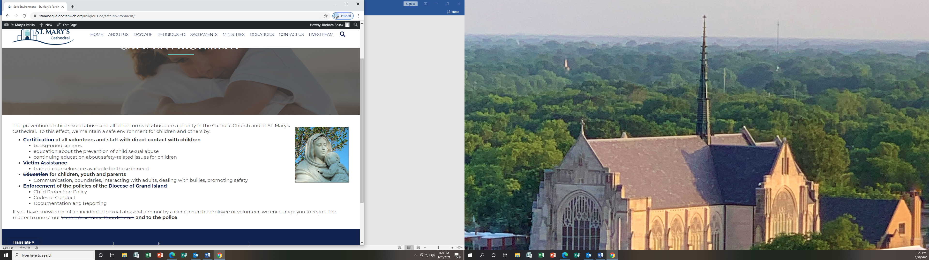
The prevention of child sexual abuse and all other forms of abuse are a priority in the Catholic Church and at St. Mary’s Cathedral. To this effect, we maintain a safe environment for children and others by:
- Certification of all volunteers and staff with direct contact with children
  - background screens
  - education about the prevention of child sexual abuse
  - continuing education about safety-related issues for children
- Victim Assistance
  - trained counselors are available for those in need
- Education for children, youth and parents
  - Communication, boundaries, interacting with adults, dealing with bullies, promoting safety
- Enforcement of the policies of the Diocese of Grand Island
  - Child Protection Policy
  - Codes of Conduct
  - Documentation and Reporting
If you have knowledge of an incident of sexual abuse of a minor by a cleric, church employee or volunteer, we encourage you to report the matter to one of our Victim Assistance Coordinators and to the police.

Also in SMIP

SMIP in the News
SMIP in Grand Island: Buenos Dias Nebraska (23 July 2012)
SMIP in Lexington: Kearney Hub (2 Oct 2012)
DACA: Lexington Clipper-Herald (29 Jan 2013)
Citizenship Classes: Lexington Clipper-Herald (19 March 2013)
Treatment of Immigrants: KHAS News 5 (12 Feb 2014)

The picture are not brighter, I thought was going to change.

Facebook

Our Facebook page is not working well. Its connected to my personal Facebook page. When I went to our livestream and click on FB it went to our page but it was my personal page! I signed out but now I cannot get into our church FB page. This has been a problem for several months. I have cleared the cookies and done everything they asked.

