HOME PAGE
1/ 2nd hero image does not capture the cross at top. Can this be fixed, or do we need a new picture?

2/ Banner below hero pictures needs to have CONFESSION TIMES

3/ Below Mass times banner: Change the statement to read:
We are a joyful community of disciples proclaiming the Good News and inviting all people to encounter the love and mercy of Jesus Christ!

3b/ Remove the Prayer of Spiritual Communion

4/ “Contact Us” button should be: WEEKLY MESSAGE AND IMPORTANT ANNOUNCEMENTS
=hyperlink to that page

=============================================

6 BUTTONS:
COVID - page -
- Title should be larger and centered
- blue banners missing the St. Jude logo
- remove bullet point #3 (it is a duplicate of bullet point #6)

My parish app -
- Title should be larger and centered
- blue banners missing the St. Jude logo

Dynamic Parish -
      - @banner, no need to have the white writing over the logo. Remove the white ‘Dynamic Parish”

Prayer Request -
- Title should be larger and centered
- blue banners missing the St. Jude logo

Flocknote -
- Title should be larger and centered
- blue banners missing the St. Jude logo
      - change contact email to: ccarter@cathedralofstjude.org
      - at top of page, add:

We love having you
as part of our flock!
Let’s keep in touch! Get important updates via email & text.
This tool lets you choose what info you'd like to receive - via email or text message - from the various ministries and groups in our church. You can unsubscribe any time.
=============================================

TWO BUTTONS

Our Events
- “Read more” takes us to Google calendar - but unpopulated

Our News
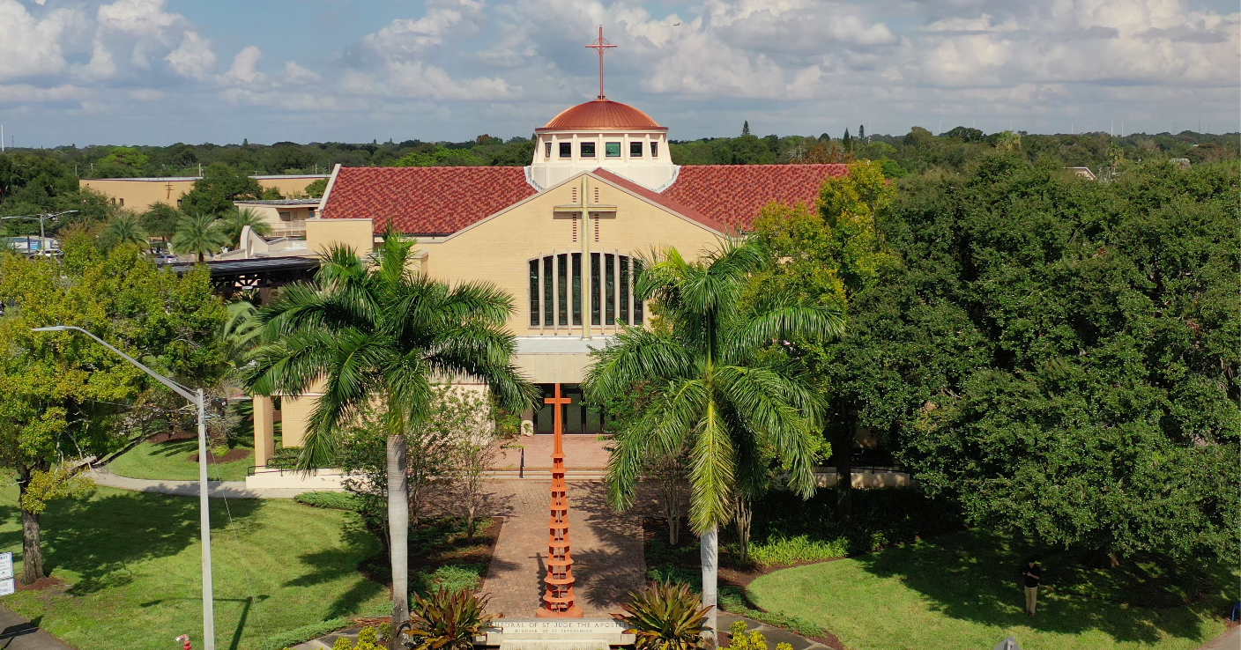
- Keep format
- Front icon should be “Bulletin” - [not the bookstore]
- BULLETINS should be the first square
- second square - change “WELCOME TO ST. JUDE….” picture:
- Flocknote should have the same sign-up as the Flocknote button above
- and should be hyperlinks to same page
- banner has white “news”, on top of a picture that is not complete

=============================================

BOTTOM BUTTONS
DOSP works
Online Giving does NOT work - takes us to the Styles page

=============================================

FOOTER

Mass times: NEED CORRECTION:
Sundays - 8:00 AM / 9:30 AM/ 11:30 AM / 6:00 PM
M- F - 8:15 AM / 11:00 AM
Sat 8:15 AM / 4:00 PM

Office hours: 9:00 AM - 4:00 PM

Quicklinks
VISIT US link does not work - please remove
HOMILIES link does not work - please remove
Should be:

1. Cathedral Tours (hyperlink to Cathedral tours under Our Parish)
2. Vatican (<link to www.vatican.va>)
3. Report Abuse ( https://www.dosp.org/safe-environment/ )
4. Formed
5. DOSP.org
6. Livestream

=============================================

CONSISTENCY MENUS
I’M NEW

- sacramental Records form should be a fillable online form
- Sacraments - forgot ‘Holy Orders’

EVENTS
GET INVOLVED - needs MORE!

For as in one body we have many parts, and all the parts do not have the same function, so we, though many, are one body in Christ and individually parts of one another. Since we have gifts that differ according to the grace given to us, let us exercise them… (Romans 12:4-6)

There are many ways in which you can get involved in the activities at the Cathedral of St. Jude the Apostle. You can choose to participate in one or more of the various ministries (hyperlink to Directory of ministries).

Additionally, you can participate in seasonal activities. If you would like to know how you can get involved, contact Charmaine Carter at ccarter@cathedralofstjude.org.

Do you have any talents you would…..

— pic of painting the youth room —

=============================================

STORE
- needs to add pictures of the bookstore that we previously provided
- change store number to: 727-343-5599

=============================================

DROP DOWN MENUS
OUR PARISH

History of the Cathedral of St Jude the Apostle
The link to ESTABLISHMENT OF THE DIOCESE OF ST PETERSBURG - doesn’t work (under the large areal pic mid-way down) - should be: https://www.dosp.org/office-of-archives-and-records/history/

=============================================

OUR STAFF
- Priests should be placed ABOVE the deacons
- Change Fr. Ralph D’Elia’s email: ralphdelia@cathedralofstjude.org
- Joey’s tech email was bounced back - mistyped: tech@cathedralofstjude.org [ the ‘d’ in cathedral was missing]
- Raise and Enlarge all faces so faces fill most of the circle,
      - especially small now are:
      - Charmaine Carter,
      - Catherine Kuizon,
      - Fr. Proulx,
      - Anne Koster,
      - Deacon John Fox,
      - Deacon John Carter

=============================================

SACRAMENTS

On front page, Text describing the 3 classes of sacraments should be enlarged.

Baptism
Fillable registration form - redundant

Older baptisms link should be to RCIA (not Becoming Catholic)

Confirmation
for over 16, Link should go to Adult Confirmation (not RCIA)

=============================================

OUR FAITH

ADULT FAITH FORMATION
RCIA
(RCIA - change pdf of Mondays, 9/7 is Labor Day)
RCIA Adults Registration should be an online fillable form
RCIA Children Registration should be an online fillable form
- blue banners missing the St. Jude logo

Becoming Catholic
3rd “click here’ should go to Confirmation prep, not RCIA
- blue banners missing the St. Jude logo

Adult Confirmation
Registration form should be an online fillable form
- Title should be larger and centered
- blue banners missing the St. Jude logo

Bible Study
Sophomore syllabus line should move over to right so lines up

Catechism class
- should be an Online fillable form —> ccarter@cath…..
-- blue banner missing the St. Jude logo

Liturgy of the Hours Class
- Title should be larger and centered
- blue banners missing the St. Jude logo

Catholic Resources -
- CHANGE - Catholicmasstimes to masstimes.org

=============================================

=============================================

MINISTRIES

MUSIC MINISTRY
COVID and Music
  - need to separate the information - Maybe be put the COVID information in a colored box?
  - email changed to: cathedralmusic2010@yahoo.com

Contemporary Music
- Joey’s face is cut off, - can you shrink the pic?
- Joey’s email is mistyped: tech@cathedralofstjude.org [ the ‘d’ in cathedral was missing]

LITURGICAL MINISTRIES

**The icons are not lined up

God’s Gift
Woman’s head is cut off - need different picture?

Sacristan
can’t see the top of the chalice - can lower, or need different pic?

Usher
banner - can’t see the top of the men’s faces - can lower, or need different pic?

SERVICE MINISTRIES

** needs to be in Alphabetical order

All Pro Day
Faces cut off on the banner

Altar Linen
small button - not clear, cross on cloth
needs prettier banner

Environment
banner - faces cut off

Funeral support
page is very pretty with the banner

Information Communication
What we do: add Flocknote: “Information Communication Ministry relays information from pastor and parish staff to parishioners through the myParish App, website, social media, Flocknote, and the weekly bulletin.”

Lighthouse
banner - not clear to me

Movies at the Cathedral
- banner - needs to be lowered
- white title of page, not really clear
- change email to: ccarter@cathedralofstjude.org

Serra Club
- heads chopped off - need different picture?

Nursing
- partial view of sphyngomanometer - need different picture?

Van ministry
- heads chopped off - need different picture?
- also - needs a CDL license, not just a regular drivers license

Welcome Home Committee
    - banner - white writings on banner and on sign clash

=============================================
OUTREACH MINISTRIES

Annulment
Fr. Ralph’s email is: ralphdelia@cathedralofstjude.org

Pinellas Hope Liason
Joyce’s head is gone

St. Vincent dePaul
food basket pics are redundant

=============================================
LAY COMMUNITIES

Columbiettes
headless - need heads, or different picture

Lay Franciscans
Want link to go directly to their website

Marian Servants
Want link to go directly to their website

Third Order Mercedarians
Want link to go directly to their website

