Table of Contents

Page Templates
Default
Columns & Rows
Contact Page
Holy Spirit
Homepage
Sacraments
Secondary
Single Post
St. Helen
Tertiary

Page Templates

Default
Yes
- Displays text in first box
No
- Does not display specific image behind title
If you would like to select an image header, select Single Post page template
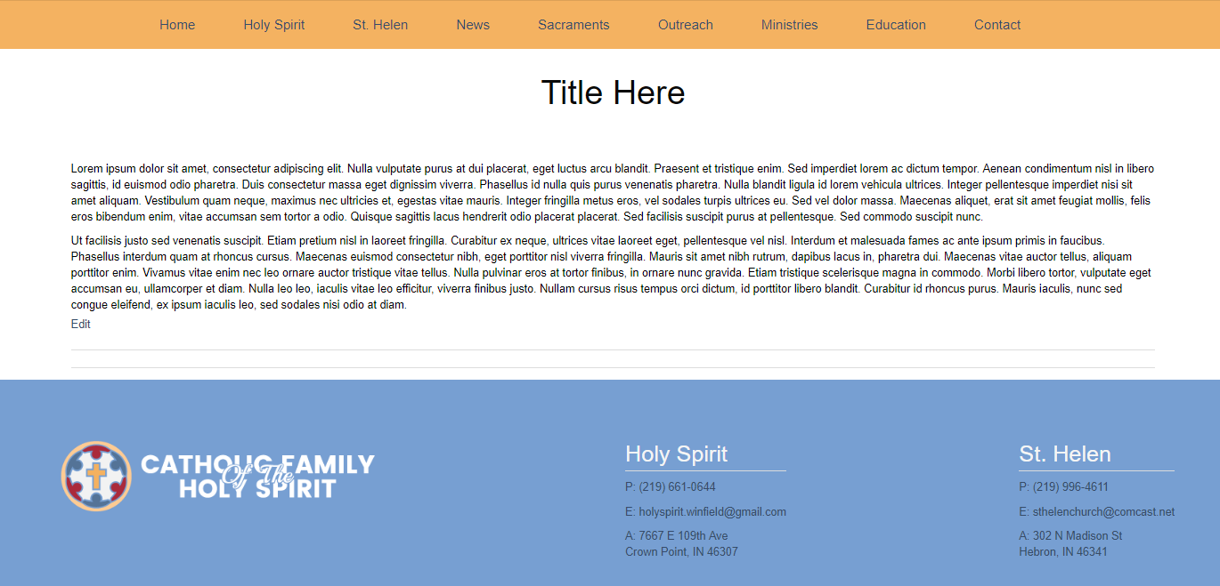

Columns & Rows
Yes
- Can create multiple rows (as seen on Sacraments, Outreach, Ministries and Education pages)
- Can create Image Left or Image Right, as seen on Holy Spirit’s Sacraments page
No
- Will not show any text that is placed in the first box
  - If you are wanting to have image left that ALSO shows the text in the first box, select “Sacraments” for your template
- Cannot have both rows and image left or right on the same page
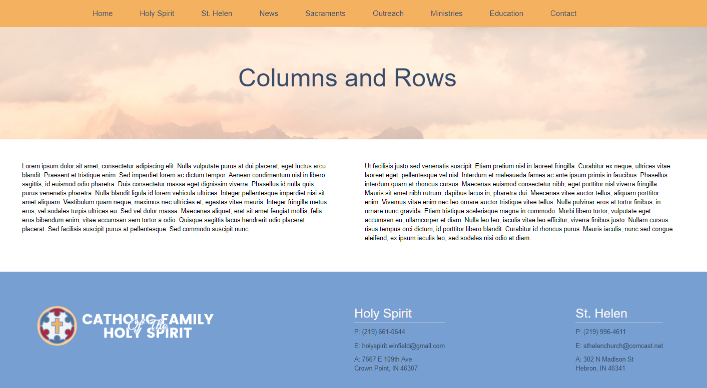

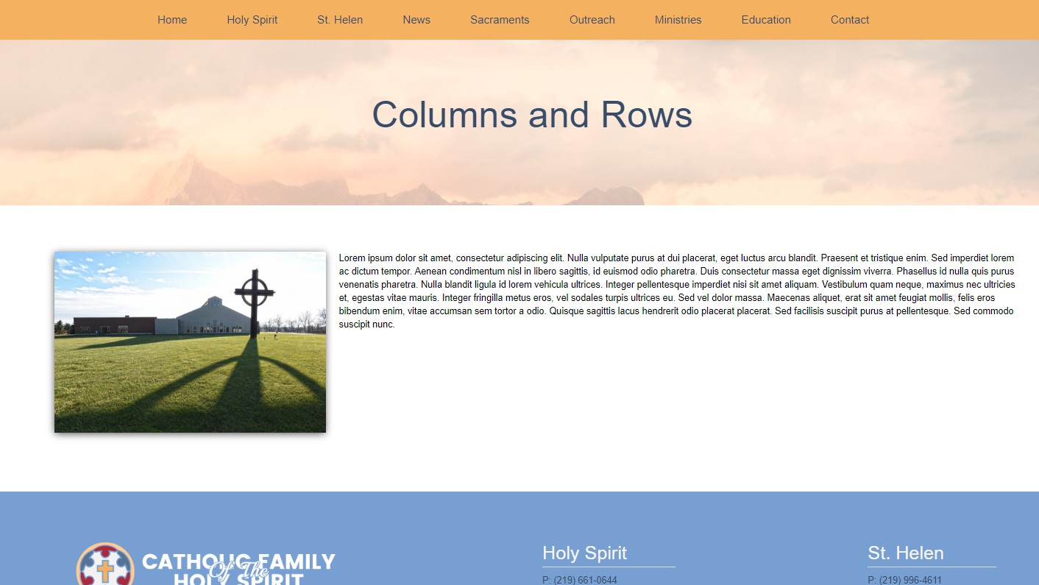

How to Add Columns and Rows
Beneath the Visual Text Editor, there is a box titled Page Templates with a button that says “Add Row”
- First Column
- Two Column
- Image Left - image on the left with text on the right
- Image Right - image on the right with text on the left

Contact Page
Do not use this page template. If you select this page template, any information you put in will be overridden by the current Contact page information.
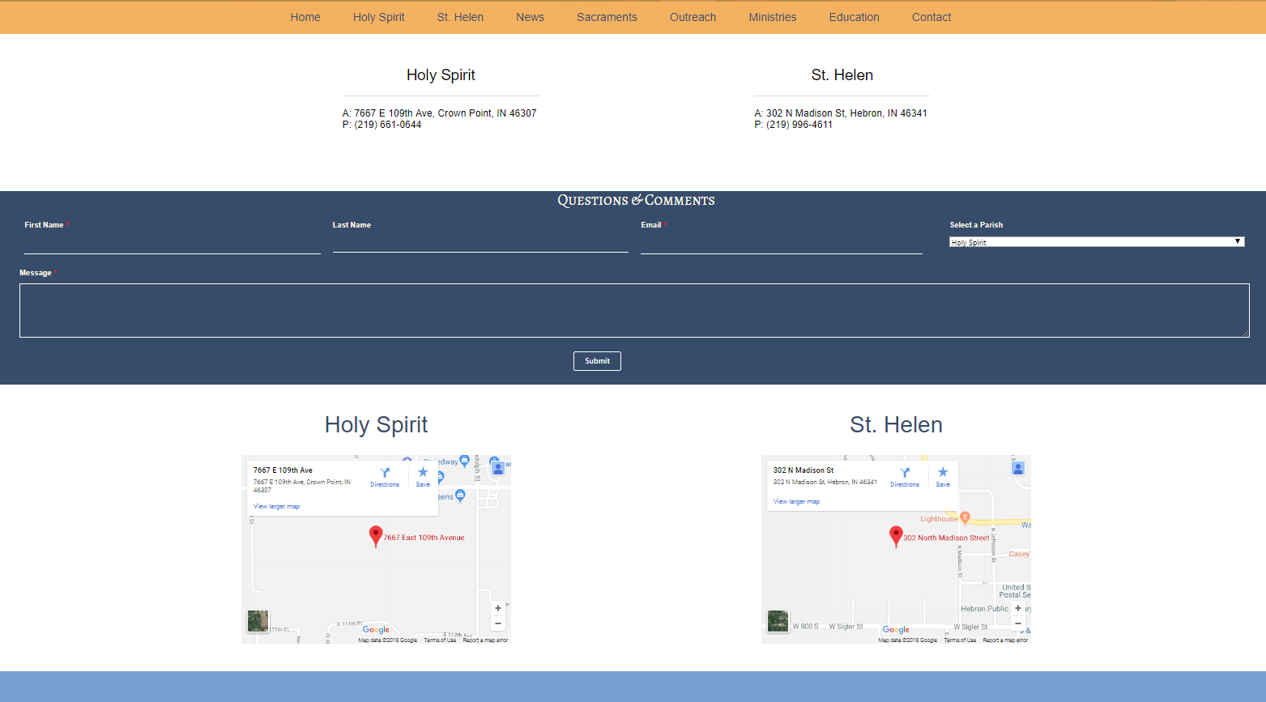

Holy Spirit
Yes
- This page template will change the color of the header and footer (as seen on Holy Spirit page).

No
- This is similar to the default page template in that there is no image at the top.
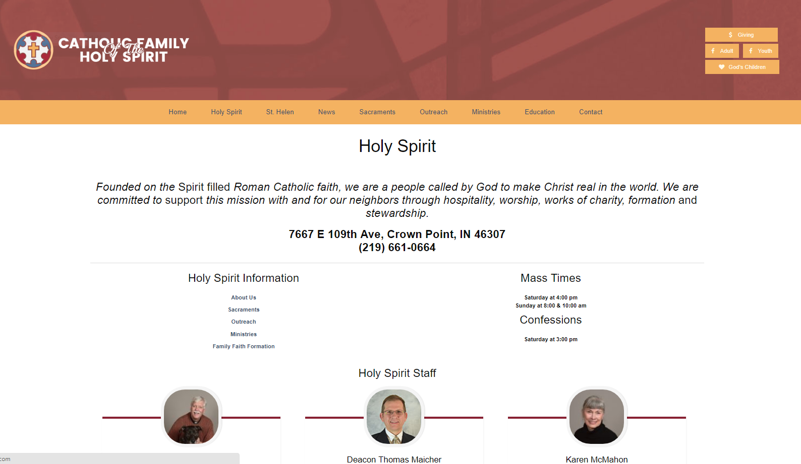

Homepage
This will display the homepage and should not be used.

Sacraments
Yes
- Displays both text in first box AND image, title, and information
- Right aligns image with text next to it
- Allows specific image behind title
No

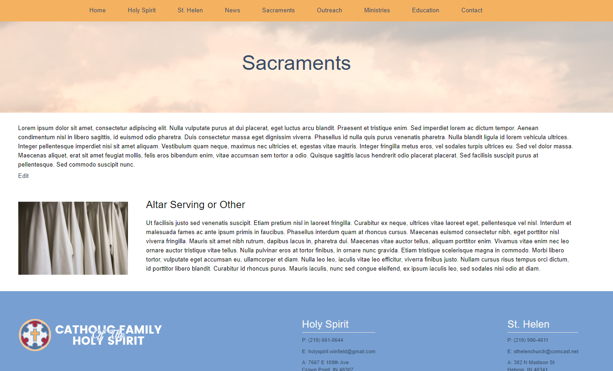

Secondary
Yes
- Adds tabs to right side of page
- Allows for adding icon, title, and information
- Allows specific image behind title
No
- Does not display text in first box
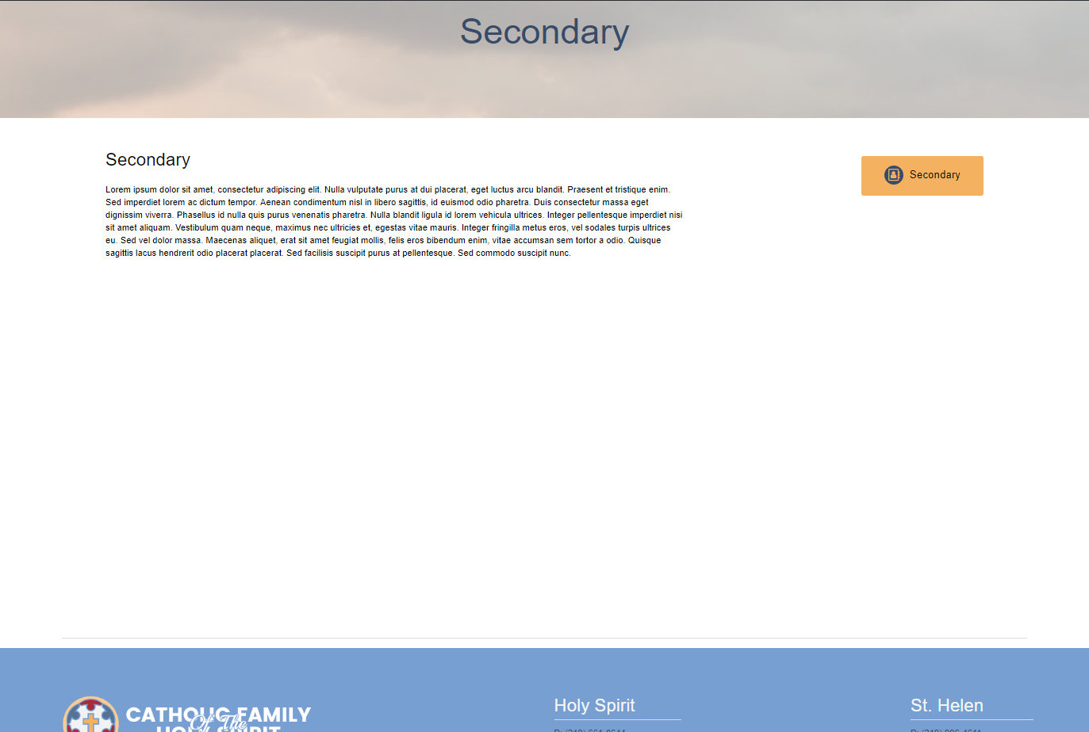

Single Post
Yes
- Allows specific image behind title
- Displays text in first box
No

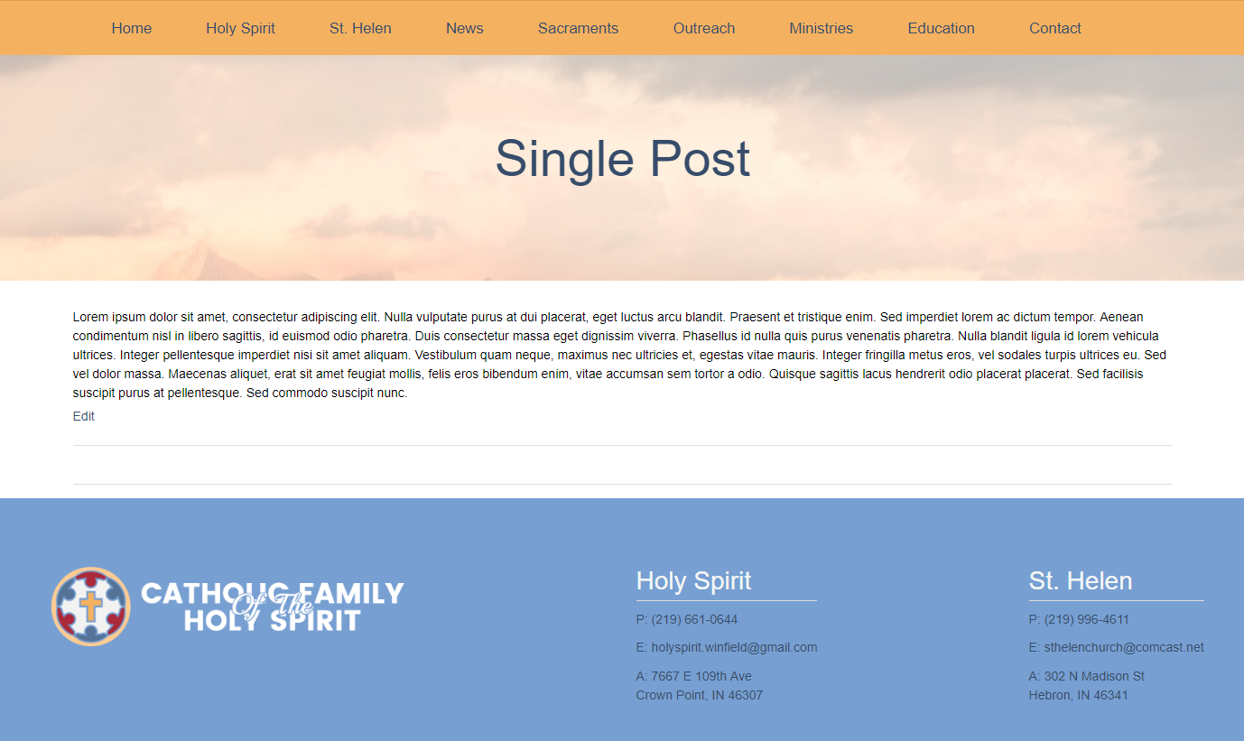

St. Helen
Yes
- Changes color of header background
- Displays text in first box
No
- Does not allow for specific image behind title
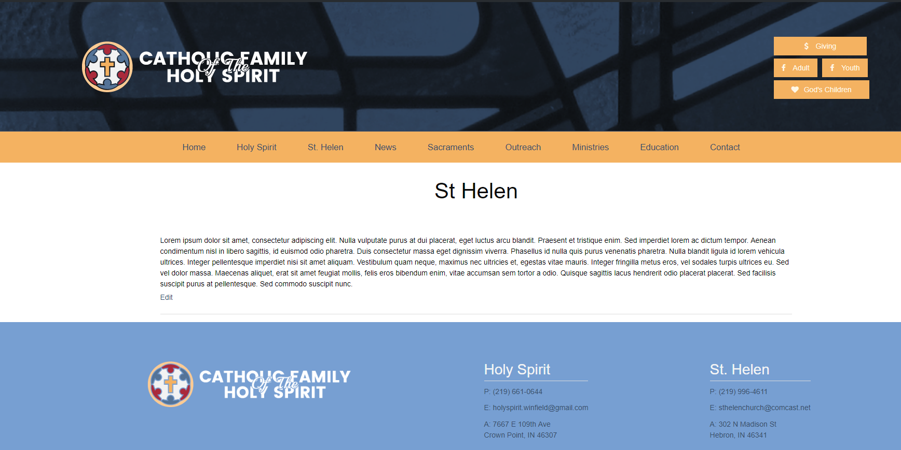

Tertiary
Do not use (no longer in use)

