Home page photo is the monstrance:

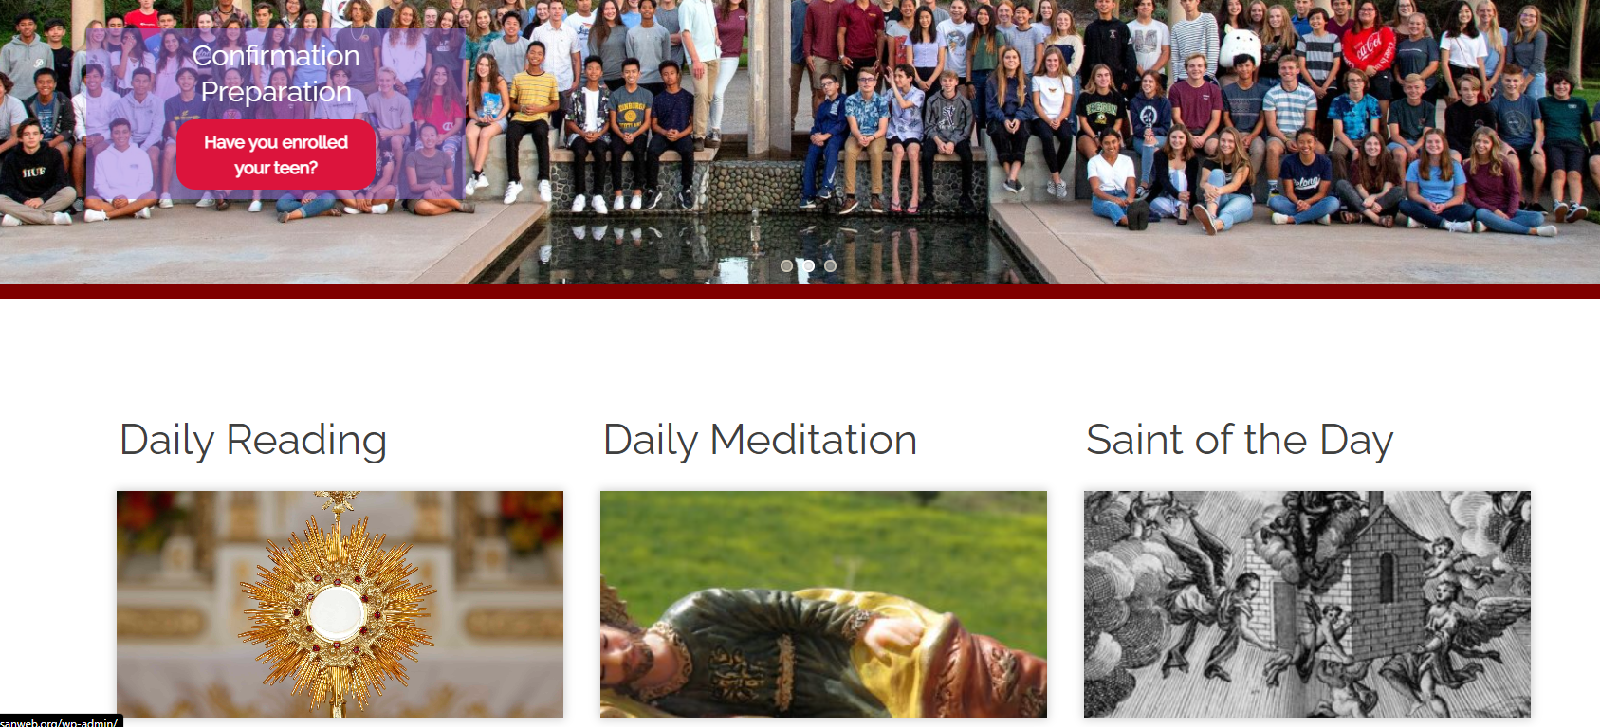

When I’m on this page https://stgg.diocesanweb.org/daily-meditations/141911/ this is at the bottom in the red boxes. I’d like that picture to be the monstrance too if possible. The sizing is fine, just the photo is wrong.

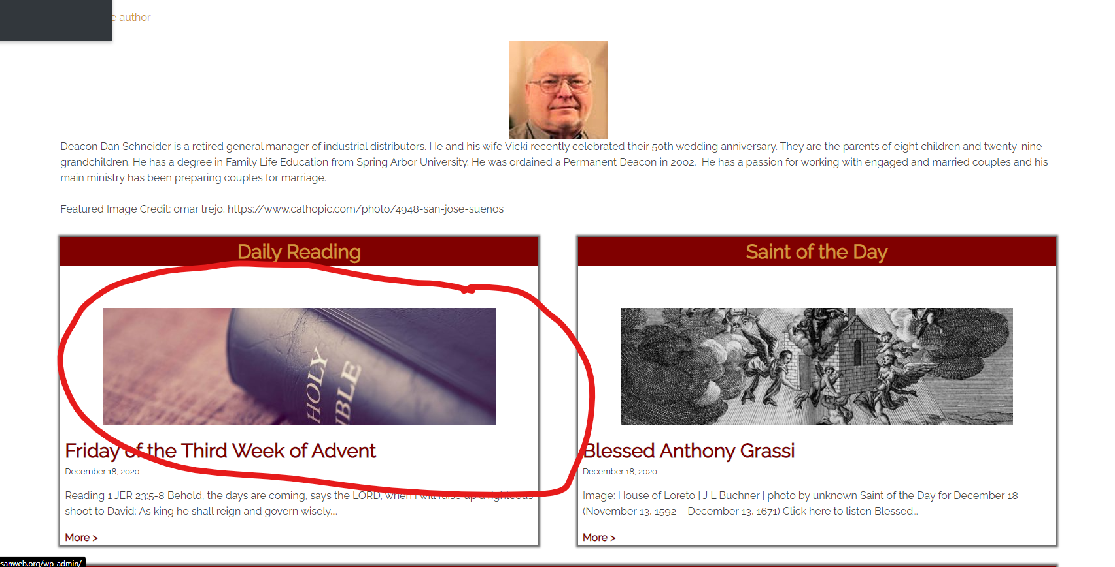

Ditto for this page https://stgg.diocesanweb.org/saint-of-the-day/141773/ :

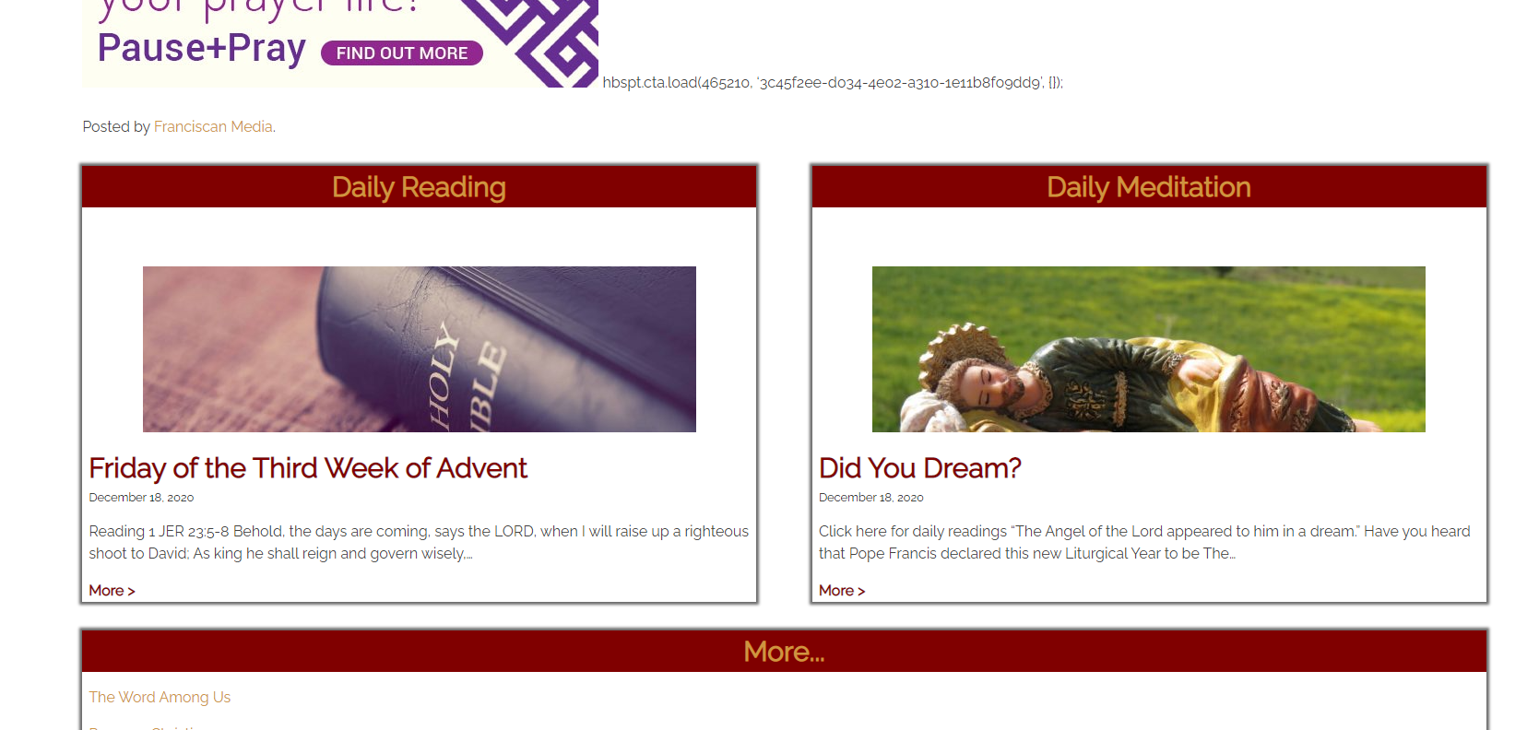

And ditto for this page https://stgg.diocesanweb.org/grow-in-faith/daily-readings/ :

