- 
They don’t have masses everyday so can we make this Saturday and Sunday and then view all please.

- Contact us form responses to go to:
Fr Charles <FrCharles@saintcabrinicatholic.org>
info@saintcabrinicatholic.org

- Remove the words that says “upcoming news and events”
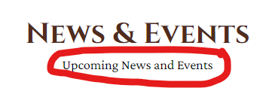
- Can we please add this section on the home page right below news and event section please. Instead of IG we will do FB and let me know if you need the embedding code for the escroll part:
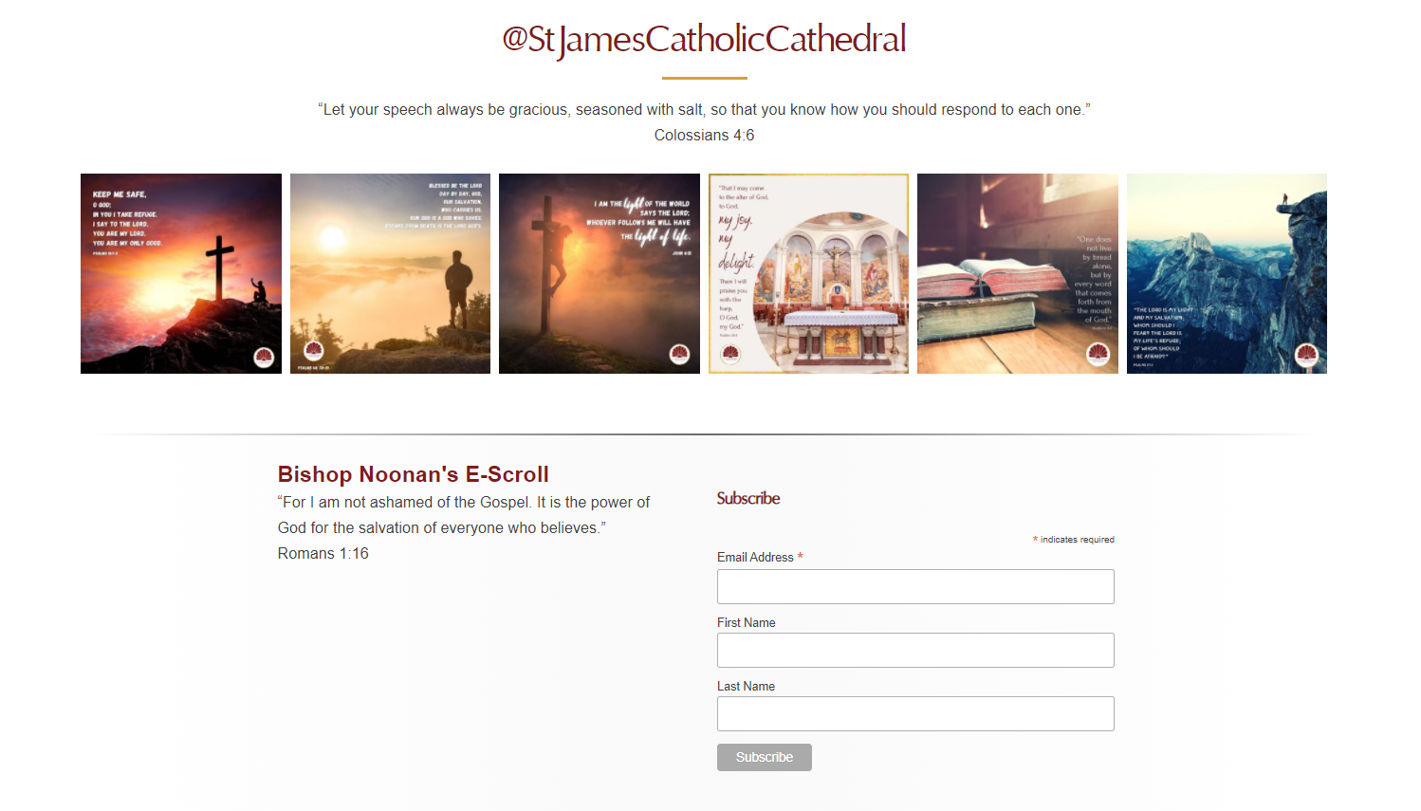

- Add more space between the columns
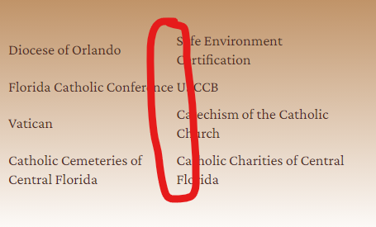
- https://saintcabrini.diocesanweb.org/parish-registration/

Can we please remove the iframe, keep the wordpress form and send the responses to info@saintcabrinicatholic.org

- 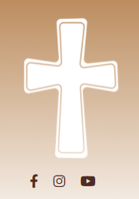
Center the social media icons to the cross

- What’s the gmail account that is connected to the calendar? And also what is the different between the calendar page and the parish calendar page. We would like to add events to the calendar page that is under news tab
- Calendar needs to be styled to match the cabrini colors (it still has st.james colors)
- On the home page banner, can we remove the black layer, keep the original image colors. Then add a bar with the heading towards the bottom of the banner (do this for all inner page banners too)

