TOP RIGHT CORNER
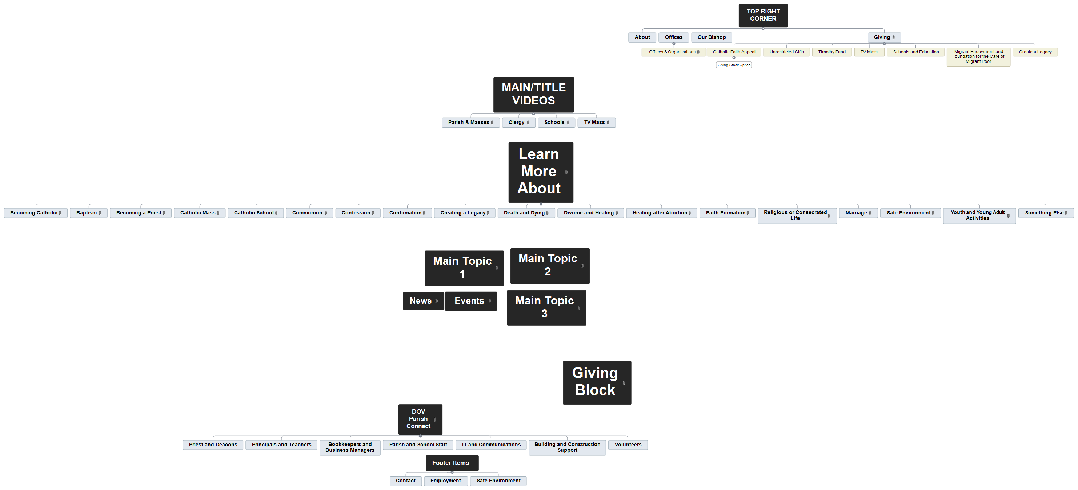
About
Offices
Offices & Organizations
Our Bishop
Giving
Catholic Faith Appeal
Giving Stock Option
Unrestricted Gifts
Timothy Fund
TV Mass
Schools and Education
Migrant Endowment and Foundation for the Care of Migrant Poor
Create a Legacy

About

Offices

Offices & Organizations

Our Bishop

Giving

Catholic Faith Appeal

Giving Stock Option

Unrestricted Gifts

Timothy Fund

TV Mass

Schools and Education

Migrant Endowment and Foundation for the Care of Migrant Poor

Create a Legacy

