MAIN/TITLE VIDEOS
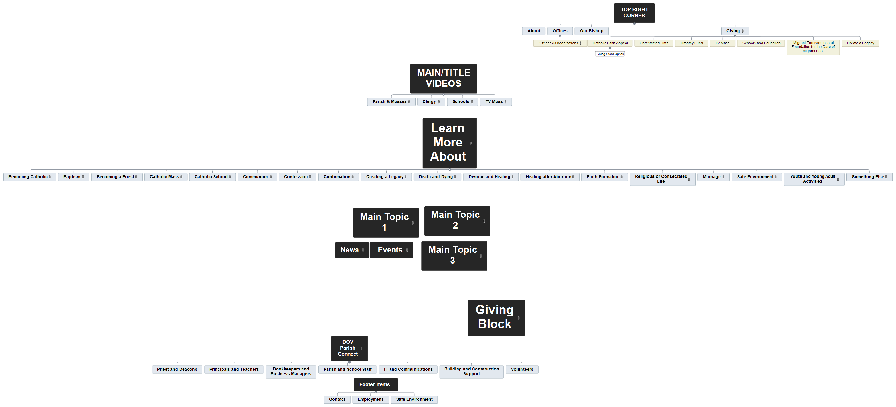
Parish & Masses
Clergy
Schools
TV Mass

Parish & Masses

Clergy

Schools

TV Mass

