Learn More About
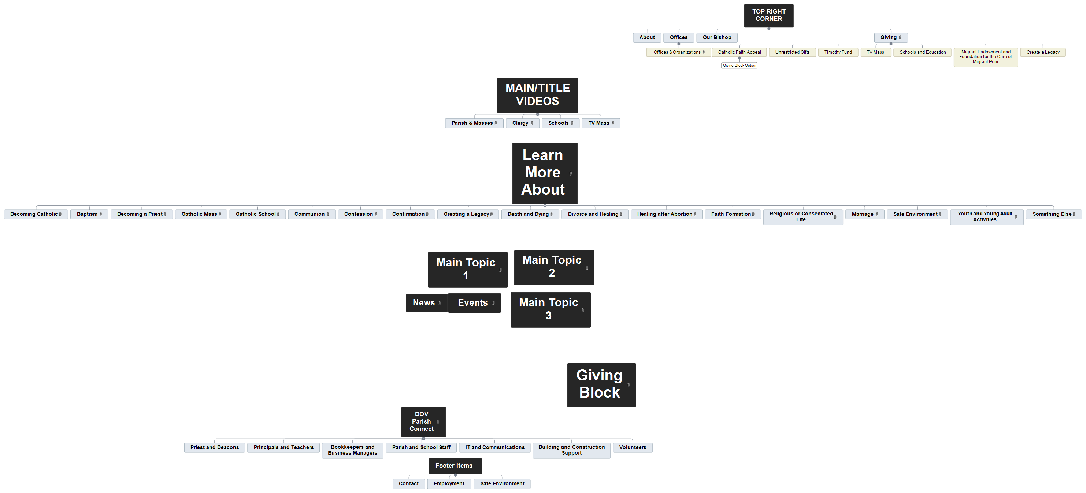
Becoming Catholic
Baptism
Becoming a Priest
Catholic Mass
Catholic School
Communion
Confession
Confirmation
Creating a Legacy
Death and Dying
Divorce and Healing
Healing after Abortion
Faith Formation
Religious or Consecrated Life
Marriage
Safe Environment
Youth and Young Adult Activities
Something Else

Becoming Catholic

Baptism

Becoming a Priest

Catholic Mass

Catholic School

Communion

Confession

Confirmation

Creating a Legacy

Death and Dying

Divorce and Healing

Healing after Abortion

Faith Formation

Religious or Consecrated Life

Marriage

Safe Environment

Youth and Young Adult Activities

Something Else

