DOV Parish Connect
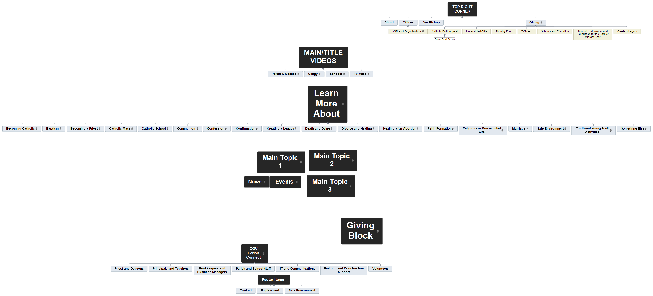
Priest and Deacons
Principals and Teachers
Bookkeepers and Business Managers
Parish and School Staff
IT and Communications
Building and Construction Support
Volunteers

Priest and Deacons

Principals and Teachers

Bookkeepers and Business Managers

Parish and School Staff

IT and Communications

Building and Construction Support

Volunteers

