Footer Items
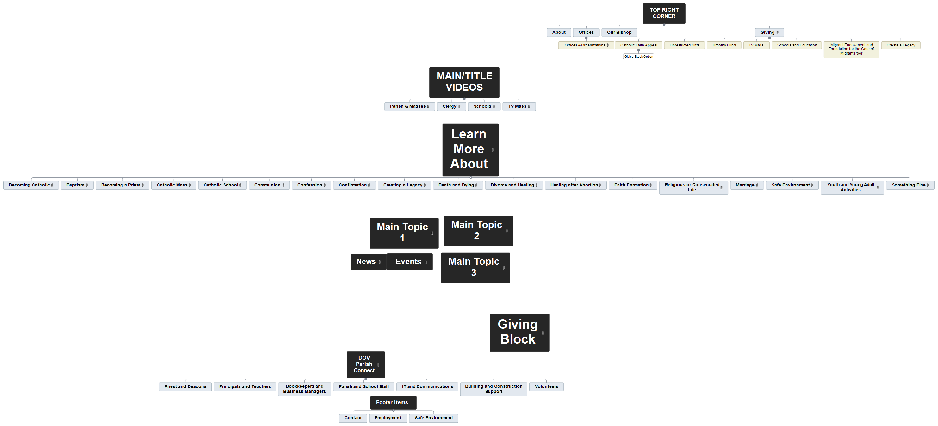
Contact
Employment
Safe Environment

Contact

Employment

Safe Environment

