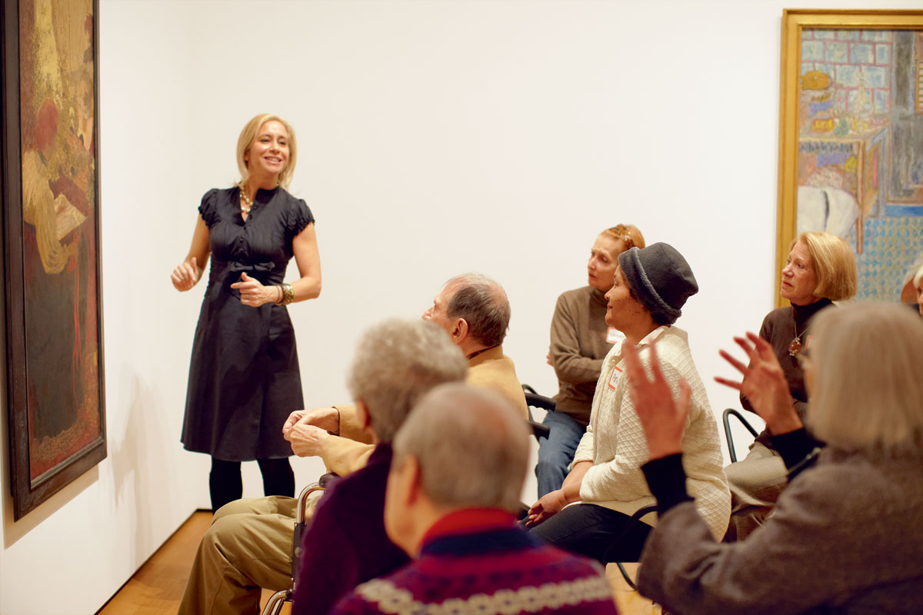

“Faith is professed with the lips and with the heart, through words and through love.”

Pope Francis

RCIA
For Adults interested in becoming Catholic or completing their Sacraments of Initiation (Baptism, Eucharist, Confirmation)
Adult Faith Formation
Frequently Asked Questions
Youth & Young Adults

Sacraments For Children
What is “Faith”? We profess our Catholic Faith in the ‘Apostles Creed’ at Mass every Sunday, but what is it we profess and how did it first come to my lips?
“It is the Church that believes first, and so bears, nourishes, and sustains my faith… Salvation comes from God alone; but because we receive the life of faith through the Church… she is our mother, she is also our teacher in the faith.”
(Catechism of the Catholic Church, 169)
Faith Formation


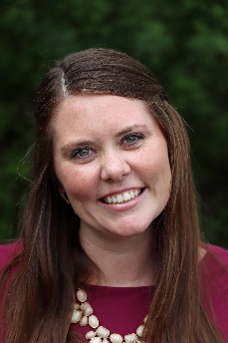
George Smith
Director of Youth & Young Adults
Ashley Fox
Director of Religious Education
Dr. Sean Myers
Director of Worship

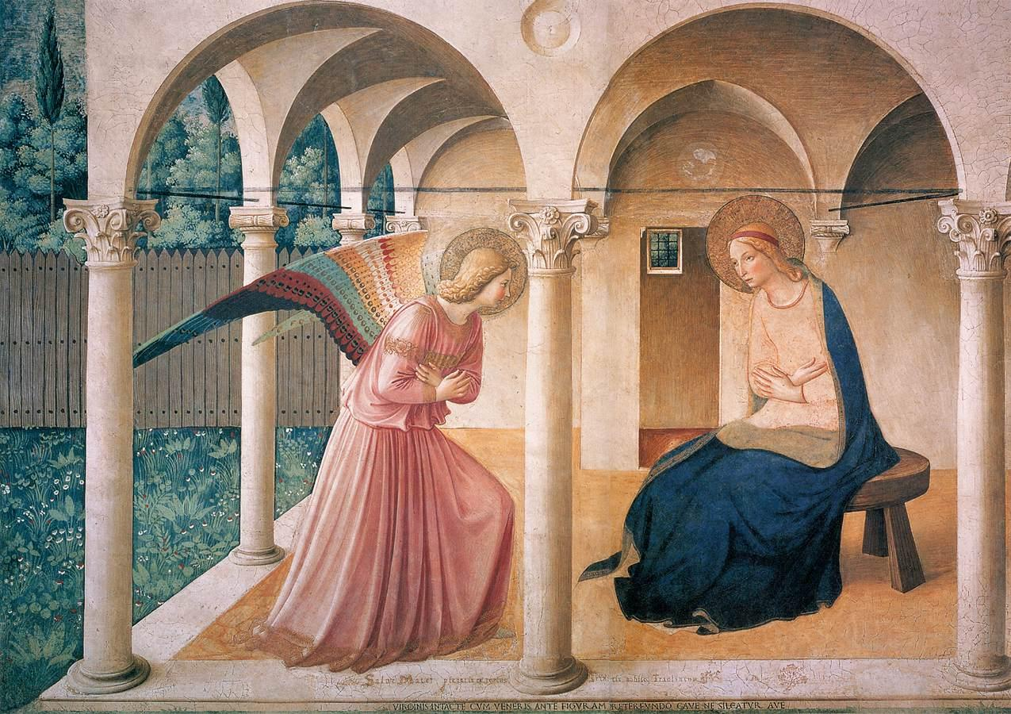
Sacraments for Children Page
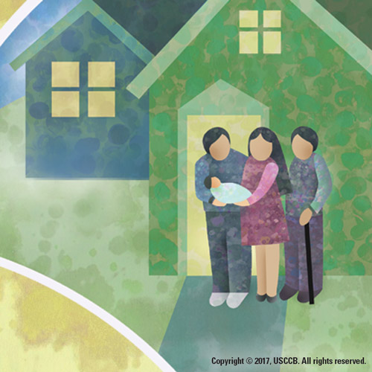
“The Church is apostolic because she is founded on the apostles, in three ways:
- she was and remains built on ‘the foundation of the Apostles,’ the witnesses chosen and sent on mission by Christ himself,
- with the help of the Spirit dwelling in her, the Church keeps and hands on the teaching, the ‘good deposit,’ the salutary words she has heard from the apostles;
- she continues to be taught, sanctified, and guided by the apostles until Christ’s return, through their successors in pastoral office: the college of bishops, ‘assisted by priests, in union with the successor of Peter, the Church’s supreme pastor.’” Catechism of the Catholic Church, 857
Under the priestly office of our bishop, Most Reverend Frank Dewane, each pastor is appointed to
“Go, therefore, and make disciples of all nations, baptizing them in the name of the Father, and of the Son, and of the Holy Spirit, teaching them to observe all [Christ] commanded [them]. (Matthew 28: 20)”
Each pastor hires a director or coordinator of religious education to continue this mission with him of evangelizing and catechizing all children within the parish boundaries; those taught at home, public, or Catholic schools. All directors and coordinators are qualified personnel and hold a Master’s Degree, Bachelor’s Degree, or equivalent in Theology. For more information, contact the parish nearest you at: “Insert link to Parish Finder.”

“Jesus, however, called the children to himself and said, ‘Let the children come to me and do not prevent them; for the kingdom of God belongs to such as these.”
Luke 18:16

First Communion
(link to letter by Bob and Parish locator)

Baptism
(link to letter by Bob and Parish locator)

First Confession
(link to letter by Bob and Parish locator)

Confirmation
(link to letter by Bob and Parish locator)

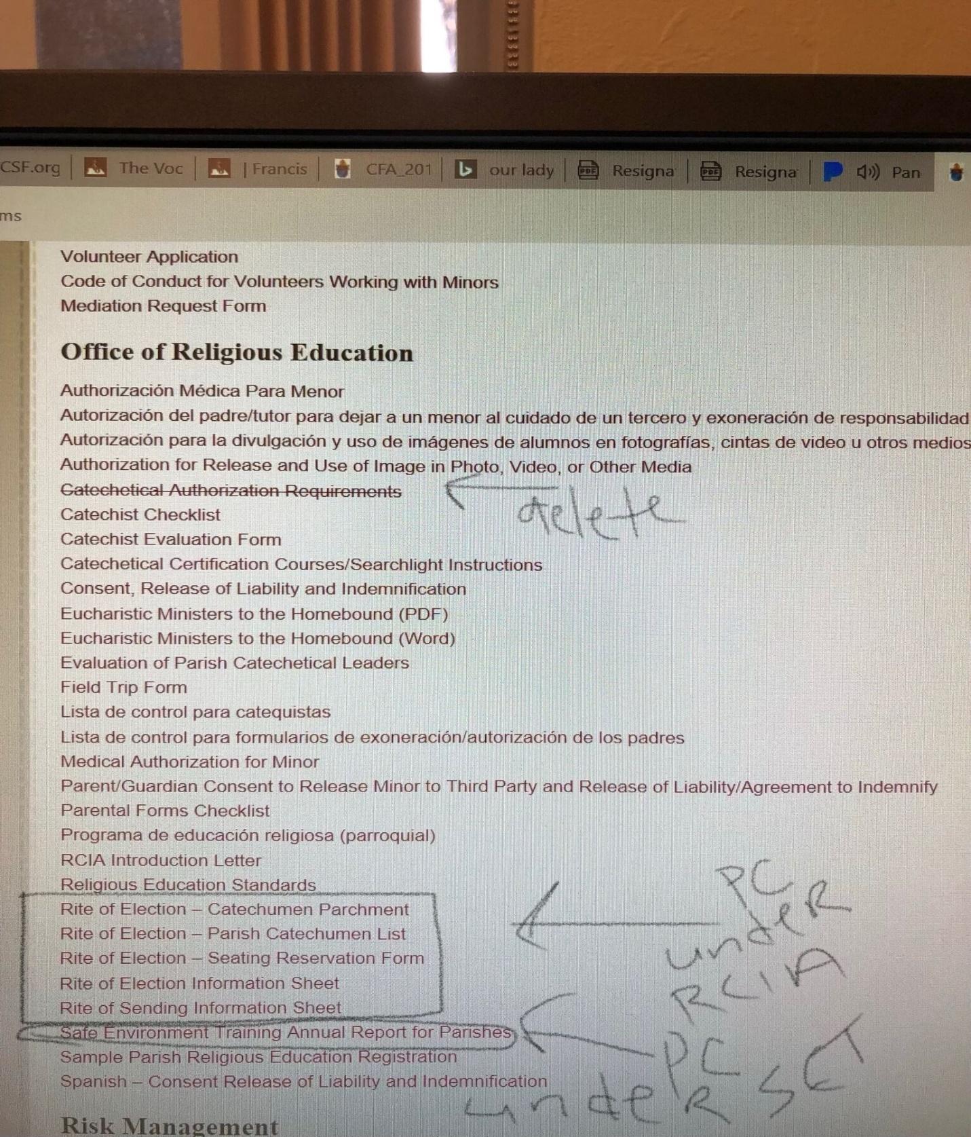
Parish Catechetical Forms for Religious Education Programs
(link to Parish Connect – see the picture below of what to transfer into this section of Parish Connect; title section “Sacraments for Children Forms” under “Office of Religious Education”
PC under RCIA = Parish Connect under “RCIA” under “Office of Religious Education”
PC under SET = Parish Connect under “Safe Environment”

Frequently Asked Questions Page
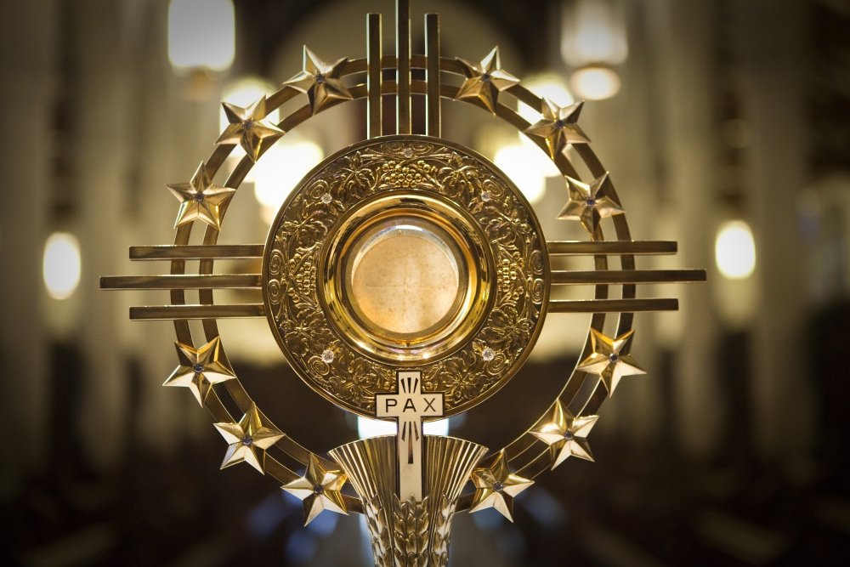

Frequently Asked Questions
- I am a Catholic School parent, why do my children need to go to Religious Education classes and receive their Sacraments through my parish?

- Why do my children need to take nearly two years of Religious Education classes before receiving each Sacrament?

- Why do I have to register with my parish for my children to receive their Sacraments?

- Why do I have to attend events or classes as part of the program for my child’s catechesis?

- What is the definition of “catechesis”?

How would these be explained via the website design? They will each require two paragraphs of an explanation. Should they link to a separate answers page? When do you need the answers from me? Should the answers be in a drop-down box once someone clicks on the question?

I am going to start with these five and see how it goes.

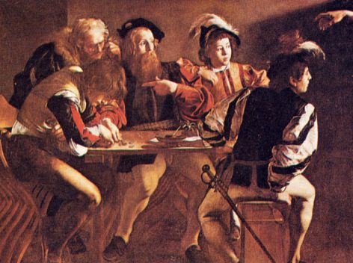
RCIA page
What is the RCIA?
The Rite of Christian Initiation of Adults (RCIA) is the class where an adult of any background, non-religious or faith, is able to learn about Catholicism to consider joining the Catholic Church and also where a baptized Catholic adult is able to continue learning about their Catholic Faith in order to complete one or more of their Sacraments of Initiation: Baptism, Confirmation, and First Communion.
Why is the RCIA held in high regard?
Many adults today have questions about multiple facets of Catholicism. The RCIA classes held within each Catholic parish allows the relaxed setting where all adults of all faiths or non-religious to attend classes and not only learn about the Catholic Faith, but begin to ponder its mysteries and ask as many questions as their hearts and minds desire. It is a free zone to learn about the Church Christ instituted that still continues to today, and will continue until His Second Coming.
What will I learn in the RCIA class?
You will learn everything from the reason why the Catholic Church is the Church Christ instituted on earth, to the mystery of the Triune God, to the Sacraments and why they exist as well as how they are practiced, to Social Justice and Religious Freedom Issues, to Virtue and Grace, as well as Sin, and the Four Last Things. You will also learn why you were created and for what purpose. There is no such class as the RCIA!
How do I join a RCIA class?
There is an RCIA class taught at every Catholic Church in the world. Please go to this Parish Locator (link) and find the closest parish near you. Contact them and ask to join the class. Typically, classes start in September and finish four to five weeks after Easter Sunday. If you are mid-year, still contact the parish and they will be able to direct you!

Adult Faith Formation Page
I want this to be a video content and events page. I do not know what that could look like?

