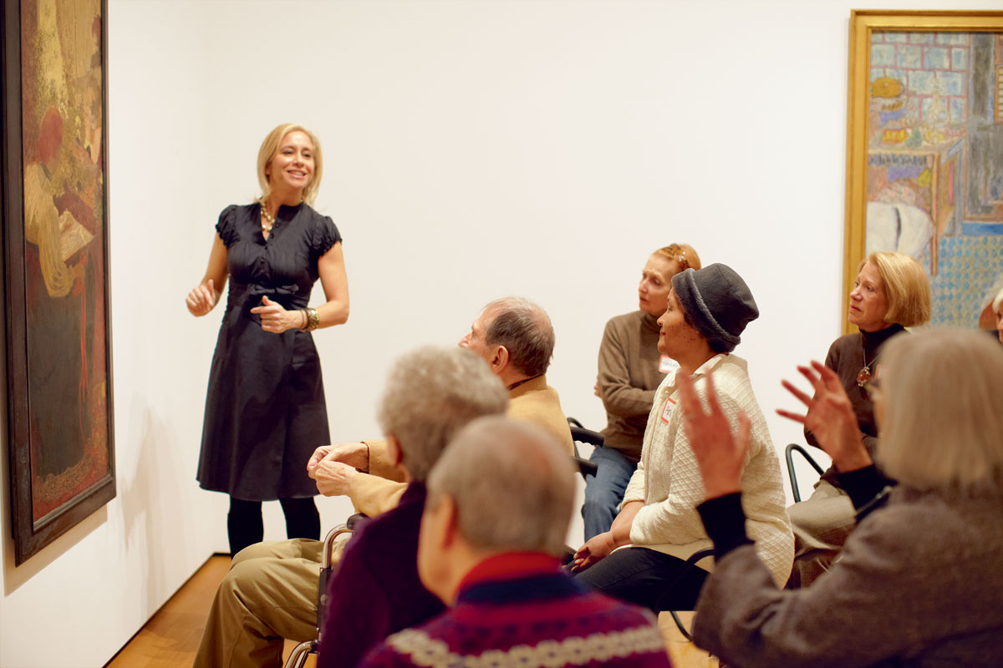
Safe Environment

As Christian adults, we have a moral and legal responsibility and are entrusted by God with the spiritual, emotional and physical well-being of minors and vulnerable adults.

Policies, Procedures, and Forms
(content on website under this, this should link to Parish Connect and the list of all our Policies/Procedures and Forms – combine into one list)
Letter from Bishop Frank Dewane
(content on website under this)

Program Registration
(content on website under this – Roger should we update it yet??)

Fingerprinting Procedures
(content on website under this)
Training Schedule
(content on website under this)

Abuse Reporting (make this a link, content on website)
Victim Assistance (make this a link, content on website)


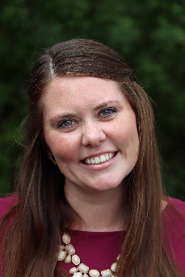
Review Board/Committee (make this a link, content on website)
Ashley Fox
Director of Safe Environment Awareness and Certification
A
Chris Macdonald
Don’t know her title?
Cara Smith
Don’t know her title?

DELETE OFF CURRENT WEBSITE AND NOT INCLUDE IN NEW WEBSITE:
Training Materials
Parish/School Annual Safe Environment Reports
Under SET Forms: Eucharistic Ministers to the Homebound crossed out links

MOVE TO PARISH CONNECT:
Logos Login

