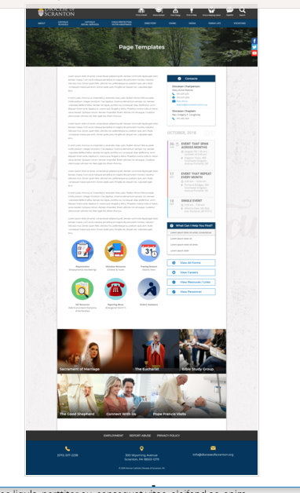
Page Content
Circle Buttons
Page Title
Contacts
Calendar
Mondrian Tiles (4 – 6)
What Can I Help You Find?
Please see above illustration of an Office Web Page. Please fill in the information below for your Office Web Page. If you do not have specific pictures available for the top photo and the Mondrian Tiles, please indicate

Page Title: Diocesan Cemeteries

Contacts
Best Practices: Please select 1 or 2 of your top contacts for your particular office. If you have more than 2 contacts, there will be an option to add a button to more personnel.
Limit: 2 Contacts
Contact 1
Title: Director of Catholic Cemeteries
Name: Dominic Rinaldi
Phone: 570-558-4310
Fax: 570-558-4311
Email: Dominic Rinaldi
Contact 2
Title:
Name:
Phone:
Fax:
Email:

What Can I Help You Find?
Best Practices: If you have more than 4 links, consider making the “resources” page as your 4th link.
Limit: 4 Links
Link 1 Title: Frequently Asked Questions
Link 1 URL: Use content found in Frequently Asked Questions.docx
Link 2 Title: Rules and Regulations
Link 2 URL: Open Cemetery - Regulation Booklet 2019.pdf in new tab
Link 3 Title:
Link 3 URL:
Link 4 Title:
Link 4 URL:

Other Sidebar Options
View All Forms Button: ☐Yes/☒No
View Careers Button: ☐Yes/☒No
View Resources/Links: ☐Yes/☒No
View Personnel: ☒Yes/☐No

Personnel: See Diocesan Cemeteries contact info.docx

Mondrian Tiles
Best Practices: If you are planning on using both the What Can I Help You Find sidebar and the Calendar sidebar option(s), you should not use the Mondrian Tiles unless you have enough text and pictures to fill the content area on the left. Using sidebar options AND the Mondrian Tiles may result in a cluttered office page.
Limit: 4-6 Tiles
Images: If you have specific images in mind, please attach the original file to your documents with instructions on which image goes to which tile.
Tile 1 Title: Cathedral Cemetery
Tile 1 Current URL (if any): Cathedral Cemetery.docx
Tile 1 Image Suggestion/Information: CathedralTile.JPG
Tile 2 Title: Calvary Cemetery
Tile 2 Current URL (if any): Calvary Cemetery.docx
Tile 3 Image Suggestion/Information: Calvarytile.JPG
Tile 3 Title: Mount Olivet Cemetery
Tile 3 Current URL (if any): MT Olivet Cemetery.docx
Tile 3 Image Suggestion/Information: MtOlivettile.JPG
Tile 4 Title: Resurrection Cemetery
Tile 4 Current URL (if any): Resurrection Cemetery.docx
Tile 4 Image Suggestion/Information: Resurrection Cemetery-tile.jpg
Tile 5 Title: Holy Cross Cemetery
Tile 5 Current URL (if any): Holy Cross Cemetery.docx
Tile 5 Image Suggestion/Information: Holycrosstile.JPG
Tile 6 Title: Saint Catherine Cemetery
Tile 6 Current URL (if any): ST Catherine Cemetery.docx
Tile 6 Image Suggestion/Information: StCatherineTile.JPG

Page Content
Best Practices: The first paragraph on your office page should contain information about your office. The rest of the page’s content is up to you. Remember, circle buttons can be used throughout your page content.
Limit: None

Our Mission Statement:

The Catholic Cemeteries of the Diocese of Scranton carry out the sacred duty of providing a dignified Christian burial for all of our beloved faithful departed.
Recognizing that our bodies are Temples of the Holy Spirit, we dedicate ourselves to providing respectful care for the grounds which contain those mortal remains.
Mindful of our obligation to comfort the sorrowful, we are committed to providing Christian compassion and counsel to those left behind in mourning and in sorrow.
Answering our call to spread the Good News, we proclaim through our words and actions our hope in the Resurrection and our belief in Our Lord’s promise of eternal life.

Please see the answers to frequently asked questions and our rules/regulations under “What Can I Help You Find?” at right.

Please click on the tiles below for information about each of our Diocesan Cemeteries.

