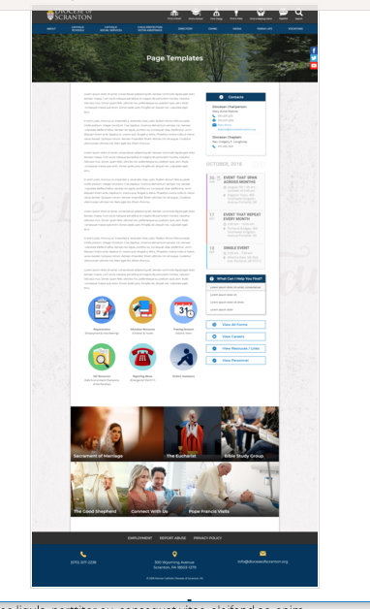
Page Content
Circle Buttons
Page Title
Contacts
Calendar
Mondrian Tiles (4 – 6)
What Can I Help You Find?
Please see above illustration of an Office Web Page. Please fill in the information below for your Office Web Page. If you do not have specific pictures available for the top photo and the Mondrian Tiles, please indicate

Page Title: Vocation Office

Contacts
Best Practices: Please select 1 or 2 of your top contacts for your particular office. If you have more than 2 contacts, there will be an option to add a button to more personnel.
Limit: 2 Contacts
Contact 1
Title: Diocesan Director of Vocations and Seminarians
Name: Reverend Donald J. Williams
Phone: 570-207-1452
Fax:
Email: Rev-Donald-Williams@dioceseofscranton.org
Contact 2
Title: Vocation Program Coordinator
Name: Dominick Costantino Jr.
Phone: 570-207-1452
Fax:
Email: Dominick-Costantino@dioceseofscranton.org

What Can I Help You Find?
Best Practices: If you have more than 4 links, consider making the “resources” page as your 4th link.
Limit: 4 Links
Link 1 Title: Vocations Website
Link 1 URL: vocations.dioceseofscranton.org
Link 2 Title:
Link 2 URL:
Link 3 Title:
Link 3 URL:
Link 4 Title:
Link 4 URL:

Other Sidebar Options
View All Forms Button: ☐Yes/☐No
View Careers Button: ☐Yes/☐No
View Resources/Links: ☐Yes/☐No
View Personnel: ☐Yes/☐No

Mondrian Tiles
Best Practices: If you are planning on using both the What Can I Help You Find sidebar and the Calendar sidebar option(s), you should not use the Mondrian Tiles unless you have enough text and pictures to fill the content area on the left. Using sidebar options AND the Mondrian Tiles may result in a cluttered office page.
Limit: 4-6 Tiles
Images: If you have specific images in mind, please attach the original file to your documents with instructions on which image goes to which tile.
Tile 1 Title:
Tile 1 Current URL (if any):
Tile 1 Image Suggestion/Information:
Tile 2 Title:
Tile 2 Current URL (if any):
Tile 3 Image Suggestion/Information:
Tile 3 Title:
Tile 3 Current URL (if any):
Tile 3 Image Suggestion/Information:
Tile 4 Title:
Tile 4 Current URL (if any):
Tile 4 Image Suggestion/Information:
Tile 5 Title:
Tile 5 Current URL (if any):
Tile 5 Image Suggestion/Information:
Tile 6 Title:
Tile 6 Current URL (if any):
Tile 6 Image Suggestion/Information:

Circle Buttons

Circle Buttons can be used at any location in the page text content. (Example: paragraph of text, 3 buttons, paragraph of text, 4 buttons)To place buttons into your page area, please copy and paste Buttons 1-6 where you would like it to go. You may use buttons multiple times on your page, with the limit of 1-6 buttons per use.
(Example: paragraph of text, 3 buttons, paragraph of text, 4 buttons)
Best Practices: These buttons should serve as other quicklinks for visitors to jump off from. It may be specific programs or most visited sub-pages from your office page.
Limit: 2-6
Button 1 Title:
Button 1 Current URL (if any):
Button 1 Image Suggestion/Information:
Button 2 Title:
Button 2 Current URL (if any):
Button 3 Image Suggestion/Information:
Button 3 Title:
Button 3 Current URL (if any):
Button 3 Image Suggestion/Information:
Button 4 Title:
Button 4 Current URL (if any):
Button 4 Image Suggestion/Information:
Button 5 Title:
Button 5 Current URL (if any):
Button 5 Image Suggestion/Information:
Button 6 Title:
Button 6 Current URL (if any):
Button 6 Image Suggestion/Information:

Page Content
Best Practices: The first paragraph on your office page should contain information about your office. The rest of the page’s content is up to you. Remember, circle buttons can be used throughout your page content.
Limit: None

Through our Baptism, we are all called to live a life of holiness and mission. Pope Francis at World Youth Day 2016 in Krakow, Poland challenged the young church to leave a mark and make a difference for good in our world. The Diocesan Vocation Office believes that when we answer this call and live as intentional and missionary disciples, there will be holier marriages, more generous single adults, and an increased number of those willing to serve as Priests, Religious and lay ecclesial ministers. All of our vocations are a gift from God. Visit our website for information about all vocations and how we can help in the discernment process.

