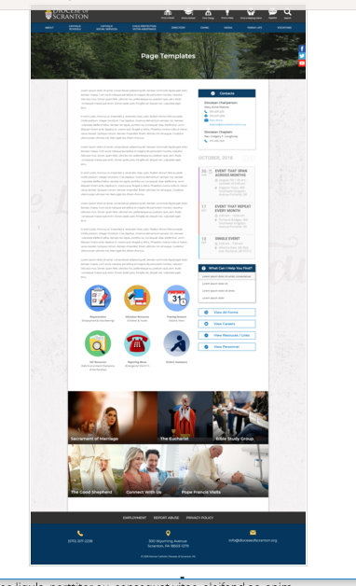
Page Content
Circle Buttons
Page Title
Contacts
Calendar
Mondrian Tiles (4 – 6)
What Can I Help You Find?
Please see above illustration of an Office Web Page. Please fill in the information below for your Office Web Page. If you do not have specific pictures available for the top photo and the Mondrian Tiles, please indicate

Page Title : Pontifical Mission Societies

Contacts
Best Practices: Please select 1 or 2 of your top contacts for your particular office. If you have more than 2 contacts, there will be an option to add a button to more personnel.
Limit: 2 Contacts
Contact 1
Title: Diocesan Director
Name: Reverend Brian J.T. Clarke
Phone: 570-207-2259
Fax:
Email: Rev-Brian-JT-Clarke@dioceseofscranton.org

Contact 2
Title: Administrative Assistant
Name: Alexandra Russin
Phone: 570-207-2269
Fax: 570-207-2268
Email: Alexandra-Russin@dioceseofscranton.org

Other Sidebar Options
View All Forms Button: ☒Yes/☐No
View Resources/Links: ☒Yes/☐No

Circle Buttons

Circle Buttons can be used at any location in the page text content. (Example: paragraph of text, 3 buttons, paragraph of text, 4 buttons)To place buttons into your page area, please copy and paste Buttons 1-6 where you would like it to go. You may use buttons multiple times on your page, with the limit of 1-6 buttons per use.
(Example: paragraph of text, 3 buttons, paragraph of text, 4 buttons)
Best Practices: These buttons should serve as other quicklinks for visitors to jump off from. It may be specific programs or most visited sub-pages from your office page.
Limit: 2-6
Button 1 Title: What is the Pontifical Mission Societies?
Button 1 Current URL (if any): Use content found in What is the Pontifical Mission Societies.docx
Button 1 Image Suggestion/Information: pontifical-mission-logo.jpg
Button 2 Title: Accomplishing our Mission Statement
Button 2 Current URL (if any): Use content found in Accomplishing our Mission Statement.docx
Button 2 Image Suggestion/Information: smiling girl.png
Button 3 Title: Mission Trips and Mission Immersion Experiences
Button 3 Current URL (if any): Use content found in Mission Trips and Mission Immersion Experiences.docx
Button 3 Image Suggestion/Information: 3 girls.png
Button 4 Title: Donations to the Pontifical Mission Societies
Button 4 Current URL (if any): Use content found in Donations to the Pontifical Mission Societies.docx
Button 4 Image Suggestion/Information: collection box or basket
Button 5 Title: Prayers
Button 5 Current URL (if any): Use content found in Prayers.docx
Button 5 Image Suggestion/Information: hands folded in prayer

Page Content
Best Practices: The first paragraph on your office page should contain information about your office. The rest of the page’s content is up to you. Remember, circle buttons can be used throughout your page content.

The Pontifical Mission Societies of the Diocese of Scranton promotes a mission spirituality and global vision in the hearts and minds of the faithful. Through education, prayer, material and financial support and local missionary involvement among the religious and lay faithful, we seek to spread the Gospel of Jesus “to the ends of the earth”.

