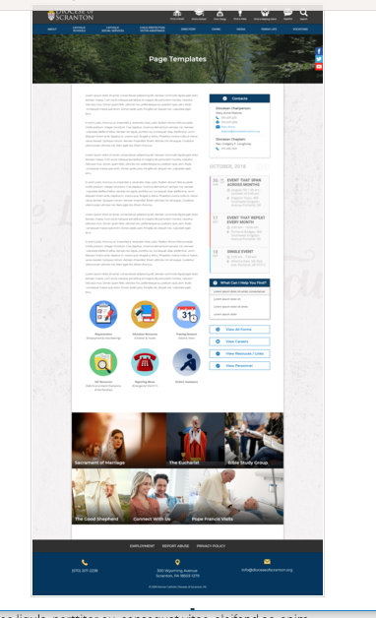
Page Content
Circle Buttons
Page Title
Contacts
Calendar
Mondrian Tiles (4 – 6)
What Can I Help You Find?
Please see above illustration of an Office Web Page. Please fill in the information below for your Office Web Page. If you do not have specific pictures available for the top photo and the Mondrian Tiles, please indicate

Page Title (Bishop’s Office, Communications, Parish Life, etc): Vicar General and Moderator of the Curia

Contacts
Best Practices: Please select 1 or 2 of your top contacts for your particular office. If you have more than 2 contacts, there will be an option to add a button to more personnel.
Limit: 2 Contacts
Contact 1
Title: Vicar General and Moderator of the Curia
Name: Thomas M. Muldowney, V.G.
Phone: 570-207-2269
Fax: 570-207-2236
Email: msgr-muldowney@dioceseofscranton.org
Contact 2
Title: Executive Administrative Assistant to the Vicar General
Name: Alexandra Russin
Phone: 570-207-2269
Fax: 570-207-2236
Email: alexandra-russin@dioceseofscranton.org

What Can I Help You Find?
Best Practices: If you have more than 4 links, consider making the “resources” page as your 4th link.
Limit: 4 Links
Link 1 Title: Diocese of Scranton Administrative Organization Chart
Link 1 URL: file found at http://www.dioceseofscranton.org/wp-content/uploads/2018/08/Organizational-Chart-Diocese-of-Scranton-August-2018-002-Final.pdf
Link 2 Title: Diocese of Scranton Councils
Link 2 URL: https://scranton.diocesanweb.org/diocese-councils/
Link 3 Title:
Link 3 URL:
Link 4 Title:
Link 4 URL:

Other Sidebar Options
View Personnel: ☒Yes/☐No

Page Content
According to Code of Canon Law, the Vicar General is the principal delegate of the Diocesan Bishop. The Vicar General possesses that delegated authority in the Diocese which belongs to the Bishop in law, that is, he possesses the power to place all administrative acts with the exception of those which the Bishop has reserved to himself or which in law requires the special mandate of the Bishop. He is the highest official in a diocese after the diocesan bishop.

The Moderator of the Curia is a priest appointed by the Diocesan Bishop whose task it is under the authority of the Bishop to coordinate the exercise of administrative responsibilities and to see that all members of the Curia dutifully fulfill the offices entrusted to them. The Moderator of the Curia fosters unity, identity, and purpose within the Curia. He guides and directs diocesan departments in the implementation of the Diocese’s mission and the priorities of the Bishop.

