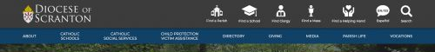

Each underlined group of words is a link.

 Development & Appeal Office (new) – use content from Development & Appeal Office Copy Revised.docx
 Diocesan Annual Appeal – link to (http://annualappeal.org/
 Ways to Make a Gift (new page) – use content from Frequently Asked Questions.docx
 Donate Now - link to http://annualappeal.org/donate-now/
 Business Tax Credit Programs for Education (EITC and OSTC) (new page)- use content from EITC OSTC Website Copy linked from Giving Landing Page.docx
 Assisting Seminarians –
St. John Vianney Endowment & Annual Golf Classic (new page to be completed)
 Estate Planning (https://dioceseofscranton.planningyourlegacy.org/
 Living as Grateful Disciples (links to Stewardship/Parish Life)

