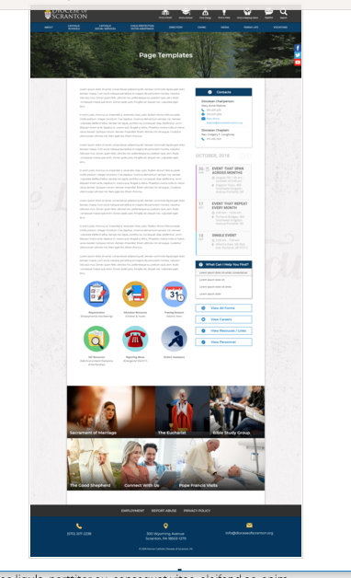
Page Content
Circle Buttons
Page Title
Contacts
Calendar
Mondrian Tiles (4 – 6)
What Can I Help You Find?
Please see above illustration of an Office Web Page. Please fill in the information below for your Office Web Page. If you do not have specific pictures available for the top photo and the Mondrian Tiles, please indicate

Page Title: Diocesan Pastoral Center

Contacts
Best Practices: Please select 1 or 2 of your top contacts for your particular office. If you have more than 2 contacts, there will be an option to add a button to more personnel.
Limit: 2 Contacts
Contact 1
Title: Events Coordinator
Name: Sue Burke
Phone: 570-591-5005
Fax: 570-207-2204
Email: Sue-Burke@dioceseofscranton.org
:

What Can I Help You Find?
Best Practices: If you have more than 4 links, consider making the “resources” page as your 4th link.
Limit: 4 Links
Link 1 Title: Downloadable Brochure
Link 1 URL: Diocesan Pastoral Center Brochure.pdf
Link 2 Title:
Link 2 URL:

Other Sidebar Options
View All Forms Button: ☐Yes/☒No
View Careers Button: ☐Yes/☒No
View Resources/Links: ☐Yes/☒No
View Personnel: ☐Yes/☒No

Page Content

The Diocesan Pastoral Center, located at 330 Wyoming Avenue in Scranton offers great event and meeting spaces! Ideal for:
- Groups in Ministry Formation
- Diocesan Conferences/Receptions
- Parish and Regional Staffs/Teams
- Adult Faith Formation Groups
- Retreat Groups of all types; Days of Reflection; Prayer Groups
- Groups of Children and Youth preparing for sacraments
- Catholic School Faculties/Boards
- Corporate Meetings or Training

See below our available facilities and costs.

Type of Event/Space Needed  (Catering Costs Extra, See Below) | Diocesan Affiliated Groups | Approved Unaffiliated Groups
Single Meeting/Classroom Space (2-3 hrs) | $50 | $75
Multiple Meeting/Classroom Spaces (2-3 hrs) | $100 | $125
Meeting/Classrooms /Dining Room (5-8hrs) | $200+meal costs | $250+meal costs
Retreat – Meeting/Dining Room/Chapel/Atrium  (5-8 hours) | $300+meal costs | $350+meal costs
Large Group – Full Facility with Auditorium,  Meeting Rooms, Dining Room, Chapel  (all reserved for your group) | $400+meal costs | $500+meal costs
Additional Opportunities
Coffee Set-Up with Light Snacks | $2-3 per person | $2-3 per person
Meal Boxed and Delivered | Actual cost of caterer | Actual cost of caterer
Meal Catered and Served | Actual cost of caterer | Actual cost of caterer
Use of Gymnasium  ( Only for group with scheduled event) | $100 w/demonstration of supervision plan | $150 w/demonstration of supervision plan

Contact Sue Burke, Events Coordinator at 570-591-5005 for more details.

