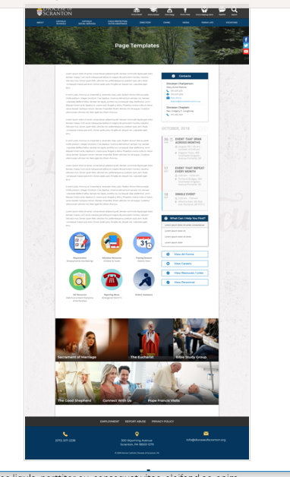
Page Content
Circle Buttons
Page Title
Contacts
Calendar
Mondrian Tiles (4 – 6)
What Can I Help You Find?
Please see above illustration of an Office Web Page. Please fill in the information below for your Office Web Page. If you do not have specific pictures available for the top photo and the Mondrian Tiles, please indicate

Page Title (Bishop’s Office, Communications, Parish Life, etc): Information Technology

Contacts
Best Practices: Please select 1 or 2 of your top contacts for your particular office. If you have more than 2 contacts, there will be an option to add a button to more personnel.
Limit: 2 Contacts
Contact 1
Title: IT Manager
Name: Connie Wisdo
Phone: 570-591-5010
Fax: 570-591-5009
Email: cwisdo@dioceseofscranton.org
Contact 2
Title: IT Support Specialist
Name: Brent Pennington
Phone: 570-591-5008
Fax: 570-591-5009
Email: bpennington@dioceseofscranton.org

What Can I Help You Find?
Best Practices: If you have more than 4 links, consider making the “resources” page as your 4th link.
Limit: 4 Links
Link 1 Title: Report a Computer Issue
Link 1 URL: Email to: computerissues@dioceseofscranton.org
Link 2 Title:
Link 2 URL:
Link 3 Title:
Link 3 URL:
Link 4 Title:
Link 4 URL:

Other Sidebar Options
View All Forms Button: ☐Yes/☒No
View Careers Button: ☐Yes/☒No
View Resources/Links: ☐Yes/☒No
View Personnel: ☐Yes/☒No

Mondrian Tiles - NONE
Best Practices: If you are planning on using both the What Can I Help You Find sidebar and the Calendar sidebar option(s), you should not use the Mondrian Tiles unless you have enough text and pictures to fill the content area on the left. Using sidebar options AND the Mondrian Tiles may result in a cluttered office page.
Limit: 4-6 Tiles
Images: If you have specific images in mind, please attach the original file to your documents with instructions on which image goes to which tile.
Tile 1 Title:
Tile 1 Current URL (if any):
Tile 1 Image Suggestion/Information:
Tile 2 Title:
Tile 2 Current URL (if any):
Tile 3 Image Suggestion/Information:
Tile 3 Title:
Tile 3 Current URL (if any):
Tile 3 Image Suggestion/Information:
Tile 4 Title:
Tile 4 Current URL (if any):
Tile 4 Image Suggestion/Information:
Tile 5 Title:
Tile 5 Current URL (if any):
Tile 5 Image Suggestion/Information:
Tile 6 Title:
Tile 6 Current URL (if any):
Tile 6 Image Suggestion/Information:

Circle Buttons - NONE

Circle Buttons can be used at any location in the page text content. (Example: paragraph of text, 3 buttons, paragraph of text, 4 buttons)To place buttons into your page area, please copy and paste Buttons 1-6 where you would like it to go. You may use buttons multiple times on your page, with the limit of 1-6 buttons per use.
(Example: paragraph of text, 3 buttons, paragraph of text, 4 buttons)
Best Practices: These buttons should serve as other quicklinks for visitors to jump off from. It may be specific programs or most visited sub-pages from your office page.
Limit: 2-6
Button 1 Title:
Button 1 Current URL (if any):
Button 1 Image Suggestion/Information:
Button 2 Title:
Button 2 Current URL (if any):
Button 3 Image Suggestion/Information:
Button 3 Title:
Button 3 Current URL (if any):
Button 3 Image Suggestion/Information:
Button 4 Title:
Button 4 Current URL (if any):
Button 4 Image Suggestion/Information:
Button 5 Title:
Button 5 Current URL (if any):
Button 5 Image Suggestion/Information:
Button 6 Title:
Button 6 Current URL (if any):
Button 6 Image Suggestion/Information:

Page Content
Best Practices: The first paragraph on your office page should contain information about your office. The rest of the page’s content is up to you. Remember, circle buttons can be used throughout your page content.
Limit: None

The IT Department happily provides direct technology support to Diocese administrative offices, cemeteries and Catholic Social Services offices. Services include: server administration, workstation and mobile device purchases, as well as setup, upgrades and troubleshooting, telephony and network support, and assistance with in-house and web-based software. On a wider scale, the IT department provides technology-related project management and consultation to Diocese of Scranton schools and parishes.

To request service or support, please email us or use the “Diocese Tech Support” icon on your desktop.

