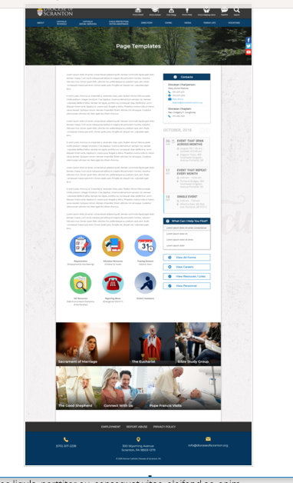
Page Content
Circle Buttons
Page Title
Contacts
Calendar
Mondrian Tiles (4 – 6)
What Can I Help You Find?
Please see above illustration of an Office Web Page. Please fill in the information below for your Office Web Page. If you do not have specific pictures available for the top photo and the Mondrian Tiles, please indicate

Page Title (Bishop’s Office, Communications, Parish Life, etc): Diocesan Tribunal

Contacts – Please use the first two contacts found on http://www.dioceseofscranton.org/diocesan-tribunal-test-page/
Best Practices: Please select 1 or 2 of your top contacts for your particular office. If you have more than 2 contacts, there will be an option to add a button to more personnel.
Limit: 2 Contacts
Contact 1
Title:
Name:
Phone:
Fax:
Email:
Contact 2
Title:
Name:
Phone:
Fax:
Email:

What Can I Help You Find? Use the first four titles and links found in the right nav of http://www.dioceseofscranton.org/diocesan-tribunal-test-page/
Best Practices: If you have more than 4 links, consider making the “resources” page as your 4th link.
Limit: 4 Links
Link 1 Title:
Link 1 URL:
Link 2 Title:
Link 2 URL:
Link 3 Title:
Link 3 URL:
Link 4 Title:
Link 4 URL:

For the above, use the first four titles and links found in the right nav of http://www.dioceseofscranton.org/diocesan-tribunal-test-page/

Other Sidebar Options
View All Forms Button: ☐Yes/☒No
View Careers Button: ☐Yes/☒No
View Resources/Links: ☒Yes/☐No – Use the content from http://www.dioceseofscranton.org/diocesan-tribunal-test-page/canonical-documents-for-marriage-preparation/
View Personnel: ☒Yes/☐No – use what’s found in the Contact Us block on http://www.dioceseofscranton.org/diocesan-tribunal-test-page/

Page Content
The Tribunal of the Diocese of Scranton is the forum in which the judicial authority of the Bishop is exercised. The Judicial Vicar, Judges and other canonical ministers and professional staff cooperate in the Bishop’s ministry of furthering the supreme law of the Church, “the salvation of souls” (canon 1752 of the 1983 Code of Canon Law).
The Tribunal of Scranton, as the ecclesiastical court of the diocese, serves the People of God in charity, justice and truth whenever there is cause to pursue or vindicate the rights of persons accorded by law. In some cases, this pertains to the recognition of his or her state in life (e.g. the validity of Holy Order, Marriage, or Religious Profession).
The Tribunal of the Diocese of Scranton carries out most of its ministerial duty by resolving questions regarding the validity or invalidity of marriage through the judicial process of marriage nullity which some refer to as an “annulment.”
In union with the whole Church, the Tribunal of Scranton believes in the sacramental dignity which Tobiah and Sarah called “true marriage”:
You made Adam, and Eve his partner and support; and those two were parents of the human race. This was your word: It is not good for the man to be alone; let us make him a helpmate like him. I now take this my beloved to be my partner, not out of self-interest but in true marriage. Grant that we may find mercy and grow old together.
Tobit 8: 5b-7
God, therefore, established Marriage as the covenant binding a man and a woman together for life in the good times and the bad, in sickness and in health; a consortium of life in which a man and woman become one, equal in dignity, responsible and self-sacrificing in love; a “sign of Christ’s love for the Church.”
Yet, the Tribunal of Scranton recognizes, along with the Church, that invalid marriages do exist by reasons determined in law. As a result, part of the ministry of the Tribunal of Scranton is to address a challenge of the validity of a given marriage. The party petitioning the Tribunal is called the “Petitioner” and the other party is called the “Respondent.”
Be assured that the Tribunal of Scranton will do its best within the limits set by canon law to assist both the Petitioner and the Respondent in exercising their rights in the process. Please feel free to call the Tribunal of Scranton at 570-207-2246 at any time.
On this website you will find information pertaining to the “formal process” referred to by others as an “annulment.” This is only one process for addressing the question of the validity of a marriage. For example, some of the other processes include “lack of canonical form” and “prior bond (ligamen).”
After the Tribunal of Scranton has determined its competence to try your case and that the “formal process” is required for your case, you may ask your pastor or the Tribunal for the necessary paperwork to initiate the process and mail them back to the Tribunal of Scranton upon completion.
Reverend Anthony J. Generose, J.C.L.
Judicial Vicar
Diocese of Scranton

