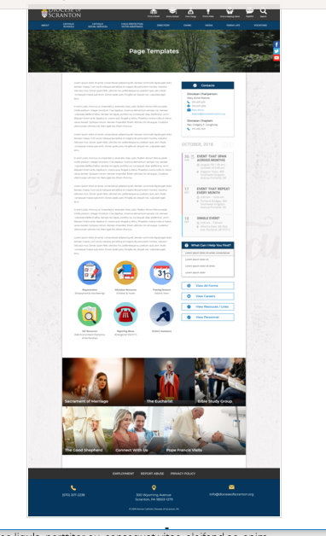
Page Content
Circle Buttons
Page Title
Contacts
Calendar
Mondrian Tiles (4 – 6)
What Can I Help You Find?
Please see above illustration of an Office Web Page. Please fill in the information below for your Office Web Page. If you do not have specific pictures available for the top photo and the Mondrian Tiles, please indicate

Photo for the top will be provided – Child protection logo

Page Title: Child Protection/Victim Assistance
Contacts
Best Practices: Please select 1 or 2 of your top contacts for your particular office. If you have more than 2 contacts, there will be an option to add a button to more personnel.
Limit: 2 Contacts
Contact 1
Title: Safe Environment Coordinator
Name: Kathleen Bolinski, LSW
Phone: 570-207-1453, ext. 1078
Fax: 570-207-1457
Email: kathleen-bolinski@dioceseofscranton.org

Contact 2
Title: Victim Assistance Coordinator
Name: Mary Beth Pacuska
Phone: 570-862-7551
Email: Mary-Beth-Pacuska@dioceseofscranton.org

Contact 3
Title: Administrative Assistant
Name: Heather Betts
Phone: 570-207-2216, ext. 1089
Fax: 570-207-1457
Email: heather-betts@dioceseofscranton.org
Contact 4
Title: Administrative Assistant
Name: Noreen O’Connor
Phone: 570-207-2216, ext. 1071
Fax: 570-207-1457
Email: noreen-oconnor@dioceseofscranton.org

What Can I Help You Find?
Best Practices: If you have more than 4 links, consider making the “resources” page as your 4th link.
Limit: 4 Links
Link 1 Title: Policy for Response to Sexual Abuse of Minors
Link 1 URL: http://www.dioceseofscranton.org/wp-content/uploads/2018/07/Diocese-of-Scranton-Sexual-Abuse-Policy-Revision-2015-TMM-Final-Amended-3.pdf
Link 2 Title: Virtus Training Schedule
Link 2 URL: http://www.dioceseofscranton.org/diocesan-directory/diocesan-offices/compliance-office/virtus/
Link 3 Title: Background Check Requirements
Link 3 URL:
Link 4 Title: Safe Environment Children’s Program
Link 4 URL:

Other Sidebar Options
View All Forms Button: ☒Yes/☐No
View Careers Button: ☐Yes/☒No
View Resources/Links: ☒Yes/☐No
View Personnel: ☒Yes/☐No

Mondrian Tiles N/A
Best Practices: If you are planning on using both the What Can I Help You Find sidebar and the Calendar sidebar option(s), you should not use the Mondrian Tiles unless you have enough text and pictures to fill the content area on the left. Using sidebar options AND the Mondrian Tiles may result in a cluttered office page.
Limit: 4-6 Tiles
Images: If you have specific images in mind, please attach the original file to your documents with instructions on which image goes to which tile.
Tile 1 Title:
Tile 1 Current URL (if any):
Tile 1 Image Suggestion/Information:
Tile 2 Title:
Tile 2 Current URL (if any):
Tile 3 Image Suggestion/Information:
Tile 3 Title:
Tile 3 Current URL (if any):
Tile 3 Image Suggestion/Information:
Tile 4 Title:
Tile 4 Current URL (if any):
Tile 4 Image Suggestion/Information:
Tile 5 Title:
Tile 5 Current URL (if any):
Tile 5 Image Suggestion/Information:
Tile 6 Title:
Tile 6 Current URL (if any):
Tile 6 Image Suggestion/Information:

Circle Buttons

Circle Buttons can be used at any location in the page text content. (Example: paragraph of text, 3 buttons, paragraph of text, 4 buttons)To place buttons into your page area, please copy and paste Buttons 1-6 where you would like it to go. You may use buttons multiple times on your page, with the limit of 1-6 buttons per use.
(Example: paragraph of text, 3 buttons, paragraph of text, 4 buttons)
Best Practices: These buttons should serve as other quicklinks for visitors to jump off from. It may be specific programs or most visited sub-pages from your office page.
Limit: 2-6
Button 1 Title: Report Abuse
Button 1 Current URL (if any):
Button 1 Image Suggestion/Information:
Button 2 Title: Victim Assistance
Button 2 Current URL (if any):
Button 3 Image Suggestion/Information:
Button 3 Title: Safe Environment Policies and Procedures
Button 3 Current URL (if any):
Button 3 Image Suggestion/Information:
Button 4 Title: Background Screening Compliance
Button 4 Current URL (if any):
Button 4 Image Suggestion/Information:
Button 5 Title: Training – Adults and Youth
Button 5 Current URL (if any):
Button 5 Image Suggestion/Information:
Button 6 Title: PA CPSL/Mandated Reporting
Button 6 Current URL (if any):
Button 6 Image Suggestion/Information:

Page Content
Best Practices: The first paragraph on your office page should contain information about your office. The rest of the page’s content is up to you. Remember, circle buttons can be used throughout your page content.
Limit: None

The Charter to Protect Children and Young People enacted by the U.S. Conference of Catholic Bishops in 2002, and the subsequent Church norms approved by the Vatican, give every diocese the mandate to establish prevention and training programs assisting everyone to recognize and deal effectively with the problem of child sexual abuse. The mission of the Diocese of Scranton is to create safe environments for children by establishing policies and programs that clearly set standards of behavior regarding contact with minors. Charter compliance is accomplished by:
- Background Checks - Insuring a thorough background screening is completed for all clergy, paid employees and volunteers that have direct contact and routine interaction with children. Routine interaction is defined as regular and repeated contact that is integral to a person’s employment or volunteer responsibilities.
- Adult and Youth Training - Providing training in recognizing and reporting any suspicions or knowledge of child abuse to appropriate civil and Church authorities.
- Code of Pastoral Conduct - Holding all clergy, all employees and all volunteers accountable to a Christ-centered, pastoral code of conduct
- Victim Assistance – Continuing a firm commitment to pastoral care of survivors of sexual abuse

Every diocese in the U.S. undergoes an annual audit to determine if it is complying with the provisions of the Charter for the Protection of Children and Young People. The Diocese of Scranton has been in compliance with all audits since inception of the review process.

Bishop Joseph C. Bambera said, “We offer our support, compassion and assistance to help survivors of sexual abuse achieve healing. We remain vigilant and firmly committed to doing everything we can to prevent abuse within our Church, parishes, school communities, and Diocesan run facilities.”

