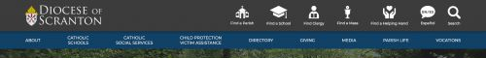

Each underlined group of words is a link.

Report Abuse– use content found in Report Abuse Sub Page.xml

Victim Assistance – use content found in Victim Assistance sub page.docx

Safe Environment Policies and Procedures – use content found in Safe Environment Policies and Procedures.xml

Background Screening Compliance – use content found in Background Check Requirements Sub Page.xml

Training – Adults and Youth – use content found in Safe Environment Training sub page.xml

PA Child Protective Services Law – use content found in PA CPSL Mandated Reporting Sub Page.xml

Please use the following image file for the megamenu (children group.jpg): 

