Welcome to Catholic Social Services of the Diocese of Scranton!

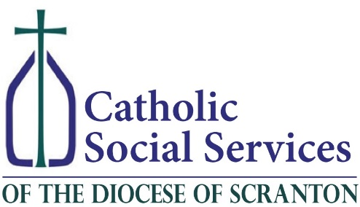

Our Mission:
Rooted in the Gospel, the mission of Catholic Social Services of the Diocese of Scranton is to serve Individuals and families in poverty and hardship, as we are called by Christ to do, and to respond compassionately to their needs. As a Catholic agency, we advocate for individual dignity and self-sufficiency and actively give of ourselves to replace despair with hope.

Vision Statement
Catholic Social Services exists to embrace the call to be servant leaders within each of the eleven counties of the Diocese of Scranton.

Core Values:
- Service to others
- Care of the poor and vulnerable
- Compassion
- Dignity and respect
- Integrity
- Trust
- Charity
- Stewardship
Leadership:
Org Chart –Organizational-Chart -3.1.pdf
Board Members – please use content from 2018 Governing Board.docx

History:
Import from: https://cssdioceseofscranton.org/content/history

Annual Report - 2016 Annual Report.pdf

