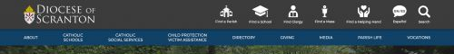

Each underlined group of words is a link. (Please alphabetize links)

About –
Link to landing page
Locations –
link to page for CSS offices directory
Careers –
Link to Btrak career page http://cssdioceseofscranton.balancetrak.com/
Find a Helping Hand –
Link to Find a Helping Hand Page
Volunteer –
Request a form to be created. See Volunteer form requirements - Volunteer Application Form.docx
Donate -
- Please link to whatever this page links to (https://cssdioceseofscranton.org/content/contribute)
Big Brothers Big Sisters –
link to their page. http://www.bbbsnepa.com/
Services –
link to Find a helping hand
Upcoming Events-
link to calendar – CSS Events
Victim’s Assistance –
link to new Child Protection/Victim Assistance landing page

