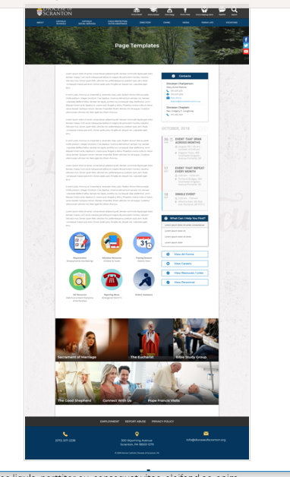
Page Content
Circle Buttons
Page Title
Contacts
Calendar
Mondrian Tiles (4 – 6)
What Can I Help You Find?
Please see above illustration of an Office Web Page. Please fill in the information below for your Office Web Page. If you do not have specific pictures available for the top photo and the Mondrian Tiles, please indicate

Page Title: Bishop’s Office

Contacts
Best Practices: Please select 1 or 2 of your top contacts for your particular office. If you have more than 2 contacts, there will be an option to add a button to more personnel.

Bishop’s Office
Diocese of Scranton
300 Wyoming Avenue, Scranton, PA 18503
Phone: 570-207-2216
Fax: 570-207-2236
Email: Bishops-Office@dioceseofscranton.org

What Can I Help You Find? – NOT USED
Best Practices: If you have more than 4 links, consider making the “resources” page as your 4th link.
Limit: 4 Links
Link 1 Title:
Link 1 URL:
Link 2 Title:
Link 2 URL:
Link 3 Title:
Link 3 URL:
Link 4 Title:
Link 4 URL:

Other Sidebar Options
View All Forms Button: ☐Yes/☒No
View Careers Button: ☐Yes/☒No
View Resources/Links: ☐Yes/☒No
View Personnel: ☒Yes/☐No - See Personnel to be listed on Bishops Page.docx

Mondrian Tiles
Best Practices: If you are planning on using both the What Can I Help You Find sidebar and the Calendar sidebar option(s), you should not use the Mondrian Tiles unless you have enough text and pictures to fill the content area on the left. Using sidebar options AND the Mondrian Tiles may result in a cluttered office page.
Limit: 4-6 Tiles
Images: If you have specific images in mind, please attach the original file to your documents with instructions on which image goes to which tile.

Tile 1 Title: Bishop Bambera’s Homilies
Tile 1 Current URL (if any): https://scranton.diocesanweb.org/about/about-the-bishop/bishops-homilies/
Tile 1 Image Suggestion/Information:

Tile 2 Title: Bishop Bambera’s Statements
Tile 2 Current URL (if any): Our current site has these as news releases, but we want a page that contains links to all the statements, so can news releases be categorized as a Bishop’s Statement and then automatically pulled into a feed that appears on this page? See http://www.dioceseofscranton.org/bishop-bamberas-statement-on-the-passing-of-bishop-robert-morlino/ as an example
Tile 3 Image Suggestion/Information:

Tile 3 Title: Pontifical Masses Scheduled
Tile 3 Current URL (if any): https://scranton.diocesanweb.org/about/about-the-bishop/bishops-mass-schedule/
Tile 3 Image Suggestion/Information:

Tile 4 Title: Clerical Appointments
Tile 4 Current URL (if any): Our current site has these as news releases, but we want a page that contains links to all the statements, so can news releases be categorized as a Clerical Appointment and then automatically pulled into a feed that appears on this page? See http://www.dioceseofscranton.org/bishop-bambera-announces-clergy-appointments-3/ and http://www.dioceseofscranton.org/bishop-bambera-announces-clergy-appointments-2/ for examples
Tile 4 Image Suggestion/Information:

Tile 5 Title: Bishop Bambera’s Pastoral Letter
Tile 5 Current URL (if any): https://scranton.diocesanweb.org/about/about-the-bishop/bishops-pastoral-letter/
Tile 5 Image Suggestion/Information: Image of the Pastoral letter on the above page

Tile 6 Title: About the Bishop
Tile 5 Current URL (if any): https://scranton.diocesanweb.org/about/about-the-bishop/
Tile 5 Image Suggestion/Information: Bishop’s image

Page Content
Best Practices: The first paragraph on your office page should contain information about your office. The rest of the page’s content is up to you. Remember, circle buttons can be used throughout your page content.
Limit: None

The Bishop’s Office provides support for the Bishop in his pastoral responsibilities and in serving the Mission of the Diocese of Scranton.


Mission Statement

We, the Catholic community
of the
Diocese of Scranton,
are called through Baptism
to imitate the servant leadership
of Jesus Christ.
In union with our Holy Father, the Pope,
we proclaim the Gospel faithfully,
celebrate the sacraments joyfully,
and boldly promote life, justice and peace
in northeastern and
north central Pennsylvania.

