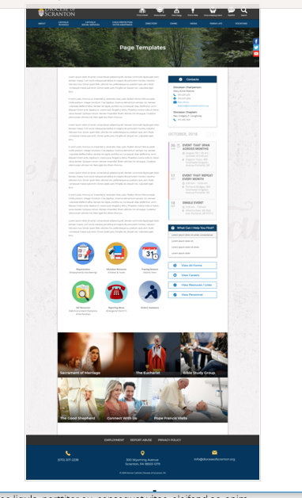
Page Content
Circle Buttons
Page Title
Contacts
Calendar
Mondrian Tiles (4 – 6)
What Can I Help You Find?
Please see above illustration of an Office Web Page. Please fill in the information below for your Office Web Page. If you do not have specific pictures available for the top photo and the Mondrian Tiles, please indicate

Page Title: OFFICE OF THE VICAR FOR CLERGY
Header Image: Picture of Priests (clergy group shot.jpg)
Picture of Deacons (DEACONS GROUP 2017.jpg) should be inserted in the body, above the main text

Contacts
Contact 1
Title: Episcopal Vicar for Clergy
Name: Reverend Jeffrey J. Walsh, V.E. – Picture in folder
Phone: 570-591-5006
Fax: 570-591-5028
Email: Rev-Jeffrey-Walsh@dioceseofscranton.org
Contact 2
Title: Administrative Assistant
Name: Mrs. Gayle M. Stancheski - Picture in folder
Phone: 570-591-5006
Fax: 570-591-5028
Email: Gayle-Stancheski@dioceseofscranton.org

What Can I Help You Find? DO NOT WANT THIS TO APPEAR ON OUR PAGE

Other Sidebar Options
View all Forms: ☒Yes/☐No Priests Emergency Form; Living Will and Health Care Power of Attorney; Financial Power of Attorney – in folder) (Deacons: Delineation of Duties and Responsibilities and Year End Report – in folder)
View Careers Button: ☐Yes/☒No
View Resources/Links: ☒Yes/☐No (2019 Special Collection Dates; Guidelines and Procedures for Maintaining Records)
View Personnel: ☐Yes/☒No

Mondrian Tiles
Best Practices: If you are planning on using both the What Can I Help You Find sidebar and the Calendar sidebar option(s), you should not use the Mondrian Tiles unless you have enough text and pictures to fill the content area on the left. Using sidebar options AND the Mondrian Tiles may result in a cluttered office page.
Limit: 4-6 Tiles
Images: If you have specific images in mind, please attach the original file to your documents with instructions on which image goes to which tile.

Tile 1 Title: Pastoral Regions of the Diocese
Tile 1 Current URL (if any): Build new page from PASTORAL REGIONS.docx
Tile 1 Image Suggestion/Information: DioceseOFScrantonMap_33-5 x 18_HP.jpg

Tile 2 Title: Boards and Councils
Tile 2 Current URL (if any): new page – use Boards and Councils.docx
Tile 2 Image Suggestion/Information: ??

Tile 3 Title: Priest and Deacon Policy Handbooks - new page containing two PDF documents: Policy Handbook for Permanent Deacons 8-10-2015 FINAL REVISION-password-protected.PDF and Priest Personnel Handbook 10 19 2016-password protected.pdf
Tile 3 Current URL (if any):
Tile 3 Image Suggestion/Information: Pics of books

Tile 4 Title: Priest Personnel Board Parish Postings (password protected; Password = Vianney1868)
Tile 4 Current URL (if any): new page using content found in Office Page Content - Priest Personnel Board Parish Postings.docx
Tile 4 Image Suggestion/Information: ??

Tile 5 Title: Vocations
Tile 5 Current URL (if any): vocations.dioceseofscranton.org
Tile 5 Image Suggestion/Information: use image from vocations home page

Tile 6 Title: Child Protection/Victim Assistance
Tile 6 Current URL (if any): New Child Protection/Victim Assistance landing page
Tile 6 Image Suggestion/Information: Child Protection--Victim Assistance.jpg

Circle Buttons NO BUTTONS-USING MONDRAIN TILES

Page Content
For the content of this page,

Please create a page similar to: Page Content Mission Statement over pic.pdf

View all Forms should link to a page containing:

PRIEST FORMS:

- Priests Emergency Form: Priest Emergency Form Fillable.pdf (Please add a note that indicates priests can either download or fill out the form online, and then save and email it OR print the form, complete it, and mail it to Diocese of Scranton, Vicar for Clergy Office, 300 Wyoming Ave., Scranton, PA 18503)
- Living Will and Health Care Power of Attorney: Living Will and Healthcare Power of Attorney.pdf
- Durable Power of Attorney: Durable Power of Attorney.pdf
DEACON FORMS:

- Delineation of Duties and Responsibilities Form: Deacon Delineation of Duties and Responsibilities.docx
- Year-End Report: Deacon Year End Report.pdf
Guide to Resources:

- 2019 Special Collection Dates : 2019 Special Collection Dates.pdf
- Guidelines and Procedures for Maintaining Records: Guidelines and Procedures for Maintaining Records.pdf

