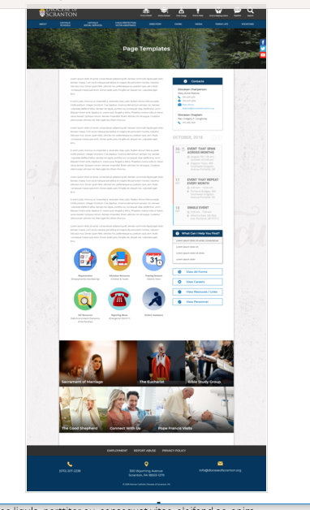
Page Content
Circle Buttons
Page Title
Contacts
Calendar
Mondrian Tiles (4 – 6)
What Can I Help You Find?
Please see above illustration of an Office Web Page. Please fill in the information below for your Office Web Page. If you do not have specific pictures available for the top photo and the Mondrian Tiles, please indicate

Page Title: Priest Personnel Board – Parish Postings
(banner image same as the one for Priest Personnel Landing Page??)

Contacts
Best Practices: Please select 1 or 2 of your top contacts for your particular office. If you have more than 2 contacts, there will be an option to add a button to more personnel.
Limit: 2 Contacts
Contact 1
Title: Vicar for Clergy
Name: Reverend Jeffrey Walsh
Phone: 570-207-2216 ext 1086
Fax: 570-591-5028
Email: Rev-Jeffrey-Walsh@dioceseofscranton.org
Contact 2
Title: Administrative Assistant
Name: Gayle Stancheski
Phone: 570-207-2216 ext 1085
Fax: 570-591-5028
Email: Gayle-Stanchescki@dioceseofscranton.org

What Can I Help You Find?
Best Practices: If you have more than 4 links, consider making the “resources” page as your 4th link.
Limit: 4 Links
Link 1 Title: Members of the Priest Personnel Board
Link 1 URL: Members of the Priest Personnel Board.docx
Link 2 Title: Pastors Eligible for Retirement
Link 2 URL: new page with content from Priests Eligible for Retirement in the next three years.docx
Link 3 Title: Discernment Response Questions
Link 3 URL: new page with content from Discernment Response.docx

Other Sidebar Options
View All Forms Button: ☐Yes/☒No
One form – discernment questions (attached as separate .pdf)
View Careers Button: ☐Yes/☒No
View Resources/Links: ☐Yes/☒No
View Personnel: ☐Yes/☒No

Mondrian Tiles - Will range from 4 to 6 depending on number of parishes with pastor openings (can be up to 3 at any given time)
Limit: 4-6 Tiles
Images: If you have specific images in mind, please attach the original file to your documents with instructions on which image goes to which tile

Tile 1 Title: Members of the Priest Personnel Board
Tile 1 Current URL (if any): content from Members of the Priest Personnel Board.docx
Tile 1 Image Suggestion/Information:
Tile 2 Title: Pastors Eligible for Retirement
Tile 2 Current URL (if any): content from Priests Eligible for Retirement in the next three years.docx
Tile 3 Image Suggestion/Information:
Tile 3 Title: Discernment Response
Tile 3 Current URL (if any): content from Discernment Response.docx
Tile 3 Image Suggestion/Information:
Tile 4 Title: Parish of…….. (specific parish with pastor opening)
Tile 4 Current URL (if any): content from Profile for Parish-X.docx
Tile 4 Image Suggestion/Information: (photo of this specific parish)
Tile 5 Title:
Tile 5 Current URL (if any):
Tile 5 Image Suggestion/Information:
Tile 6 Title:
Tile 6 Current URL (if any):
Tile 6 Image Suggestion/Information:

Circle Buttons (not using these for this page)

Page Content
Best Practices: The first paragraph on your office page should contain information about your office. The rest of the page’s content is up to you. Remember, circle buttons can be used throughout your page content
Limit: None

Discernment and Transition Process for new Pastoral Appointments
1. Review this material and prayerfully consider God's will, in light of the needs of the Church of Scranton and your particular gifts and sense of calling. Note that, in addition to the most immediate pastor transitions, those anticipated retirements for the next five years are also shown here, to assist your discernment.
2. Use the reflection questions (attached at left sidebar) to evaluate your availability and suitability for any of the particular openings. These questions will also guide the conversation between interested transitioning pastors and the Priest Personnel Board. Please know that the Board may need to ask pastors to generously consider a new appointment.
3. Contact a member of the Priest Personnel Board to arrange an "exploratory conversation" during which you could learn more about the most immediate opportunities, the potential for partnership or linkage related to these, and possible models for pastoral leadership suited to each opening. At this time you could also share your personal considerations and express your interest in any of the options. Please understand that the Priest Personnel Board is committed to upholding confidentiality.
4. When it becomes appropriate for Parish Pastoral Council members to know of a pastor's intended move (i.e., at the time of a known retirement, or at the point of an approved transfer) members of the Priest Personnel Board and Office for Parish Life team will also begin dialogue with parish leaders in order to learn more about the current circumstances and vision guiding the parish. This step may lead to some adjustments in the openings, and further dialogue with interested pastors, before a final determination can be made.
5. Once adequate information has been shared, and discernment made about the best match of gifts and needs, the Priest Personnel Board will recommend to the Bishop the new appointments.
6. The Bishop makes appointments. In rare instances he will need to make decisions which differ from the recommendations, based on extenuating circumstances known to him and for the care of souls.

