Page Title Catholic Schools

Contacts
Best Practices: Please select 1 or 2 of your top contacts for your particular office. If you have more than 2 contacts, there will be an option to add a button to more personnel.
Limit: 2 Contacts
Contact 1
Title: Diocese Secretary of Catholic Education/Chief Operating Officer
Name: Jason W. Morrison
Phone: 570-207-2251
Fax: 570-207-2261
Email: JMorrison@DioceseofScranton.org
Contact 2
Title:
Name:
Phone:
Fax:
Email:

What Can I Help You Find?
Best Practices: If you have more than 4 links, consider making the “resources” page as your 4th link.
Limit: 4 Links
Link 1 Title: Locate A School
Link 1 URL: Please link to “Find a School” search
Link 2 Title: Enroll A Student
Link 2 URL:
Link 3 Title: Apply for Tuition Assistance
Link 3 URL:
Link 4 Title: Support the Scholarship Foundation
Link 4 URL:

Other Sidebar Options
View All Forms Button: ☐Yes/☒No
View Careers Button: ☒Yes/☐No
View Resources/Links: ☒Yes/☐No
View Personnel: ☒Yes/☐No

Mondrian Tiles
Best Practices: If you are planning on using both the What Can I Help You Find sidebar and the Calendar sidebar option(s), you should not use the Mondrian Tiles unless you have enough text and pictures to fill the content area on the left. Using sidebar options AND the Mondrian Tiles may result in a cluttered office page.
Limit: 4-6 Tiles
Images: If you have specific images in mind, please attach the original file to your documents with instructions on which image goes to which tile.
Tile 1 Title: News
Tile 1 Current URL (if any): http://www.dioceseofscranton.org/catholicschools/catholic-light-school-pages/
Tile 1 Image Suggestion/Information: 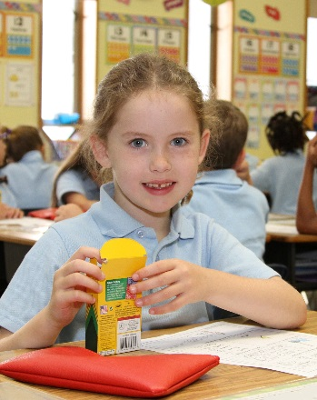

Tile 2 Title: Celebrating Catholic Schools in the Diocese of Scranton
Tile 2 Current URL (if any): https://youtu.be/3GLoQEwo3NY
Tile 2 Image Suggestion/Information: 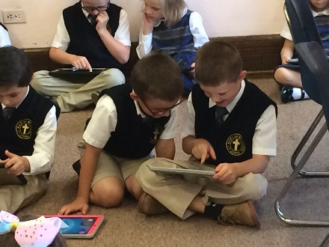

Tile 3 Title: Catholic Schools Week
Tile 3 Current URL (if any):
Tile 3 Image Suggestion/Information: 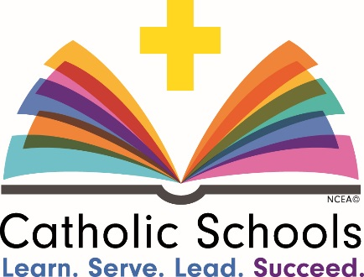

Tile 4 Title: Individualized Instruction
Tile 4 Current URL (if any):
Tile 4 Image Suggestion/Information: 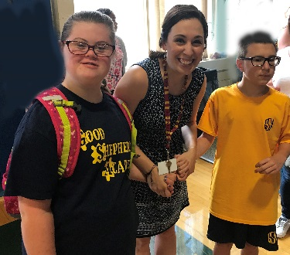

Tile 5 Title: VIRTUS/Safe Environment
Tile 5 Current URL (if any): New Safe Environment Page
Tile 5 Image Suggestion/Information: 

Tile 6 Title: Social Media
Tile 6 Current URL (if any): https://www.facebook.com/DosCatholicSchools and https://twitter.com/DoSCathSchools
Tile 6 Image Suggestion/Information: Image with Facebook and Twitter logos

Page Content
Best Practices: The first paragraph on your office page should contain information about your office. The rest of the page’s content is up to you. Remember, circle buttons can be used throughout your page content.
Limit: None

In the Diocese of Scranton, we are proud of the 16 elementary schools and 4 high schools that provide a well-rounded education, offering an enriching curriculum that includes the arts, foreign languages, physical education and latest computer technology to complement the core subjects of religion, math, language arts, social studies, and science.

Beginning with Pre-Kindergarten and continuing through 12th grade, our curriculum is structured to enable each student to reach their greatest potential. If your child has individual learning needs, we will work with you to meet them. Four schools offer Individualized Instruction programs for students with exceptionalities: All Saints Academy (PK – 8) in Scranton, Holy Cross High School (9 – 12) in Dunmore, Good Shepherd Academy (PK – 8) in Kingston, and Holy Redeemer High School (9 – 12) in Wilkes-Barre.

All of our 20 Catholic schools are accredited by the Middle States Association, and all of our teachers are state-certified educators, who inspire their students and bring amazing experiences into their classrooms.

Your student deserves the best education, one that has an excellent environment that prepares students for college and life ahead. Choosing one of our Catholic Schools is the best investment you can makes for his or her future and a decision you can be proud you made.

Diocese of Scranton Catholic Schools Mission Statement
We, the Catholic Schools of the Diocese of Scranton, are committed to educate students and their families in the Catholic faith. We provide a Catholic education that is spiritually sound and academically excellent. We strive to prepare our students to be faith-filled leaders and life-long leaders dedicated to serving the church and society.

