Support the Scholarship Foundation

The Mission of the Diocese of Scranton Scholarship Foundation is to provide tuition assistance to families who desire a Catholic education in Diocesan schools. One avenue to accomplish this is by working with the business community within the eleven counties of the Diocese of Scranton to participate in the Educational Improvement Tax Credit Program (EITC) and the Opportunity Scholarship Tax Credit Program (OSTC) offered by the state of Pennsylvania. In addition, scholarship monies are made available through the Bishop McCormick Endowment and the Academic Angel Program.

ACADEMIC ANGEL PROGRAM
The Academic Angel program allows individuals to support our students and families directly through the Diocese of Scranton Scholarship Foundation. Your contribution is an investment in a child’s future… the outcomes speak for themselves. Our schools offer our youth an instructional environment that challenges the mind, while inspiring and strengthening the spirit. Please complete the below form and be sure to indicate if you would like your gift restricted to a particular school or used where most needed, and if your gift is a memorial.
Please add link to pdf “Academic Angel 2018”

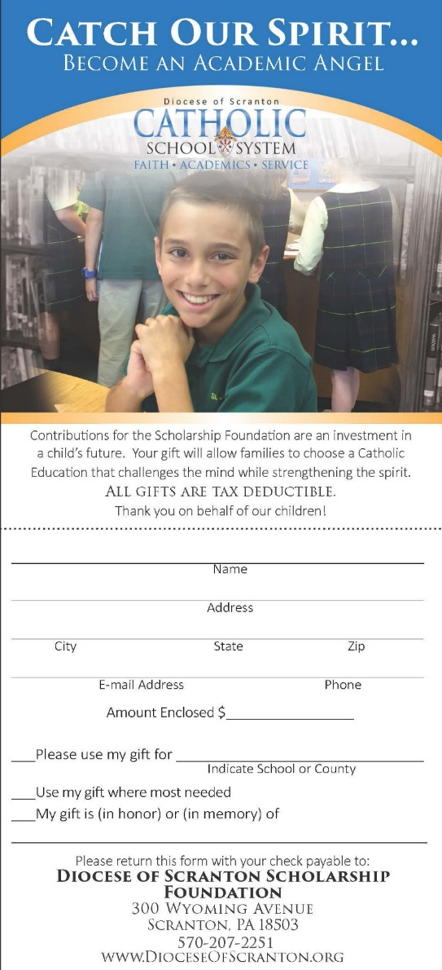

YOUR BUSINESS CAN HELP BUILD THE FUTURE!
The generosity of the corporations who contribute to the Diocese of Scranton Scholarship Foundation enables many families to exercise choice in the education of their children. Many parents desire that their children be educated in a strong academic environment where Catholic Faith is greatly enhanced. Unfortunately, financial stress eliminates this option for some. The support of corporate contributions through the EITC/OSTC program allows this choice to become a reality.

HOW CAN YOUR BUSINESS HELP?
Pennsylvania Corporations may take advantage of the Educational Improvement Tax Credit Program (EITC) and the Opportunity Scholarship Tax Credit Program (OSTC) offered through the State of Pennsylvania’s Department of Community and Economic Development (DCED), which allows businesses to make donations to eligible scholarship organizations such as the Diocese of Scranton Scholarship Foundation.
Full information and applications may be found by logging onto the DCED website: https://dced.pa.gov/programs/educational-improvement-tax-credit-program-eitc/

HOW DOES THE TAX CREDIT PROGRAM WORK?
Grades K through 12: A tax credit of 75% of Pennsylvania State Taxes is granted for a one-year commitment. A 90% tax credit is granted for a two-year commitment. The maximum is $750,000 per year per corporation. All donations up to the maximum amount are accepted.
Pre-K: A tax credit of 100% for the first $10,000 of contribution to an eligible organization is granted to a corporation regardless of the number of years applied for. A 90% tax credit is granted for the remaining contribution up to a maximum of $200,000 per corporation.

WHAT BUSINESSES QUALIFY?
Businesses that pay any of the following Pennsylvania State Taxes may apply for tax credits through the EITC/OSTC program:
- Personal Income Tax
- Capital Stock/Foreign Franchise Tax
- Corporate Net Income Tax
- Bank Shares Tax
- Title Insurance & Trust Company Shares Tax
- Insurance Premiums Tax excluding surplus lines, unauthorized, domestic/foreign marine)
- Mutual Thrift Tax
- Malt Beverage Tax
- Surplus Lines Tax
- Tax credits can be distributed through more than one level of pass through entities, and new changes now include spousal participation

OPPORTUNITY SCHOLARSHIP TAX CREDIT (OSTC) PROGRAM:
In August of 2012, the Commonwealth expanded the amount of funding available for scholarships through the existing EITC Program and created the Opportunity Scholarship Tax Credit (OSTC) Program.
The OSTC Program is intended to enable eligible students residing within the boundaries of an underperforming school to either attend another public school outside of their district or attend a non-public school. This Program provides tax credits to eligible businesses contributing to an Opportunity Scholarship Organization.
Effective August 8, 2012, the Diocese of Scranton Scholarship Foundation was approved as an Opportunity Scholarship Organization and businesses now have the option of supporting both the OSTC and the EITC program for our Catholic school students and their families. The online application can be found at: https://dced.pa.gov/programs/opportunity-scholarship-tax-credit-program-ostc/

THE EITC/OSTC PROCESS FOR APPROVAL:
1. Fill out the application on the DCED website above.
2. The business then receives a letter of approval from DCED for participation.
3. The business submits their monetary contribution within 60 days to the Diocese of Scranton Scholarship Foundation.
4. The Diocese provides the business with an acknowledgement of the contribution.
5. The business submits the acknowledgement to DCED.
6. DCED communicates with the PA Department of Revenue and applicable credit is applied to business tax account. A notice is provided to the business.
7. Credit is applied as if paid at the beginning of the tax year.
8. The credit is taken as a payment of taxes on the businesses annual tax return filing.
9. This entire process must take no more than 90 days.

HOW ARE THE AWARDS MADE?
Families will be eligible for financial aid if their children are enrolled in a K-12 or Pre-K school in the Diocese of Scranton. State income guidelines set household income limits for the 2018-19 school year at $85,000 with an income allowance of $15,608 for each additional dependent. Guidelines are subject to change. The Diocese of Scranton Scholarship Foundation awards needs based financial assistance. A third-party vendor, FACTS Grant and Aid, evaluates all applications. Using objective criteria, the applications are ranked according to need within each school.

HOW MANY FAMILIES RECEIVE ASSISTANCE?
Each year, more than 1,000 families receive tuition awards from the Diocese of Scranton Scholarship Foundation which is funded primarily from business contributions under the EITC and OSTC programs.

YOUR CONTRIBUTION
Your contribution to the Diocese of Scranton Scholarship Foundation will enable more families to take advantage of Catholic Education. In doing so, you may take pride in knowing that your company has made a contribution that has helped many families and their children in such a positive way.

