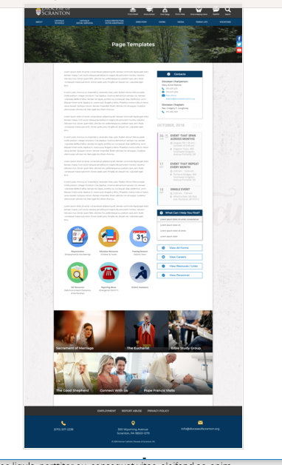
Page Content
Circle Buttons
Page Title
Contacts
Calendar
Mondrian Tiles (4 – 6)
What Can I Help You Find?
Please see above illustration of an Office Web Page. Please fill in the information below for your Office Web Page. If you do not have specific pictures available for the top photo and the Mondrian Tiles, please indicate

Page Title (Bishop’s Office, Communications, Parish Life, etc): Chancellor

Contacts
Best Practices: Please select 1 or 2 of your top contacts for your particular office. If you have more than 2 contacts, there will be an option to add a button to more personnel.
Limit: 2 Contacts
Contact 1 Linda E. Price, J.C.L.
Title: Chancellor
Name:
Phone: 570-207-2216
Fax: 570-207-2236
Email: Linda-Price@dioceseofscranton.org
Contact 2 Heather Betts
Title: Administrative Assistant
Name:
Phone: 570-207-2216 ext. 1089
Fax: 570-207-2236
Email: Heather-Betts@dioceseofscranton.org

Other Sidebar Options
View All Forms Button: ☐Yes/☒No
View Careers Button: ☐Yes/☒No
View Resources/Links: ☒Yes/☐No
View Personnel: ☐Yes/☒No

Mondrian Tiles (These would also be the links found on the Resources/Links page)
Best Practices: If you are planning on using both the What Can I Help You Find sidebar and the Calendar sidebar option(s), you should not use the Mondrian Tiles unless you have enough text and pictures to fill the content area on the left. Using sidebar options AND the Mondrian Tiles may result in a cluttered office page.
Limit: 4-6 Tiles
Images: If you have specific images in mind, please attach the original file to your documents with instructions on which image goes to which tile.
Tile 1 Title: Papal Blessing
Tile 1 Current URL (if any): http://www.dioceseofscranton.org/diocesan-directory/papal-blessing-request/
Tile 1 Image Suggestion/Information: an image related to Pope Francis?
Tile 2 Title: Papal Audience
Tile 2 Current URL (if any): none. Use content from Papal Audience.docx
Tile 3 Image Suggestion/Information: an image of the Holy Father perhaps? Or the Vatican?
Tile 3 Title: Genealogical Research
Tile 3 Current URL (if any): Use content from Genealogical Research.docx;
Tile 3 Image Suggestion/Information: whatever you think appropriate
Tile 4 Title: Transfer of Church sui iuris
Tile 4 Current URL (if any): Use content from Transfer of Church.docx
Tile 4 Image Suggestion/Information: perhaps some type of design? Or whatever you choose

Page Content
Best Practices: The first paragraph on your office page should contain information about your office. The rest of the page’s content is up to you. Remember, circle buttons can be used throughout your page content.
Limit: None

Welcome to the Office of the Chancellor. The Chancellor maintains the official records of the diocesan curia, is the principal ecclesiastical notary to the Bishop, assists the Bishop in providing canonical consultation in areas of Church law, and also drafts, issues and safeguards official documents. The duties of the Chancellor may also extend to assisting the Bishop and the Diocese of Scranton in whatever capacity the Bishop chooses.

