Social Media

The Diocese of Scranton presence on social media includes Facebook.com/DioceseofScranton and Twitter.com/DioceseofScr.

Several other departments, such as Parish Life, Vocations and Catholic Social Services, manage their own Facebook pages.

Bishop Bambera posts on Twitter.com/BishopBambera.

www.Facebook.com/DioceseofScranton

www.Twitter.com/DioceseofScr

www.Twitter.com/BishopBambera


Diocesan Catholic Schools

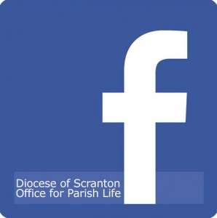
Diocesan Office for Parish Life

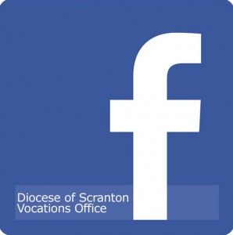
Diocesan Vocations Office

Catholic Social Services

St. Francis of Assisi Kitchen

St. Vincent de Paul Kitchen (Catholic Social Services)

Big Brothers/Big Sisters of the Bridge (Catholic Social Services)

Diocesan Catholic Youth Center

