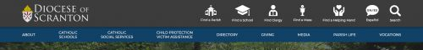

Each underlined group of words is a link.

CTV: Catholic Television – use content found in MEDIA CTV Catholic Television content page.docx

Diocesan Calendar – needs discussion
Diocesan News – link to new News Feed/Page
Diocesan Website – use content found in MEDIA Diocesan Website content page.docx
Social Media – use content found in MEDIA Social Media content page.docx

The Catholic Light – use content found in MEDIA The Catholic Light content page.docx

