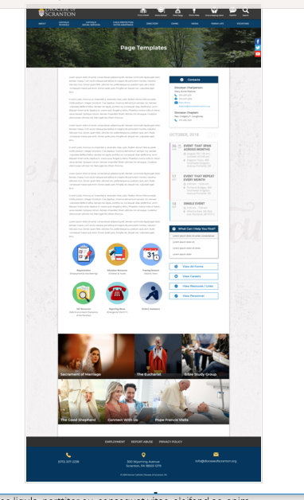
Page Content
Circle Buttons
Page Title
Contacts
Calendar
Mondrian Tiles (4 – 6)
What Can I Help You Find?
Please see above illustration of an Office Web Page. Please fill in the information below for your Office Web Page. If you do not have specific pictures available for the top photo and the Mondrian Tiles, please indicate

Page Title (FINANCIAL SERVICES): WE do not have any specific pictures in mind.

Contacts
Best Practices: Please select 1 or 2 of your top contacts for your particular office. If you have more than 2 contacts, there will be an option to add a button to more personnel.
Limit: 2 Contacts
Contact 1
Title: Financial Services Department
Name:
Phone: 570-207-2237
Fax: 570-207-1459
Email: finance@dioceseofscranton.org (new)
Contact 2
Title:
Name:
Phone:
Fax:
Email:

What Can I Help You Find?
Best Practices: If you have more than 4 links, consider making the “resources” page as your 4th link.
Limit: 4 Links
Link 1 Title: Form 1099 Requirements
Link 1 URL: https://www.irs.gov/instructions/i1099msc
Link 2 Title: Parish Chart of Accounts
Link 2 URL: This will be linked to one of the Resource pdfs
Link 3 Title Parish Annual Financial Report
Link 3 URL: This will be linked to one of the Resource pdfs
Link 4 Title: Frequently Asked Questions
Link 4 URL: New page containing FAQs (content listed later in this document)

Other Sidebar Options
View All Forms Button: ☒Yes/☐No
View Careers Button: ☐Yes/☒No
View Resources/Links: ☒Yes/☐No
View Personnel: ☒Yes/☐No

Mondrian Tiles we do not want any Mondrian tiles at this time

Circle Buttons – we do not want any circle buttons at this time

Page Content
Best Practices:

Financial Services is responsible for the accounting function for the administrative offices of the Diocese of Scranton. This includes the maintenance and preparation of the Diocesan financial statements, the processing of parish assessments and shared administrative costs, the maintenance of the Diocesan Institute and the preparation of the annual budget. The Finance Office is also responsible for the internal audit program for parishes. We provide additional oversight and support, as needed, to other Diocesan organizations.

Financial Statements – Last five years (pdf format)

Forms:

Form W-9 and instructions (pdf )
Travel & Expense Form (pdf)
Accounts Payable Voucher (pdf)
Annual Financial Report (Excel)

Resources:

Form 1099 IRS (link) https://www.irs.gov/forms-pubs/about-form-1099-misc
Parish Accounting/Budgeting Manual – Chart of Accounts (pdf)
Second Collection Schedule
Social Justice Donation Guidelines
Parish Finance Councils
Guidelines & Procedures for bank accounts
Bequest Policy procedures
Building Commission Policy
Credit Card Use Policy
Designated Fund Policy
Gas Policy
Speaker Policy Guidelines
Guidelines & Procedures for Management of Sunday Collections
Guidelines & Procedures for Payroll
Guidelines & Procedures for Cash Disbursements
Guidelines & Procedures For Maintaining Records
Guidelines & Procedures for Mass Stipend Funds
Perpetual Care Funds Investment Interest Income Usage Policy
Policy & Procedures for Parish project Requests
Endowment Fund Policy
Agreement Regarding Parish Building Usage
Guidelines & Procedures For Scrip

Best practices for Record Retention - http://www.usccb.org/about/financial-reporting/upload/diocesan-financial-management.pdf

Frequently Asked Questions

Who should get a Form 1099?

A Form 1099-MISC, Miscellaneous Income, should be filed for each person in the course of your business to whom you have paid $600 or more during the year for services performed by someone who is not your employee, prizes and awards, legal fees and rents.

What is the Annual Financial Report?

The Annual Parish Financial Report is a certification from each parsih that reports an accurate accounting of the parish’s financial operations for the fiscal year in accordance with the Diocesan Accounting Policies and Procedures.

What is the Diocese fiscal year?
The Diocesan fiscal year runs from July 1 through June 30 of the following year.

What is the Diocese’s Savings and Loan Trust Fund?

The diocese maintains a cooperative savings and loan program, in trust for diocesan entities, to manage deposits of medium to long term funds and also to issue loans to participating members, primarily for construction projects. Funds in excess of an entity’s short-term operating needs must be on deposit in the Savings & Loan Trust Fund.

Personnel:
Robert Miller, CPA
Director of Finance
Robert-Miller@dioceseofscranton.org

Eileen E. Bartoli
Assistance Director of Finance
Eileen-Bartoli@dioceseofscranton.org

Ann Dougherty, CPA
Director of Accounting Operations
Ann-Dougherty@dioceseofscranton.org

Diana Castellano, CPA
Senior Accountant
Diana-Castellano@dioceseofscranton.org

Dawn McGowan
Administrative Manager
Dawn-McGowan@dioceseofscranton.org

Stephanie Morgan
Accounts Payable
Stephanie-Morgan@dioceseofscranton.org

Cheryl Tantalla
Accounts Receivable/Billing
Cheryl-Tantalla@dioceseofscranton.org

Calendar:
Just one event for now:
The deadline for filing paper form 1099 – Misc is January 31, 2019.

