Diocese of Scranton Offices

The Chancery

300 Wyoming Avenue
Scranton, PA, 18503
570-207-2238

- Bishop’s Office
- Catholic Social Services
- Catholic Schools
- Chancellor
- Development / Annual Appeal
- Diocesan Cemeteries
- Diocesan Tribunal
- Episcopal Vicar for Clergy
- Financial Services
- Human Resources/Safe Environment
- Information Technology
- Pontifical Mission Societies
- Property and Risk Management
- Vicar General and Moderator of the Curia
- Vocations and Clergy Formation

- Catholic Light
- Communications
- Parish Life
- Pastoral Center
Diocesan Pastoral Center

330 Wyoming Avenue
Scranton, PA, 18503
570-207-2213

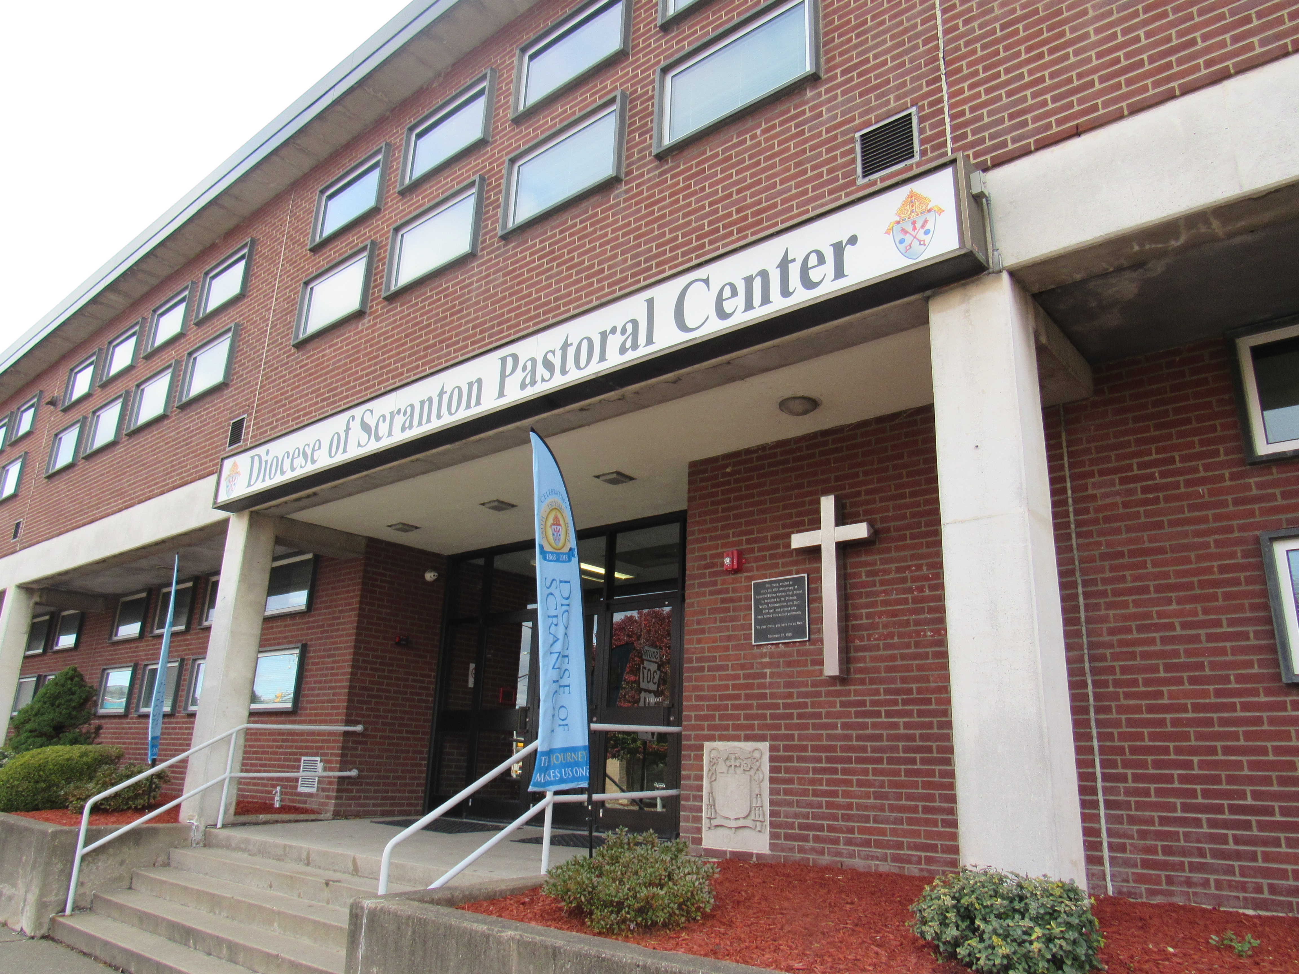
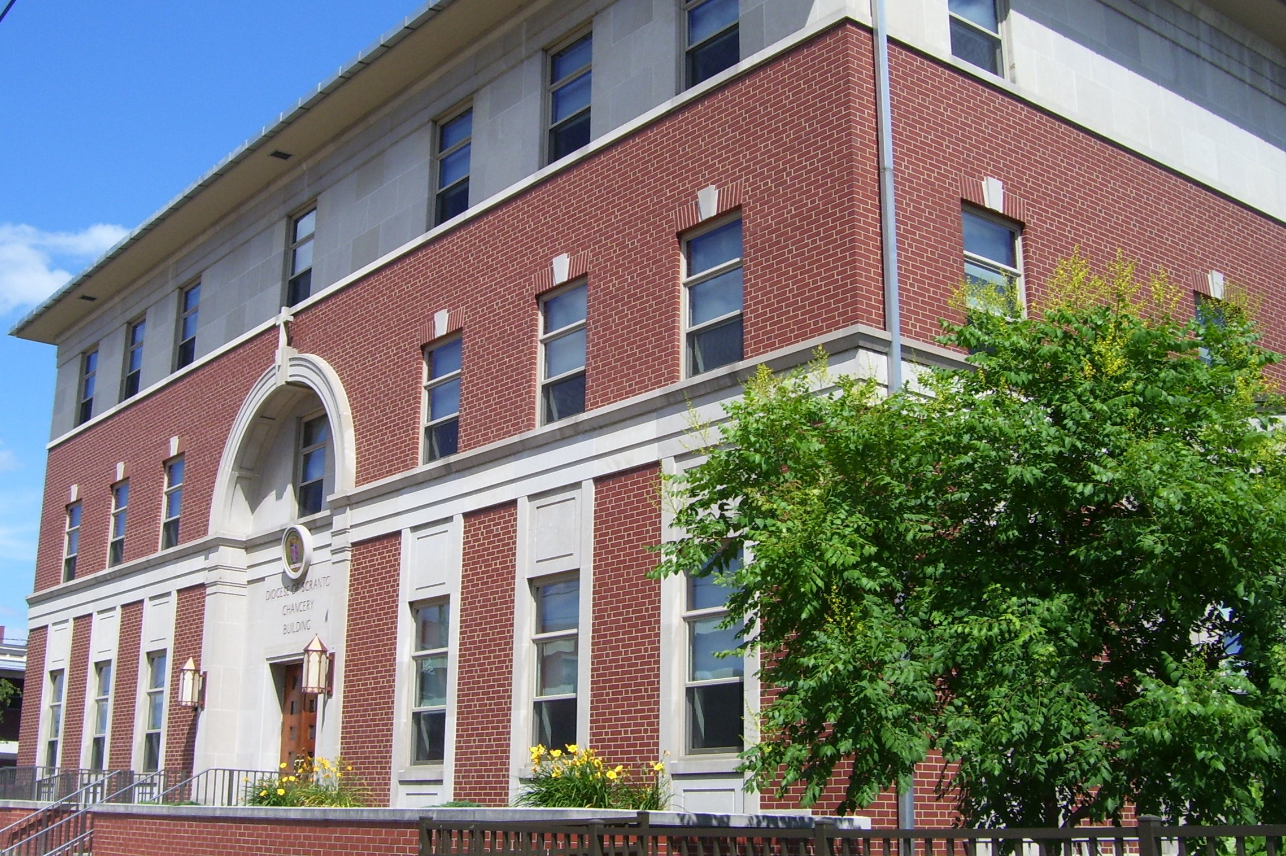

Diocese Organizations and Personnel

Diocese of Scranton Organization Chart- from http://www.dioceseofscranton.org/wp-content/uploads/2018/08/Organizational-Chart-Diocese-of-Scranton-August-2018-002-Final.pdf
Staff Directory – use content found in the directory Diocesan is building for us!

Priests, Deacons, Religious
- Clergy – link to Find Clergy
- Religious Communities – use content found in Religious Communities.docx

Parishes – link to Find a Parish (can we default to the page opening up to listing of all parishes?)

Catholic Youth Center – link to http://www.wyomingvalleycyc.org/
Diocese of Scranton Long-Term Care Facilities – use content found in Diocese Long Term Care.docx

- Catholic Hospitals – use content found in Catholic Hospitals.docx
- Catholic Long-Term Care Facilities – use content found in Other Catholic Long-Term Care Facilities.docx
- Catholic Universities – use content found in Catholic Universities and Colleges.docx
- Diocesan Spiritual Organizations – use content found in Diocesan Spiritual Organizations.docx
- Monasteries and Formation Centers – use content found in Monasteries and Formation Centers.docx
- Retreat Facilities – use content found in Retreat Facilities.docx
- Third Orders and Associations of the Lay Faithful – use content found in Third Orders and Associations of the Lay Faithful.docx
Additional Catholic and Diocesan Organizations

