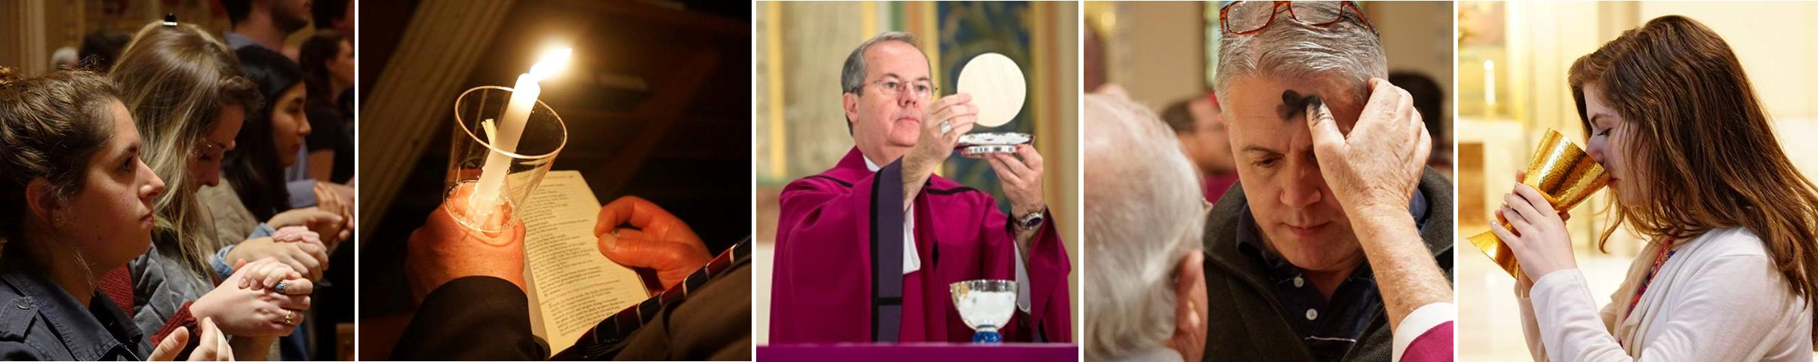
WORSHIP—use line collage as background photo

Contacts
Best Practices: Please select 1 or 2 of your top contacts for your particular office. If you have more than 2 contacts, there will be an option to add a button to more personnel.
Limit: 2 Contacts
Contact 1
Title: Director for WORSHIP
Name: David A. Baloga
Phone: 570-207-2213 ext. 1158
Fax: 570-207-2204
Email: David-Baloga@dioceseofscranton.org
Contact 2
Title: Administrative Assistant
Name: Diane Franklin
Phone: 570-207-2213 ext. 1103
Fax: 570-207-2204
Email: Diane-Franklin@dioceseofscranton.org

What Can I Help You Find?
Best Practices: If you have more than 4 links, consider making the “resources” page as your 4th link.
Limit: 4 Links
Link 1 Title: Extraordinary Minister of Communion Training
Link 1 URL:
Link 2 Title: Holy Days of Obligation for the Current Year
Link 2 URL:
Link 3 Title: Confirmation Documents
Link 3 URL:
Link 4 Title:
Link 4 URL:

Other Sidebar Options
View All Forms Button: ☒Yes/☐No
View Careers Button: ☒Yes/☐No
View Resources/Links: ☒Yes/☐No
View Personnel: ☒Yes/No

Mondrian Tiles
Best Practices: If you are planning on using both the What Can I Help You Find sidebar and the Calendar sidebar option(s), you should not use the Mondrian Tiles unless you have enough text and pictures to fill the content area on the left. Using sidebar options AND the Mondrian Tiles may result in a cluttered office page.
Limit: 4-6 Tiles
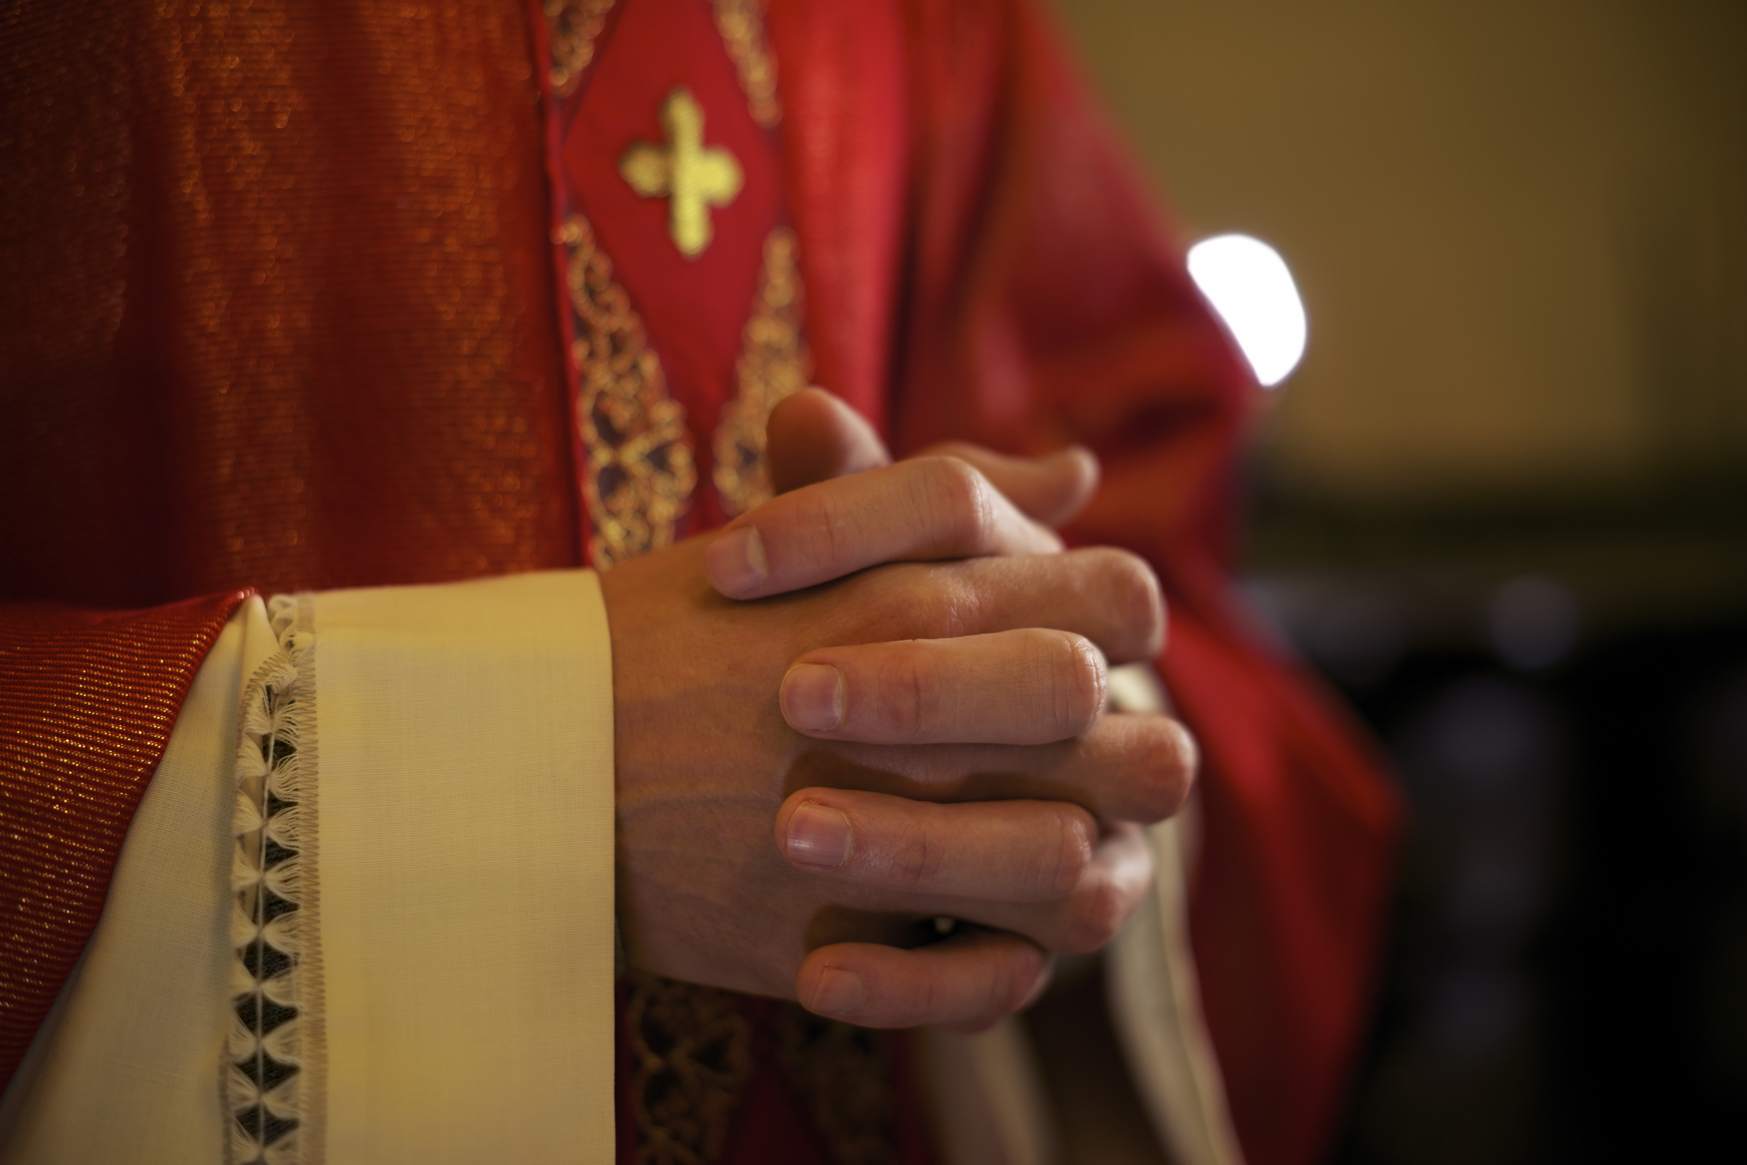
Images: If you have specific images in mind, please attach the original file to your documents with instructions on which image goes to which tile.
Tile 1 Title: Liturgical Guidelines
Tile 1 Current URL (if any):
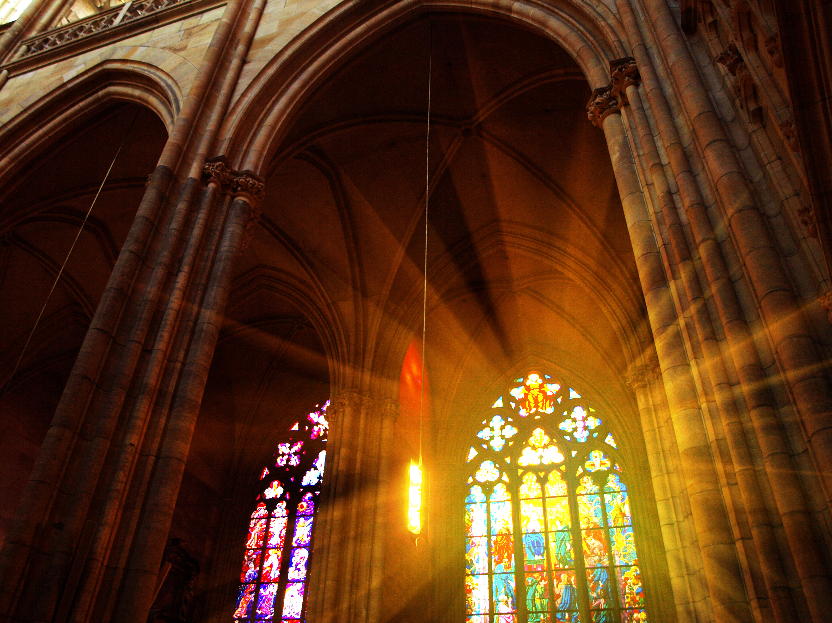
Tile 1 Image Suggestion/Information: priest with red vestment photo
Tile 2 Title: Liturgical Updates
Tile 2 Current URL (if any):
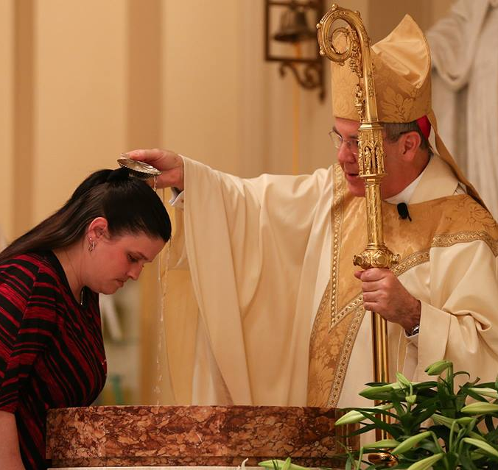
Tile 3 Image Suggestion/Information: Roman Missal—big read book
Tile 3 Title: Sacraments & Christian Initiation
Tile 3 Current URL (if any):
Tile 3 Image Suggestion/Information: Bishop Bambera baptizing
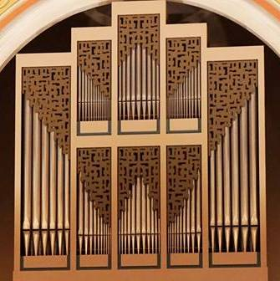
Tile 4 Title: Liturgical Music
Tile 4 Current URL (if any):
Tile 4 Image Suggestion/Information: Cathedral pipe organ
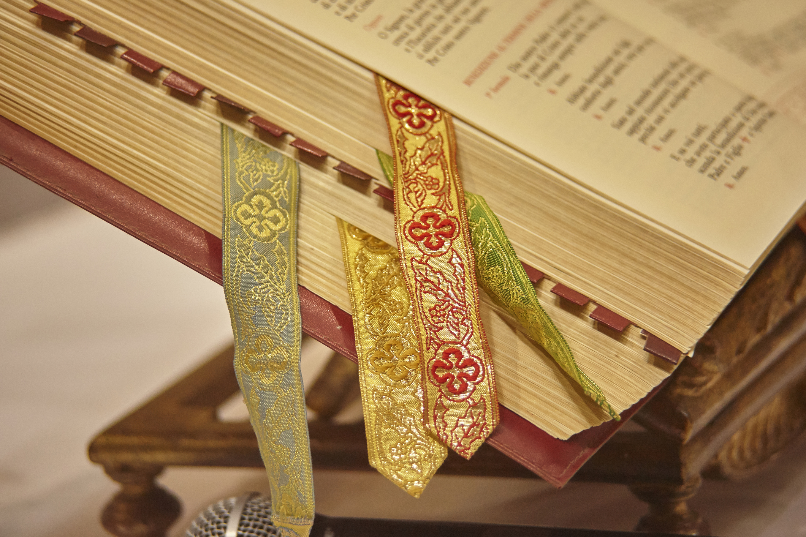
Tile 5 Title: Diocesan Liturgical Commission
Tile 5 Current URL (if any):
Tile 5 Image Suggestion/Information: stock photo of meeting
Tile 6 Title: [Seasonal Topic] Influenza and Liturgical Adaptations
Tile 6 Current URL (if any):
Tile 6 Image Suggestion/Information: sick person—find photo

Page Content

I CALL us to be servant leaders who WORSHIP our God and celebrate the Sacraments in union with the universal Church.

Basic to the faith life of the local parish community is its great act of worship, the liturgy. It challenges and celebrates our relationship with God, one another, and the world. According to the Second Vatican Council, baptized believers fulfill their liturgical role at worship through “that conscious and active participation … which is demanded by the nature of the liturgy, and to which the Christian people … have a right and obligation by reason of their baptism.” (Constitution on the Sacred Liturgy, Chapter 1, Paragraph 14a)

We must take every advantage to emphasize that at the heart of our mission to be evangelizers is the Paschal Mystery of Christ celebrated in the Eucharistic liturgy. It is into Christ’s dying and rising that we were baptized. And here it is that we faithfully strive to understand and appreciate our own daily dying and rising. This Paschal Mystery lies at the heart of our hope for one another.

Meeting this challenge calls for reflection and study around the following practical considerations:
- Present Sunday as the “weekly Easter,” an expression of the identity of our community and the center of its life and mission;
- Develop a comprehensive catechesis of the Eucharist including the implementation of the Roman Missal;
- Find ways to promote: liturgical catechesis in the parish, an improved quality of participation by parishioners of all ages in Sunday Mass, the calling of men and women to liturgical ministries, the training of liturgical ministers, both spiritually and functionally, and improved use of music and art to enhance liturgical celebrations in a way that the world can comprehend;
- Help parishioners to understand that the same “Spirit” of God transforming the bread and wine at Eucharist is also breathing life into our scripture readings at Mass;
- Provide for the needs of new immigrants in the context of our liturgical celebrations; and
- Engage a Director of Liturgy in each parish or cluster of parishes to coordinate worship for the community.

(from Bishop Bambera’s Pastoral Vision, Wounded and Loved, Regathering the Scattered)

