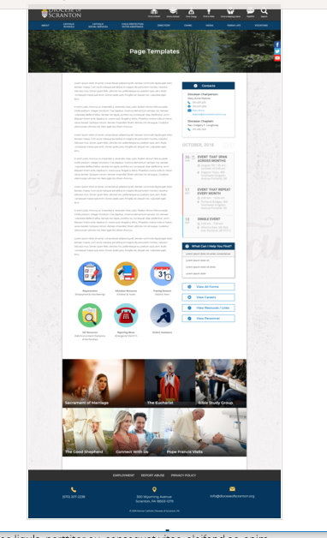
Page Content
Circle Buttons
Page Title
Contacts
Calendar
Mondrian Tiles (4 – 6)
What Can I Help You Find?
Please see above illustration of an Office Web Page. Please fill in the information below for your Office Web Page. If you do not have specific pictures available for the top photo and the Mondrian Tiles, please indicate

Page Title (Bishop’s Office, Communications, Parish Life, etc):
Family Life

Contacts
Best Practices: Please select 1 or 2 of your top contacts for your particular office. If you have more than 2 contacts, there will be an option to add a button to more personnel.
Limit: 2 Contacts
Contact 1
Title:
Name:
Phone:
Fax:
Email:
Contact 2
Title:
Name:
Phone:
Fax:
Email:

What Can I Help You Find?
Best Practices: If you have more than 4 links, consider making the “resources” page as your 4th link.
Limit: 4 Links
Link 1 Title:
Link 1 URL:
Link 2 Title:
Link 2 URL:
Link 3 Title:
Link 3 URL:
Link 4 Title:
Link 4 URL:

Other Sidebar Options
View All Forms Button: ☒Yes/☐No
View Careers Button: ☐Yes/☐No
View Resources/Links: ☒Yes/☐No
View Personnel: ☐Yes/☐No

Mondrian Tiles
Best Practices: If you are planning on using both the What Can I Help You Find sidebar and the Calendar sidebar option(s), you should not use the Mondrian Tiles unless you have enough text and pictures to fill the content area on the left. Using sidebar options AND the Mondrian Tiles may result in a cluttered office page.
Limit: 4-6 Tiles
Images: If you have specific images in mind, please attach the original file to your documents with instructions on which image goes to which tile.
Tile 1 Title: Enrichment
Tile 1 Current URL (if any): *See document
Tile 1 Image Suggestion/Information:
Tile 2 Title: Support
Tile 2 Current URL (if any): *See document
Tile 3 Image Suggestion/Information:
Tile 3 Title: /Liturgy
Tile 3 Current URL (if any):
Tile 3 Image Suggestion/Information:
Tile 4 Title:
Tile 4 Current URL (if any):
Tile 4 Image Suggestion/Information:
Tile 5 Title: Enrichment
Tile 5 Current URL (if any):
Tile 5 Image Suggestion/Information:
Tile 6 Title: Support/Crisis
Tile 6 Current URL (if any):
Tile 6 Image Suggestion/Information:

Circle Buttons

Circle Buttons can be used at any location in the page text content. (Example: paragraph of text, 3 buttons, paragraph of text, 4 buttons)To place buttons into your page area, please copy and paste Buttons 1-6 where you would like it to go. You may use buttons multiple times on your page, with the limit of 1-6 buttons per use.
(Example: paragraph of text, 3 buttons, paragraph of text, 4 buttons)
Best Practices: These buttons should serve as other quicklinks for visitors to jump off from. It may be specific programs or most visited sub-pages from your office page.
Limit: 2-6
Button 1 Title:
Button 1 Current URL (if any):
Button 1 Image Suggestion/Information:
Button 2 Title:
Button 2 Current URL (if any):
Button 3 Image Suggestion/Information:
Button 3 Title:
Button 3 Current URL (if any):
Button 3 Image Suggestion/Information:
Button 4 Title:
Button 4 Current URL (if any):
Button 4 Image Suggestion/Information:
Button 5 Title:
Button 5 Current URL (if any):
Button 5 Image Suggestion/Information:
Button 6 Title:
Button 6 Current URL (if any):
Button 6 Image Suggestion/Information:

Page Content
Best Practices: The first paragraph on your office page should contain information about your office. The rest of the page’s content is up to you. Remember, circle buttons can be used throughout your page content.
Limit: None

The Christian family constitutes a specific revelation and realization of ecclesial communion … it can and should be called a domestic church. It is a community of faith, hope, and charity (Catechism of the Catholic Church, 2204).

Import video:
https://www.youtube.com/watch?v=tXCCg8zocTU

The Diocese of Scranton is joyfully committed to celebrating and supporting families. Families are the Body of Christ, peopling our parishes and bringing our diocese to life! For further information or assistance, please contact your pastor or the Office for Parish Life.

The family is the domestic church.
-What does this mean?
-How could my family do it?
Click below to watch a short video to help you understand how your family is/ can be holy:
In English
In Spanish
Don’t miss the reflection questions at the end!

A family often begins with a marriage. In these cases, the marital relationship is the foundation upon which all other family relationships are built. Please click here to access a wealth of resources to help strengthen and sustain your marriage.
*Link to Marriage page 7

“If you want to bring happiness to the whole world, go home and love your family.” - Mother Teresa

