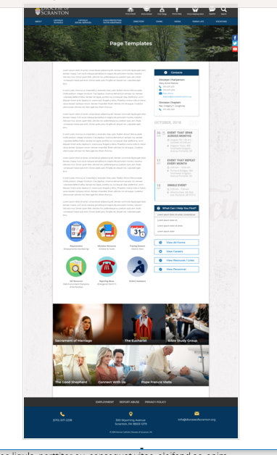
Page Content
Circle Buttons
Page Title
Contacts
Calendar
Mondrian Tiles (4 – 6)
What Can I Help You Find?
Please see above illustration of an Office Web Page. Please fill in the information below for your Office Web Page. If you do not have specific pictures available for the top photo and the Mondrian Tiles, please indicate

Page Title (Bishop’s Office, Communications, Parish Life, etc):
COMMUNITY

Contacts
Best Practices: Please select 1 or 2 of your top contacts for your particular office. If you have more than 2 contacts, there will be an option to add a button to more personnel.
Limit: 2 Contacts
Contact 1
Title: Director for Community and Family Development
Name: Jennifer Housel
Phone: 570-207-2213 x 1104
Fax:
Email: jhousel@dioceseofscranton.org
Contact 2
Title:
Name:
Phone:
Fax:
Email:

What Can I Help You Find?
Best Practices: If you have more than 4 links, consider making the “resources” page as your 4th link.
Limit: 4 Links
Link 1 Title:
Link 1 URL:
Link 2 Title:
Link 2 URL:
Link 3 Title:
Link 3 URL:
Link 4 Title:
Link 4 URL:

Other Sidebar Options
View All Forms Button: ☒Yes/☐No
View Careers Button: ☐Yes/☐No
View Resources/Links: ☒Yes/☐No
View Personnel: ☐Yes/☐No

Mondrian Tiles
Best Practices: If you are planning on using both the What Can I Help You Find sidebar and the Calendar sidebar option(s), you should not use the Mondrian Tiles unless you have enough text and pictures to fill the content area on the left. Using sidebar options AND the Mondrian Tiles may result in a cluttered office page.
Limit: 4-6 Tiles
Images: If you have specific images in mind, please attach the original file to your documents with instructions on which image goes to which tile.
Tile 1 Title: Marriage
Tile 1 Current URL (if any): *See Marriage overview document and subpages
Tile 1 Image Suggestion/Information:
Tile 2 Title: Family Life
Tile 2 Current URL (if any): *See Family Life overview document and subpages
Tile 3 Image Suggestion/Information:
Tile 3 Title: Stewards: Grateful Disciples
Tile 3 Current URL (if any):
Tile 3 Image Suggestion/Information:
Tile 4 Title: Parish Cultural Integration
Tile 4 Current URL (if any):
Tile 4 Image Suggestion/Information:
Tile 5 Title: Grief Support
Tile 5 Current URL (if any): http://www.dioceseofscranton.org/holinessandmission/bereavement-2/
Tile 5 Image Suggestion/Information:
Tile 6 Title: Ecumenism and Interfaith
Tile 6 Current URL (if any):
Tile 6 Image Suggestion/Information:

Circle Buttons

Circle Buttons can be used at any location in the page text content. (Example: paragraph of text, 3 buttons, paragraph of text, 4 buttons)To place buttons into your page area, please copy and paste Buttons 1-6 where you would like it to go. You may use buttons multiple times on your page, with the limit of 1-6 buttons per use.
(Example: paragraph of text, 3 buttons, paragraph of text, 4 buttons)
Best Practices: These buttons should serve as other quicklinks for visitors to jump off from. It may be specific programs or most visited sub-pages from your office page.
Limit: 2-6
Button 1 Title:
Button 1 Current URL (if any):
Button 1 Image Suggestion/Information:
Button 2 Title:
Button 2 Current URL (if any):
Button 3 Image Suggestion/Information:
Button 3 Title:
Button 3 Current URL (if any):
Button 3 Image Suggestion/Information:
Button 4 Title:
Button 4 Current URL (if any):
Button 4 Image Suggestion/Information:
Button 5 Title:
Button 5 Current URL (if any):
Button 5 Image Suggestion/Information:
Button 6 Title:
Button 6 Current URL (if any):
Button 6 Image Suggestion/Information:

Page Content
Best Practices: The first paragraph on your office page should contain information about your office. The rest of the page’s content is up to you. Remember, circle buttons can be used throughout your page content.
Limit: None

“I call us to be servant leaders who build COMMUNITY through hospitality, respect, inclusion and holiness.”

Building a successful parish-based community ministry as Bishop Bambera challenges us to do in his pastoral letter, Wounded and Loved, Regathering the Scattered, requires tapping each and every able Catholic’s baptismal call to serve. There is much ministry to do but the good news is that there are plenty of baptized sisters and brothers to invite to participate.

The Community Coordinating Team can be the source of organizing community work. One challenge is to create an effective structure for carrying out this important work. The structure must be able to encourage and nurture community ministry in the parish with a view to the larger picture provided by the parish pastoral council.
1. Go and Make Disciples reminds us that every person is called into relationship with Jesus and that relationship is always lived out by active, loving participation in a community. Bishop Bambera reinforces that idea. Therefore, creating a sense of community that pervades all aspects of parish life is essential.
We all have – and are—stories of faith … We can understand evangelization in light of these stories of faith: namely, how we have been changed by the power of Christ’s Word and sacraments and how we have an essential role in sharing that faith through our daily lives as believers. Looked at in this way, evangelization is what we are all about! Being involved in the story of salvation is what faith is all about! Evangelization is the essential mission of the Church. (Go and Make Disciples, p. 4)
For the believer, faith is not a private affair acted upon in isolation; it is a call to holiness with a community of people; it means living out a faith commitment with a community of people. (Wounded and Loved, p. 11) 13

2. Go and Make Disciples provides the insight that the three goals of evangelization are all important. Therefore, community ministry must have these three simultaneous foci: we must develop the holiness of the individual throughout life; we must reach out to everyone to invite them into a relationship with Jesus Christ; and community ministry includes making the world a more just and respectful place for everyone.
Community Coordinating Team
In your parish, the Community Coordinating Team might be involved with these aspects of parish life — the Office for Parish Life has resources to support you:
- Marriage Preparation (Pre-Cana); Earlyweds Support
- Marriage Enrichment and Support
- Hospitality and Inclusivity
- Family Faith and Discipleship
- Evangelization
- Caring Ministries
- Spiritual Development and Retreats
- Ecumenism and Interfaith Relations

Ministries of Community
In Wounded and Love, Regathering the Scattered, Bishop Bambera highlights five “practical considerations” for community ministry in parish:
• Nurture the personal relationship of our members with God
• Deepen everyone’s knowledge of God’s saving ways
• Encourage and empower members to be evangelizers at home, school, in the workplace, neighborhood, marketplaces, and places of leisure
• Reach out to the unchurched, inactive and alienated, inviting them to join in the Church’s belief and worship and life of discipleship
• Strive to promote the consciousness that we are all part of a global community and our actions often have broader implications than just within our local community

