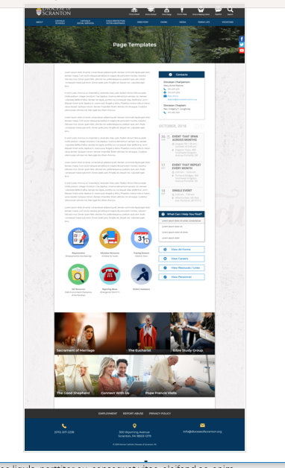
Page Content
Circle Buttons
Page Title
Contacts
Calendar
Mondrian Tiles (4 – 6)
What Can I Help You Find?
Please see above illustration of an Office Web Page. Please fill in the information below for your Office Web Page. If you do not have specific pictures available for the top photo and the Mondrian Tiles, please indicate

Page Title (Parish Life): (David has a photo collage for this page banner)

Contacts
Best Practices: Please select 1 or 2 of your top contacts for your particular office. If you have more than 2 contacts, there will be an option to add a button to more personnel.
Limit: 2 Contacts
Contact 1
Title: Diocesan Secretary for Parish Life
Name: Catherine Jantsch Butel, D.Min. (Photo)
Phone: 570-207-2213 ext 1148; Mobile: 570-862-5290
Fax: 570-207-2204
Email: catherine-butel@dioceseofscranton.org
Contact 2
Title: Receptionist
Name: Jennifer Andres (Photo)
Phone: 570-207-2213 ext 1102
Fax: 570-207-2204
Email: jennifer-andres@dioceseofscranton.org

What Can I Help You Find? (Still Revising These)
Best Practices: If you have more than 4 links, consider making the “resources” page as your 4th link.
Limit: 4 Links
Link 1 Title: Formation for Servant Leadership Certificate Program
Link 1 URL: (landing page for Formation)
Link 2 Title: PreCana Registration
Link 2 URL: (page within the Community section of OPL)
Link 3 Title: Diocesan Guidelines for Confirmation
Link 3 URL: (page within both the Word and Worship sections of OPL)
Link 4 Title: Pastoral and Finance Council Guidelines
Link 4 URL: (page within Council section of OPL)

Other Sidebar Options
View All Forms Button: ☒Yes/☐No
View Careers Button: ☒Yes/☐No
View Resources/Links: ☒Yes/☐No
View Personnel: ☒Yes/☐No

Mondrian Tiles
Best Practices: If you are planning on using both the What Can I Help You Find sidebar and the Calendar sidebar option(s), you should not use the Mondrian Tiles unless you have enough text and pictures to fill the content area on the left. Using sidebar options AND the Mondrian Tiles may result in a cluttered office page.
Limit: 4-6 Tiles
Images: If you have specific images in mind, please attach the original file to your documents with instructions on which image goes to which tile (David has the photos for these tiles – he will direct their Tile assignment)

. (URL for each of these will be a landing sub-page within the site – see other page templates in the OPL folder, one for each of these tiles)
Tile 1 Title: WORD
Tile 1 Current URL (if any):
Tile 1 Image Suggestion/Information:
Tile 2 Title: WORSHIP
Tile 2 Current URL (if any):
Tile 3 Image Suggestion/Information:
Tile 3 Title: COMMUNITY
Tile 3 Current URL (if any):
Tile 3 Image Suggestion/Information:
Tile 4 Title: SERVICE
Tile 4 Current URL (if any):
Tile 4 Image Suggestion/Information:
Tile 5 Title: FORMATION
Tile 5 Current URL (if any):
Tile 5 Image Suggestion/Information:
Tile 6 Title: COUNCILS
Tile 6 Current URL (if any):
Tile 6 Image Suggestion/Information:

Circle Buttons

Circle Buttons can be used at any location in the page text content. (Example: paragraph of text, 3 buttons, paragraph of text, 4 buttons)To place buttons into your page area, please copy and paste Buttons 1-6 where you would like it to go. You may use buttons multiple times on your page, with the limit of 1-6 buttons per use.
(Example: paragraph of text, 3 buttons, paragraph of text, 4 buttons)
Best Practices: These buttons should serve as other quicklinks for visitors to jump off from. It may be specific programs or most visited sub-pages from your office page.
Limit: 2-6
Button 1 Title:
Button 1 Current URL (if any):
Button 1 Image Suggestion/Information:
Button 2 Title:
Button 2 Current URL (if any):
Button 3 Image Suggestion/Information:
Button 3 Title:
Button 3 Current URL (if any):
Button 3 Image Suggestion/Information:
Button 4 Title:
Button 4 Current URL (if any):
Button 4 Image Suggestion/Information:
Button 5 Title:
Button 5 Current URL (if any):
Button 5 Image Suggestion/Information:
Button 6 Title:
Button 6 Current URL (if any):
Button 6 Image Suggestion/Information:

Page Content
Best Practices: The first paragraph on your office page should contain information about your office. The rest of the page’s content is up to you. Remember, circle buttons can be used throughout your page content. (We may eventually have an intro video for this page)
Limit: None

The Office for Parish Life of the Diocese of Scranton is an integrated resource team in service to all aspects of Parish Life: Word, Worship, Community and Service. Members of our team work directly on-site in parishes to provide leadership formation, spiritual renewal, program design and resourcing, training for people in all types of parish ministry, and consulting on specific parish needs. Throughout the liturgical year, the Office for Parish Life provides regional and Diocesan level events for ministry formation, youth and young adult engagement, and networking among peer groups of parish ministry leaders.

The charter and vision for the Office for Parish Life Team comes from the 2011 Pastoral Letter of Bishop Bambera, Wounded and Loved, Re-gathering the Scattered. In his words:

Pastoral leadership encourages the fullest possible collaboration of clergy, religious and laity, men and women, in the common mission of the Church. This collaboration is possible only with the support of appropriate structures which both insure participation in decision-making and facilitate involvement in ministry.
We look to the parish as the center of Catholic Christian life - where members and their families are fed and formed for mission by means of immersion in a community fluent in the language of discipleship. From the Bishop’s pastoral letter, we pursue these stated goals:
- To align all of our resources, activities and energies with three evangelization goals: to live our faith fully, to share it freely with others, and to transform the world in Christ;
- To call forth the Baptized to assume positions of servant leadership; and,
- To foster the spirit of co-responsibility – supporting each parish in its unique journey to becoming a fully participative community of lived faith.

