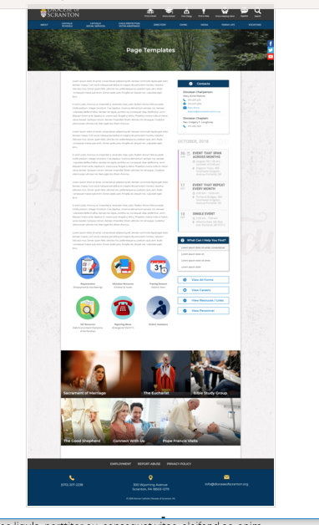
Page Content
Circle Buttons
Page Title
Contacts
Calendar
Mondrian Tiles (4 – 6)
What Can I Help You Find?
Please see above illustration of an Office Web Page. Please fill in the information below for your Office Web Page. If you do not have specific pictures available for the top photo and the Mondrian Tiles, please indicate

Page Title (Councils): (David has a photo for top banner)

Contacts
Best Practices: Please select 1 or 2 of your top contacts for your particular office. If you have more than 2 contacts, there will be an option to add a button to more personnel.
Limit: 2 Contacts
Contact 1
Title: Coordinator for Pastoral Council Development
Name: Ann Marie Cawley
Phone: 570-207-2213 ext. 1131
Fax: 570-207-2204
Email: ann-marie-cawley@dioceseofscranton.org
Contact 2
Title: Diocesan Secretary for Parish Life
Name: Catherine Butel
Phone: 570-207-2213 ext. 1148
Fax: 570-207-2204
Email: catherine-butel@dioceseofscranton.org

What Can I Help You Find? (Still working with Ann Marie on these)
Best Practices: If you have more than 4 links, consider making the “resources” page as your 4th link.
Limit: 4 Links
Link 1 Title: Discernment Process for Selecting Council Members
Link 1 URL:
Link 2 Title: Steps and Timeline for Pastoral Planning Process
Link 2 URL:
Link 3 Title: Prayers for a Council Meeting
Link 3 URL:
Link 4 Title: Planning Facilitator Resources (password protected)
Link 4 URL:

Other Sidebar Options
View All Forms Button: ☒Yes/☐No
View Careers Button: ☐Yes/☐No
View Resources/Links: ☒Yes/☐No
View Personnel: ☐Yes/☐No

Mondrian Tiles
Best Practices: If you are planning on using both the What Can I Help You Find sidebar and the Calendar sidebar option(s), you should not use the Mondrian Tiles unless you have enough text and pictures to fill the content area on the left. Using sidebar options AND the Mondrian Tiles may result in a cluttered office page.
Limit: 4-6 Tiles
Images: If you have specific images in mind, please attach the original file to your documents with instructions on which image goes to which tile. (David is identifying photos for each tile)
Tile 1 Title: Parish Pastoral and Finance Council Formation
Tile 1 Current URL (if any): http://opldoscouncils.com/council-membership.html; also http://opldoscouncils.com/ppc-101.html and http://opldoscouncils.com/pfc-101/ and http://opldoscouncils.com/ongoing-council-formation/
Tile 1 Image Suggestion/Information:
Tile 2 Title: Pastoral Planning Process
Tile 2 Current URL (if any): http://opldoscouncils.com/pastoral-planning/
Tile 3 Image Suggestion/Information:
Tile 3 Title: Putting the Plan Into Action
Tile 3 Current URL (if any): http://opldoscouncils.com/putting-the-plan-into-actio/
Tile 3 Image Suggestion/Information:
Tile 4 Title: Stewards: Grateful Disciples
Tile 4 Current URL (if any): (still being created) (page also shown under Community section and within Development section of the website)
Tile 4 Image Suggestion/Information:
Tile 5 Title: Committee/Coordinating Team Tools
Tile 5 Current URL (if any): (need to check this with Ann Marie)
Tile 5 Image Suggestion/Information:
Tile 6 Title: Parish Partnerships – Cluster and Deanery Planning
Tile 6 Current URL (if any): http://opldoscouncils.com/partnershipcollaboration.html
Tile 6 Image Suggestion/Information:

Circle Buttons

Circle Buttons can be used at any location in the page text content. (Example: paragraph of text, 3 buttons, paragraph of text, 4 buttons)To place buttons into your page area, please copy and paste Buttons 1-6 where you would like it to go. You may use buttons multiple times on your page, with the limit of 1-6 buttons per use.
(Example: paragraph of text, 3 buttons, paragraph of text, 4 buttons)
Best Practices: These buttons should serve as other quicklinks for visitors to jump off from. It may be specific programs or most visited sub-pages from your office page.
Limit: 2-6
Button 1 Title:
Button 1 Current URL (if any):
Button 1 Image Suggestion/Information:
Button 2 Title:
Button 2 Current URL (if any):
Button 3 Image Suggestion/Information:
Button 3 Title:
Button 3 Current URL (if any):
Button 3 Image Suggestion/Information:
Button 4 Title:
Button 4 Current URL (if any):
Button 4 Image Suggestion/Information:
Button 5 Title:
Button 5 Current URL (if any):
Button 5 Image Suggestion/Information:
Button 6 Title:
Button 6 Current URL (if any):
Button 6 Image Suggestion/Information:

Page Content
Best Practices: The first paragraph on your office page should contain information about your office. The rest of the page’s content is up to you. Remember, circle buttons can be used throughout your page content.
Limit: None (Still working with Ann Marie on this)

Pastors and parish leaders will find in this section of the website the support needed to select, form and equip members of your parish to serve in the leadership ministries of Pastoral Council and Finance Council. The site includes a resource-rich toolkit for use in the primary pastoral planning roles of both charting the course for the parish into the future and of securing the means for the mission. This is a journey you take earnestly with your whole parish community, and we can accompany you every step along the way!

