Welcome to the Diocese of Scranton!

Our Mission:
We, the Catholic community of the Diocese of Scranton, are called through Baptism to imitate the servant leadership of Jesus Christ. In union with our Holy Father, the Pope, we proclaim the Gospel faithfully, celebrate the sacraments joyfully, and boldly promote life, justice and peace in northeastern and northcentral Pennsylvania.

Our diocese was founded in 1868, and encompasses the counties of Bradford, Lackawanna, Luzerne, Lycoming, Monroe, Pike, Sullivan, Susquehanna, Tioga, Wayne, and Wyoming.

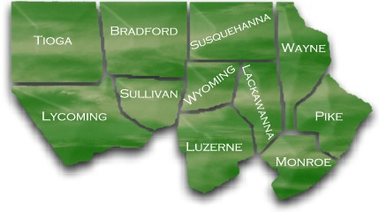

Bishop Joseph Bambera (please link to Bishop’s page) serves as the tenth Bishop of Scranton. He was appointed by Pope Benedict XVI, ordained, and installed as bishop in 2010.

The Cathedral of Saint Peter is the Mother Church of the Roman Catholic Diocese of Scranton. The Cathedral has been serving the faithful of the diocese and beyond since 1853. For more information, visit the Cathedral’s website, www.stpeterscathedral.org.

The 120 parishes of the Diocese enjoy the membership of over 249,000 parishioners, and over 14,500 children from pre-school through high school, attend our 20 schools. For more information and statistics, visit annualappeal.org/fast_facts/

We welcome you to join our community, and to use our Find a Parish (please link to Find a Parish search) tool if you are looking for a spiritual home in our Diocese!

Our Chancery is located at 300 Wyoming Avenue, Scranton, PA, 18503, and is open Monday-Friday, 9 a.m. to 5 p.m. We can be reached by phone at 570-207-2238.

DIOCESAN - Below are titles of Mondrian tiles and pictures to place at the bottom:

Bishop Bambera 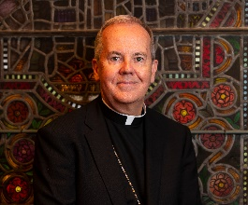 | The Diocese of Scranton Seal 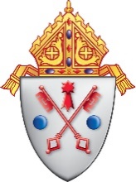 | History of the Diocese 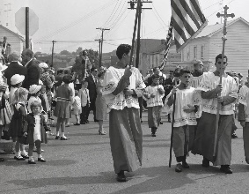
Diocese Maps | Diocesan Councils  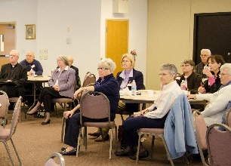 | Regions/Deaneries – use church.jpg or similar

