
“TRUE” Logo
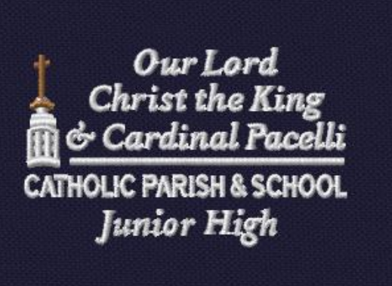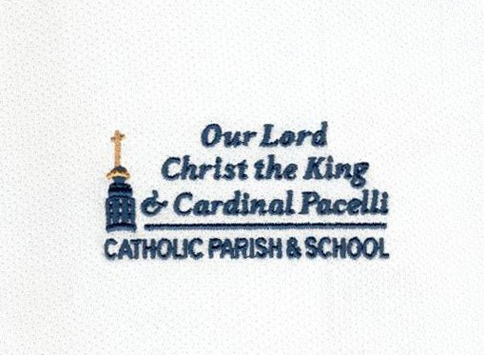
Modified Logo to fit on school uniform that I need AI version (vector) of to give to uniform company. I need your graphic designer to create AI files matching what you see here.

