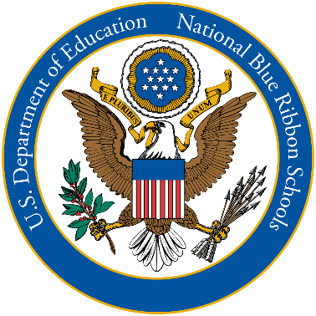 | Our Mission  Cardinal Pacelli, parish school of Our Lord Christ the King, is driven by Christian values, committed to academic excellence, strengthened by a nurturing community, and dedicated to educating both the heart and mind, while serving the Lord.

