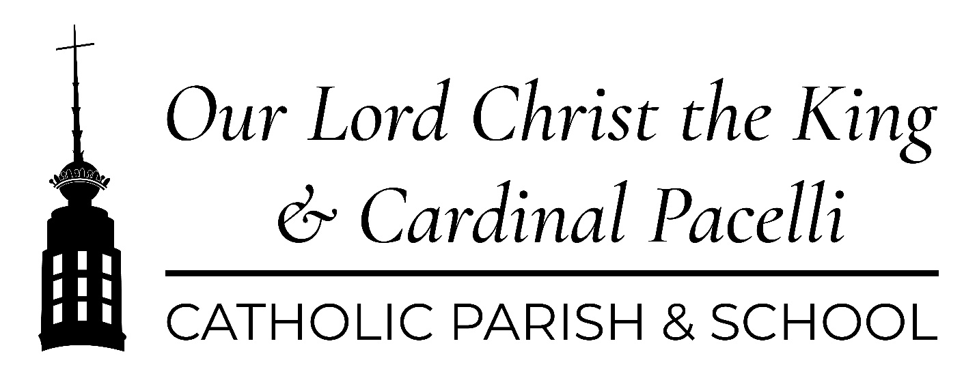
About the New Logo
Designer: Diocesan
Font: The title font is Cormorant Garamond Medium Italic and the sub-header font is Montserrat Regular.
Pantone colors:
Burgundy - PANTONE 1815 C Gold - PANTONE143 C
Pacelli blue: PMS 288C/U Pacelli orange:021C
Versions – SEE BELOW
Four versions exist in color, black & white, and white as JPG, PNG, TIF
1). Church and School Combined, 2). Church Only 3). School Only 4). Tower only
The Keeper
Alisa Fisher, fisher_a@olctk.org
Rationale
In 2020 Our Lord Christ the King and Cardinal Pacelli School adopted new mission statements. This led to a renewed sense of purpose and a desire to strengthen our Catholic identity. When a decision was made to redesign the church website, we committed to incorporating a logo that would better communicate our core values.
The new Our Lord Christ the King Church and Cardinal Pacelli School logo unites our faith community through the touchpoint of the church tower. Our mission to serve God is embodied in the tower that bears a globe, along with the cross and crown iconography that is so essential in our parish. In it we find our highest calling: to unite in Christ, to nurture education, and to be strengthened by service. The tower, the highest point in Mt. Lookout, is a beacon of hope to all who see it.
Timeline
The new logo becomes official for use in all instances on April 1, 2021.
Version 1: Combined Church & School
Version 2: Church only
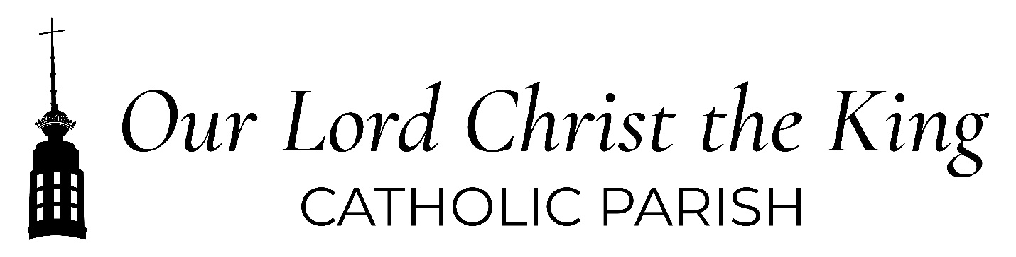
Version 3: School Only
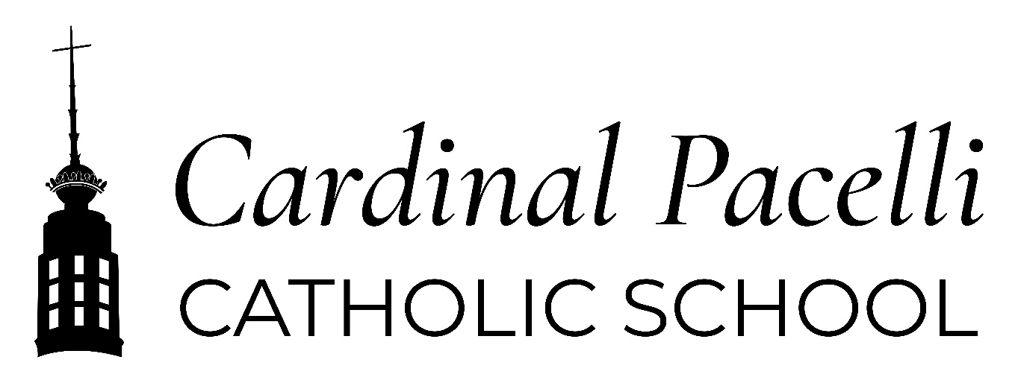
Version 4: Tower


