St Brigid Website Feedback
KEY TO COMMENTS
Hyperlink issues
Text Editing issues
Content issues
Page Layout issues
Page Function issues

CHURCH
- Homepage (http://stbrigid-midland.diocesanweb.com/)
  - Navigation Menu – when window size is reduced, the navigation menu does not stay in a straight line.
  - Header Photo – this would be awesome if it showed people in the pews!
  - “View All” buttons on News & Announcements and Upcoming Events is not currently functional – reroutes to the homepage. View all on the event scroll should, presumably, route to the Calendar page.
    - Within the News & Announcements section, if you click a specific item, the page you are taken to features the image first with the text below. The image is so large that I have to scroll to find the text – you might consider reversing the order here so that the text comes before the image, especially since the image is the same one used for the thumbnail on the homepage.
    - Within the Upcoming Events, if you click on an event, you are rerouted to Google Calendar and the event details pop up.
      - This in and of itself isn’t an issue, but the amount of information for each event is limited to whatever gets put on the calendar. For example, the Word and Communion service event looks like this: 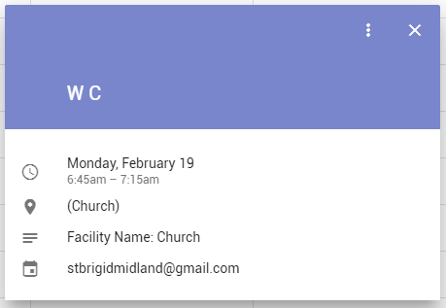
If I didn’t know what W C stood for, I would not know what this event was, who to contact if I wanted more details, and where in the church to go to attend. Reoccurring events like this probably need a link included in the Google Calendar event that links back to the website page related to the event, and events that are not permanently featured on the website need more detail flushed out or at least a contact person beyond the St B’s email address (unless that address is monitored frequently on the weekends)
  - Footer Menu (Quick Links)
    - I got a good laugh out of checking the links here – The USCCB link goes to usccb.com – United States Crane Certification Bureau. Needs to be corrected to .org
    - Is there any particular reason that the “Quick Links” are not available on any other page besides the homepage?
- Mass Times
  - Sunday 9am mass has the letter O used instead of the digit 0
  - Word and Communion services are not listed on this page
  - This would be a good place to mention post-mass fellowship opportunities like coffee and donuts and pancake breakfasts – even just a single sentence would suffice.
- Online Giving
  - “Announcement Letter” hyperlink is black, all other hyperlinks on this page are blue.
- New Families
  - 5 different text formats used in the first 5 lines. Consider the following changes:
    - Change “SAY HELLO” to the same format as “NEW PARISHIONERS”
    - Remove indent before “Thank you for your interest…”, reformat this line to match “To register with St. Brigid…” line
  - Consider removing the month (ie July) that is listed above the new members list so that no one knows when the page was last updated (or, should I say, NOT updated).
  - The wording here switches back and forth from “New Parishioners” to “New Families”. Pick one. This includes picking one to use for your menus, as the top menu says New Families and the menu in green immediately below the header says New Parishioners under the Connect dropdown menu.
  - The line below the list of new families references the “current event scroll” – this phrase should have a hyperlink to the actual event scroll for increased functionality.
- Pastor’s Desk
  - The image used on the Dec. 31 post does not stretch the width of the page, presumably due to the file size. This makes the page look stylistically dated. Either the page formatting needs to resize the photo to match the text width, or the text width needs to be constrained to a set width that matches all future photo widths.
- ABOUT US Menu
  - Consider reversing the order of the menu items here. “St Brigid” is the first option, which one might assume was about St Brigid, the church, but it is literally about St Brigid. St Brigid is probably not what most people are looking for in “About” section.
- About the Building page
  - The vertical gap between “doors” and “floors” sections is awkwardly large. If this is caused by the lack of things to say about the floors, move the “floor” section to underneath the “crucifix” section where the text wrapping won’t cause such noticeable gaps.
- Calendar
  - There is not an overly obvious way to get to the next (or previous) month’s events, as the only button is a very small arrow to the far right and left of the page. Consider adding “NEXT MONTH” and “PREVIOUS MONTH” buttons at the bottom of the calendar.
- Children’s Faith Formation
  - First line references outdated information (2015-16) and links back to current website. UPDATE. Remove dash between ON-LINE to read ONLINE
  - Second line sends you to the 2013-14 registration form as a pdf. Update this hyperlink to be a download for the same form that your download (2017-18) via the “Grow” dropdown menu under “Faith Formation Registration”.
  - Preschool and Kindergarten - Liturgy of the Word with Children description needs to be reworded, as this occurs during Mass, not “as we are dismissed from 9:00am Mass” (unless I am getting things mixed up here).
- Adult Faith Formation
  - Under Opportunities, the description for each item listed is cut off and ends with […]. Each event needs to have a concise description for this page, or no description at all. It looks like it currently just pulls the first 60 words of the event page info instead.
  - The Tuesday AM Women’s Bible Study is not listed here. Presumably it should be?
  - It may be helpful to add a “Contact XXX for more information on our Adult Faith Formation Opportunities” under the opportunities list, as the ones listed may not fit what someone is looking for and this page might not get updated as often as new things are available for Adult Faith Formation. Some people also just like calling – ha!
- Youth Faith Formation
  - Not really sure what’s going on with the formatting here (see screenshot below), perhaps consider taking this out of the current grid format and having a hyperlinked list at the top of the page with everything then listed below as a scrolling format. I’m guessing this page isn’t done being developed, so no feedback for this page until it is completed.
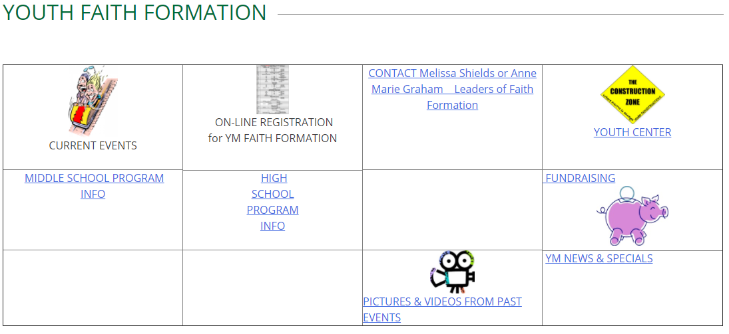
- Prayer Requests
  - This links to http://srsclare.com/prayer-request/ - is that where it is supposed to link to?
  - Should this be moved from the Worship menu to the Contact menu? Seems more logical to me, but that’s an opinion.
- Sacraments
  - Consider reformatting to match the format on the Parish Leadership page (widget with left handed vertical menu that opens on page descriptions) to reduce the need to scroll – this would be especially helpful for mobile users. Each Sacrament would need their own section, instead of being split into Initiation, Healing, and Serving…the Faithful. I would not know where to look for Marriage under the current page format.
  - Reconciliation description needs to be updated to reflect the current times.
  - Anointing of the Sick needs to be updated to reflect Fr. Andy as the contact.
  - Matrimony formatting needs a vertical space between CCC 1639 quote and the sentence beginning “The sacrament of marriage…” in order to match the formatting of all the other sacraments listed. Update contact to Fr. Andy
  - Holy Orders
    - Hyperlink should be updated to go directly to the diocese’s page for vocations (https://saginaw.org/vocations-0), not just the general diocese page.
    - Consider adding Fr. Andy’s contact here, as he is the Director of Priesthood Vocations at the diocese level.
- Parish Leadership
  - Each group description needs a contact person and a meeting location.
  - Social Committee description references the Hospitality Committee, which is underlined, but doesn’t have a hyperlink. Either add a hyperlink or remove the underline.
- Parish Groups
  - Some formatting issues here, consider reformatting to match the format on the Parish Leadership page (widget with left handed vertical menu that opens on page descriptions).
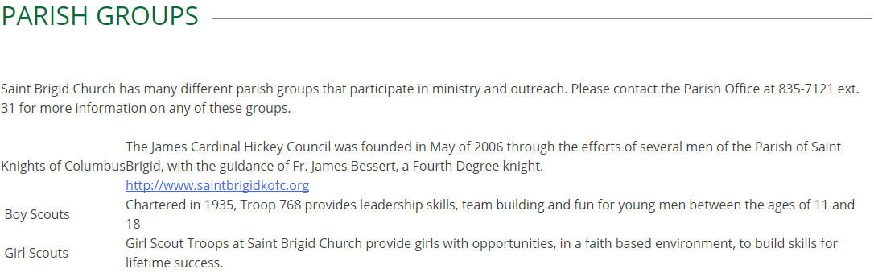

- Outreach Groups
  - Some formatting issues here, consider reformatting to match the format on the Parish Leadership page (widget with left handed vertical menu that opens on page descriptions).
    - Group summary is formatted to show up on the line immediately preceding the next group title, with a large vertical gap above. Swap gap and text placement so that the gap follows the summary, not the title.
    - Text formatting for the group summaries is small – consider increasing size.
    - None of these hyperlinks work. Are pages being built for each of these?
- Music
  - Change “sschweinsberg@stbrigid-midland.org” hyperlink to have her actual name, add phone number contact info.
- Liturgical Life
  - Remove italicized text formatting, difficult to read. If you really want to denote the difference between the quotes and the referenced documents, italicize the document titles instead.
  - Capitalize “This” at beginning of the sentence “This takes shape in many forms…”
  - Hyperlink the references to parish activities listed out “Mass, Sacraments, Liturgy of the Hours” as possible (ie hyperlink “Mass” to the Mass Times page).
  - Hyperlink “Sunday Eucharist” to the Mass Times page.
- Schedules
  - Change Liturgical Ministry hyperlinks to open in a new tab.
- Parish Staff
  - The email button is really small, consider increasing the size of the envelope graphic or adding a line of text above or below it saying “email”
  - Move “bio” dropdown option to its own line, currently is unnoticeable next to the phone number. Consider hyperlinking each person’s name and photo to also open the bio section.
- Contact Us
  - The line about “See the individual staff pages for email addresses and extension numbers” should include a hyperlink to the staff page. This line should also go ABOVE the email widget, to prevent unnecessary emails from being sent to the general inbox.

