All Saints Parish Website
Content Document – April 2018
Home Page
All Saints Catholic Church
9300 Stonewall Road
Manassas, VA 20110
Tel: (703) 368-4500
Fax: (703) 257-9299
Email: Link to web contact form
Twitter: https://twitter.com/allsaintsva
Three boxes of content:
- Mass schedule
SATURDAY
5:30 p.m.
SUNDAY
English
7:30 a.m.
9:30 a.m.
11:30 a.m.
5:30 p.m.
SUNDAY
Español
9:30 a.m. - Manassas Park Community Center
1:30 p.m. – All Saints Catholic Church
3:30 p.m. – All Saints Catholic Church
7:00 p.m. – All Saints Catholic Church
WEEKDAY MASS:
Monday – Friday
7:00 and 8:30 a.m.
Saturday
8:00 a.m.
First Friday
8:00 p.m.
SACRAMENT OF PENANCE
Wednesday 6:30 – 8:00 p.m.
Friday 7:30 – 8:00 a.m.
Saturday 3:00 – 4:00 p.m.
First Friday 7:00 – 7:45 p.m.
By Appointment
Eucharistic Adoration (link to page)
- Registration / Welcome New Parishioners / Becoming Catholic
- Latest News / Bulletin Links
Posts from latest news categories and links to previous four bulletins
Other items on the home page:
Email signup
Event Calendar
Formed.org
Images (include Mary/Courtyard photo)
Welcome Video (future project)
Saint of the Day?
Parish Theme
Our Parish
Welcome New Parishioners / Registration
LRR

Becoming Catholic
LRR
Welcome! We are pleased that you are interested in finding out more about the Catholic Faith. Some are blessed to receive this gift as an infant and grow up in the Catholic faith, while others embrace the faith when they are older.
- If you have not been baptized, the process of Christian initiation (known also as the Rite of Christian Initiation of Adults or RCIA) prepares you to enter into the Catholic Church by celebrating the sacraments of Christian initiation: Baptism, Confirmation and Holy Eucharist.
- If you were already baptized in another Christian tradition, the initiation process prepares you to enter into full communion with the Catholic Church by celebrating the sacraments of Confirmation and the Eucharist.
Rite of Christian Initiation of Adults (RCIA) and Children (RCIC) meets weekly from September to Easter. Please see R.C.I.A. for additional information or speak with one of our parish priests.
.
Our Priests & Deacons
Our parish community is served by the following priests and deacons:
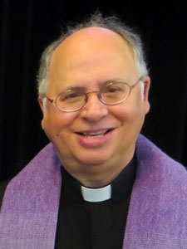
Rev. Lee R. Roos – Pastor

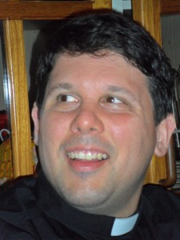
Fr. Juan Puigbo – Parochial Vicar

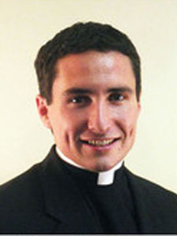
Fr. Noah Morey – Parochial Vicar
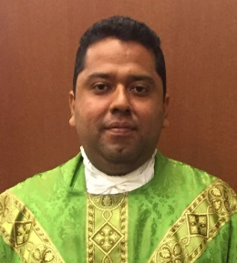
Fr. Mauricio Pineda – Parochial Vicar
Deacons
Rev. Mr. John W. Eberlein, Permanent Deacon
Deacon Brian R. Majewski, Permanent Deacon
Deacon James R. Van der Voorde, Permanent Deacon
Parish Staff
Parish Office
Office – (703) 368-4500
Fax – (703) 257-9299
Hours*
Monday, Tuesday, Wednesday and Thursday - 9:00 a.m. to 9:00 p.m.
Friday - 9:00 a.m. to 8:00 p.m.
Saturday and Sunday - 9:00 a.m. to 3:00 p.m.
*Closed Monday - Friday from 12:00 noon to 1:00pm
After hours, a recorded message is provided on (703) 368-4500. Please follow the instructions for emergency calls.
If you are planning to move outside the parish boundaries, please help us to keep your family registration information up-to-date. Let us know if you have moved within the parish, changed your phone number or email address, or added a new member to your family.
Pastor
Rev. Lee R. Roos 703-393-2155
Parochial Vicars
Rev. Noah Morey 703-393-2152
Rev. Juan Puigbo 703-393-2153
Rev. Mauricio Pineda 703-393-2154
Deacons
Rev. Mr. John W. Eberlein, Permanent Deacon
Deacon Brian R. Majewski, Permanent Deacon
Deacon James R. Van der Voorde, Permanent Deacon
The following staff members are here to serve you at our parish office:
Parish Office
Secretary to the Pastor/Scheduling Coordinator
Tania Velazquez 703-393-2155 tvelazquez@allsaintsva.org
Administrative Assistant (Bulletin Coordinator/Parish Registration/Sacramental Records)
Linda Gaynord 703-393-1430 lgaynord@allsaintsva.org
Reception
Cristina Jimenez 703-368-4500 cjimenez@allsaintsva.org
Director of Facilities and Auxiliary Services
Bill Andre 703-368-4500 x224 wandre@allsaintsva.org
Director of Finance and Human Resources
Tim Johnson 703-393-2150 tjohnson@allsaintsva.org
Bookkeeper
Martha Stine 703-393-2148 mstine@allsaintsva.org
Protection of God’s Children—Program Coordinator
Janet Smith 703-393-2158 jsmith@allsaintsva.org

All Saints Catholic School
Principal
David Conroy, Jr. 703-368-4400 dconroy@allsaintsva.org
All Saints Catholic School website
Religious Education
Director of Religious Education
Samantha Welsh 703-393-2142 swelsh@allsaintsva.org
Religious Education website
Coordinator of Religious Education
Marylee Grabowski 703-393-2142 x215 mgrabowski@allsaintsva.org
Confirmation Coordinator
Vickie Taylor 703-393-2142 x249 vtaylor@allsaintsva.org
Administrative Assistant, Christian Initiation Programs
Laura Fuentes 703-393-2142 x216 lfuentes@allsaintsva.org
Administrative Assistant, Religious Education Program
Tracy Polanco 703-393-2142 tpolanco@allsaintsva.org
Youth Ministry
Director of Youth Ministry and Upper Room Theatre Ministry
Rob Tessier 703-393-2141 rtessier@allsaintsva.org
Youth Ministry website
Assistant Director of Youth Ministry
Mary Arsena 703-393-2141 x161 marsena@allsaintsva.org
Youth Ministry Program Assistant
Candida Benitez 703-393-2141 x246 cbenitez@allsaintsva.org
Liturgy and Music Ministry
Director of Music and Liturgy
Tim Lewicki 703-393-2146 tlewicki@allsaintsva.org
Parish Services
Director of Pastoral Care
Mrs. Gillian Quintana 703-393-1411 quintana@allsaintsva.org
Sr. Anne Marie Lange, OSB
Sr. Trinidad Montero, OSB

Bethany Food Pantry—Program Coordinator
Vickie Taylor 703-366-1655 bethanyfoodpantry@allsaintsva.org
Catholic Charities—Counselor
Annie Mosimann 703-393-2149
Lorenzo Resendez
Catholic Charities—Hogar Immigrant Services
Legal Assistance 703-534-9805

Advisory Bodies

Finance Council
Canon 537 of the 1983 Code of Canon Law requires each parish to have a Finance Council whose purpose is to aid the Pastor in the administration of parish code. The All Saints Parish Finance Council is the principal advisory body to the Pastor on financial matters affecting the church, school, and other ministries of the parish, including all fundraising activities. The Council also advises the Pastor on the acquisition, use, management, and disposition of non-financial assets of the parish.
Chairperson: Dr. John Sparks
- Liturgy Committee
The Liturgy Committee has both a consulting and planning responsibility. Musicians, Ushers, Lectors, Eucharistic Ministers, Art & Environment and Greeter Coordinators are represented on the committee. The Sunday Eucharist is the source and summit of the church life.
Chairperson: Mr. Tim Lewicki
- Pastoral Council
The Pastoral Council is the Pastor’s principal advisory body on all pastoral matters affecting the life of the parish. It is the central “clearinghouse” for all new parish initiatives and proposed changes in current policies, programs, and processes. Council members are selected through a discernment process.
- Facilities Committee
The Facilities Committee works with the Pastor on issues related to campus buildings and grounds, safety and security, and strategic planning.

History

“Here we are assembled on the very fields which not many years ago was the scene of the most bloody battles of the war. When not only man fought against man, but relations against relations, whose blood still, we may say, rests upon this earth.”
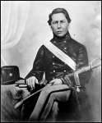
With these words Bishop William Elder dedicated the first All Saints Church on a hot August day in 1879.
The corner stone was laid by Richmond Bishop J.J. Keane on November 29, 1878. Placed in the stone was a relic of the Civil War dug up from the church’s foundation. Silver coins, copies of the Catholic Mirror, Catholic Review, and the Manassas Gazette were also included. The corner stone was moved to the chapel of the church in 1974.
When All Saints was founded in 1879, the small mission church sat fewer than 100 parishioners, served hundreds of square miles with its jurisdiction extending north to the Potomac River, east to Woodbridge and Triangle, and west to the Bull Run Mountains.
First designated as a mission church, the wooden structure, with a 75 foot steeple and seating capacity for less than 100, was the largest religious structure in the town. The small church served as a parish for hundreds of square miles; stretching north to the Potomac River, east to Woodbridge and Triangle, and west to the Bull Run Mountains. The parish was later split into a number of parishes: St. Francis of Assisi in Triangle (1947), Our Lady of Angels in Woodbridge (1959), St. Timothy in Centreville (1969), Holy Family in Dale City (1970), and Holy Trinity in Gainesville (2001).
For many years, the pastor would travel from Warrenton to Manassas for Sunday Mass. Father Patrick Donelan died of heatstroke while traveling to Manassas in 1866. In July 1929, Father Michael Cannon became the first resident pastor of the new independent parish of All Saints.
The Stigmatine Fathers were invited by Bishop Peter Ireton to take over pastoral responsibility in 1942. The Fathers oversaw the growth of All Saints parish, including the opening of All Saints Catholic School in 1957 and the present church in 1974. In 1993, the Stigmatine requested that the Arlington Diocese take over the parish staffing.
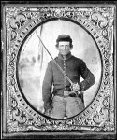
The present church is staffed by four resident priests and provides daily masses, two masses on Saturday in anticipation of Sunday, and seven masses on Sunday ( two Masses in Spanish and one children’s mass). Throughout the history of our parish, the population outsized its facilities. Prior to building our current church, our previous church seated only 860 parishioners.
In 1995, All Saints launched a Building Fund Campaign to raise money toward the day when a larger church could be built. A second building fund, Rooted in Faith - Forward in Hope, was conducted in 2002 and six million dollars was pledged toward the new church and the Diocesan Capital Campaign. Most recently, a New Church Completion Campaign raised five millions in pledges. The annual 5 Car Raffle and Parish Festival were instrumental sources of revenue for the building fund.
While the former church built in 1974 seated 800, the size of the church had proven inadequate. It was exciting to see that our nine weekend liturgies were overflowing with so many Catholic faithful. To meet needs of our growing Hispanic community, Sunday Masses are also offered in Spanish as we celebrate the cultural diversity of the community with love and faith.
To continue serving the growing needs of the parish, a Building Fund Campaign was established in 1995. An addition to All Saints Catholic School was built in 1999 and the school began offering Pre-Kindergarten (for four year old students) in addition to Kindergarten through 8th grade.
On November 1, 2008, The Solemnity of All Saints, 800 parishioners and guests gathered for the Groundbreaking Ceremony for the new church. The Most Reverend Paul S. Loverde, Bishop of Arlington, presided. The Honorable Harry J. Parrish II, Mayor of Manassas; Senator Charles Colgan, Virginia State Senator; Delegate Robert G. Marshall, Virginia House of Delegates; Dr. John Sparks, Chairperson of the All Saints Finance Council; and Rev. Robert C. Cilinski, Pastor, opened the ceremony with remarks. Parishioners were encouraged to bring a bag of earth from their homes and at the conclusion of the ceremony were invited to place it in the altar area of the new church.
All Saints began as a tiny mustard seed but has grown into a very large family where all of God’s people are welcomed. With more than 21,000 registered parishioners today, All Saints claims the distinction of being the largest Catholic parish in Virginia. *Photos provided from the U.S. Library of Congress.

Our Mission
We, the people of All Saints Catholic Church located in Manassas, Virginia, are an ever changing and evolving community, steeped in a rich history and diverse culture. We are dedicated, hard-working families and individuals from virtually every walk of life.
We are disciples of the Lord Jesus. By virtue of our baptism, we live our Catholic faith and are God’s voice calling out to others. We celebrate the Eucharist and Sacraments, live out the scriptures in service to our neighbors, and are faithful to Church teachings.
We are called to keep our faith vibrant and to pass on the faith for all generations to come, that we may bring others closer to Christ and continue building the kingdom of God.

Parish Boundaries
All Saints Catholic Church
9300 Stonewall Road
Manassas, VA 20110

Boundaries:
Beginning at Lee Hwy. (U.S. 29) and Bull Run (Fairfax County Line—Southeast on Bull Run to the Occoquan River—Southwest on Occoquan River through Lake Jackson Watershed to Cedar Run (creek) to boundary of Marine Corps Base Quantico at Aden Rd.—West along the Marine Corps Base Quantico boundary to the Fauquier County line—Northwest along county line to the Norfolk Southern railroad tracks southwest of Nokesville—Northeast along the Norfolk Southern railroad tracks to the Rte. 234 bypass (excluding all of the Manassas Regional Airport) —Northwest along the Rte. 234 bypass (Prince William Pkwy.) to its intersections with I66, then due north on a straight line to Lee Hwy. (U.S. 29) —East on Lee Hwy. to Fairfax County line.
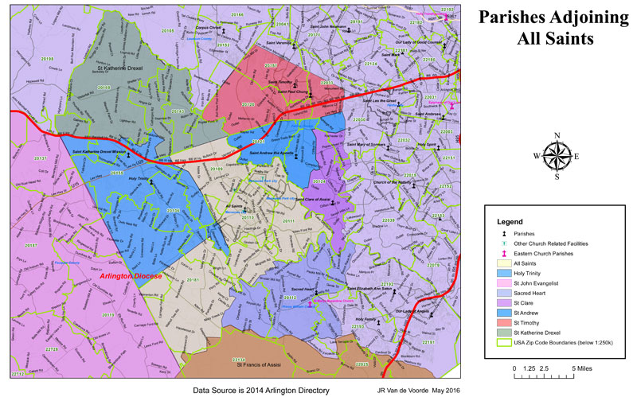

Protection of God’s Children
At All Saints Catholic Church and School, keeping our children safe is our number one priority. We are committed to the Diocesan policy for the Safety and Protection of Children and Youth which requires that all clergy, employees and volunteers who have contact with children complete criminal background checks and attend a live training seminar “Protecting God’s Children.”
This training is helpful for all adults and parents and can be accessed using the website at www.virtus.org. The Diocese of Arlington provides numerous opportunities to attend training throughout the year. Questions can be addressed to Janet Smith, Coordinator of Child Protection, at (703) 368-4500 x158.
By becoming aware of the warning signs of abuse, by paying attention and working together, we create an environment at All Saints where our children and youth are protected and safe.

Resources

Catholic Links
  - Arlington Diocese Online
  - United States Conference of Catholic Bishops

Other News
  - 40 Days for Life – Manassas

Parish Links
  - All Saints Catholic School Facebook
  - All Saints Catholic School Alumni Facebook
  - All Saints Religious Education Facebook
  - All Saints Youth Ministry Facebook
  - Parish Giving
  - Upper Room Theatre Ministry Facebook
  - Twitter (Parish) @allsaintsva / Twitter (RE) @allsaintsvaRE

Employment

There are currently no employment opportunities at All Saints Catholic Church.
Prayer for Employment
(If not seeking employment, pray this prayer for those who are.)
God, our Father, I turn to you seeking your divine help and guidance as I look for suitable employment. I need your wisdom to guide my footsteps along the right path and to lead me to find the proper things to say and do in this quest. I wish to use the gifts and talents you have given me, but I need the opportunity to do so with gainful employment. Do not abandon me, dear Father, in this search, but rather grant me this favor I seek so that I may return to you with praise and thanksgiving for your gracious assistance.
Grant this through Christ, our Lord.
Amen.
St. Joseph the Worker, pray for us!
Resources
- All Saints Catholic Church - Printable Application for_Employment
- Catholic Diocese of Arlington – Employment Opportunities
- Catholic Jobs
- Homeschoolers M.A.R.C.H.
All activities sponsored by or affiliated with All Saints Catholic Church must receive approval from the pastor for website and social media usage.

Praying b
Worship
Mass schedule
All Masses are at All Saints Catholic Church (9300 Stonewall Rd., Manassas, VA 20110) unless otherwise noted.
SATURDAY
5:30 p.m.
SUNDAY
English
7:30 a.m.
9:30 a.m.
11:30 a.m.
5:30 p.m.
SUNDAY
Español
9:30 a.m. - Manassas Park Community Center
1:30 p.m.
3:30 p.m.
7:00 p.m.
WEEKDAY MASS:
Monday – Friday
7:00 and 8:30 a.m.
Saturday
8:00 a.m.
First Friday
8:00 p.m.
SACRAMENT OF PENANCE (Reconciliation)
Wednesday 6:30 – 8:00 p.m.
Friday 7:30 – 8:00 a.m.
Saturday 3:00 – 4:00 p.m.
First Friday 7:00 – 7:45 p.m.
By Appointment
Eucharistic Adoration (link to page)

Sacraments
- Sacrament of Baptism
Infant Baptism—In Baptism, we are freed from sin and spiritually reborn as a member of the Church. Parish registration is required to receive the sacrament of Baptism. Before the scheduled Baptism, parents must attend a one-time class, and the Catholic Godparent(s) must obtain a Certificate of Eligibility from their parish verifying that they are registered and practicing members.
- Baptisms in English are celebrated every other Sunday at 1:00 p.m. in the chapel and on designated Saturdays at 10:00 a.m. To schedule Baptism in English, please contact the parish office at 703.393.1430.
- Baptisms in Spanish are generally celebrated three Sundays a month at 2:45 p.m. and on Saturday at 10:00 a.m. To schedule Baptism in Spanish, please contact our parish office at 703.368.4500.
Adult Baptism—Rite of Christian Initiation of Adults (RCIA)
- Sacrament of Penance (Reconciliation)
Penance reconciles sinners to God, healing the faithful and uniting the body of Christ, His Church. The sacrament of Penance is offered at All Saints at the following times. For additional information or to schedule an appointment, please contact the parish office at 703.368.4500.
Wednesday 6:30-8:00 p.m.
Friday 7:30-8:00 a.m.
Saturday 3:00-4:00 p.m. (except Holy Saturday)
First Friday 7:00-7:45 p.m.
- Sacrament of the Holy Eucharist
We receive the body and blood of our Lord, Jesus Christ through the sacrament of Communion and unite ourselves to Him. Children at All Saints make their First Holy Communion in second grade (after a two year preparation period), and must be enrolled in All Saints Catholic School or in our Religious Education Program.
- Sacrament of Confirmation
Through the sacrament of Confirmation, we receive the fullness of the Holy Spirit who empowers us to do the work of Christ and his Church. Young adults at All Saints make their Confirmation in 8th grade (after a two year preparation period), and must be enrolled in All Saints Catholic School or in our Religious Education Program.
Adult Confirmation – link to RCIA
- Sacrament of Holy Matrimony
The sacrament of Holy Matrimony is the sacred union of a man and woman who establish a covenant to glorify God in their marriage and exemplify Christ to others. Parish registration for at least one member of the couple is required. A minimum six-month preparation program is required for Pre-Cana after first notifying a priest of your intention to marry. You are encouraged to call our parish office at 703.393.1430 as soon as you become engaged.
Link to Wedding Music Information & Guidelines (in Music Ministry section)
- Holy Orders
Holy Orders / Consecrated Life: Is the Lord calling you? For information about priesthood, the permanent diaconate, or the consecrated life in a religious community, contact a priest, deacon, or the Diocesan Vocations Office at 703.841.2514.
- Anointing of the Sick
Anointing of the Sick brings spiritual gifts to convey God’s grace during illness, especially near the time of death. Please call the parish office at 703.368.4500 to request this sacrament and for home or hospital visitation. Those anticipating surgery are encouraged to request this sacrament prior to being admitted to the hospital.

Eucharistic Adoration
During Eucharistic Adoration, parishioners unite in sharing hours of adoration before the Blessed Sacrament throughout the day and evening. Please consider taking one hour before the Blessed Sacrament exposed for public prayer in the chapel.
Sunday 8:00 p.m. – Monday 7:00 a.m.
Wednesday 9:00 a.m. – Thursday 7:00 a.m.
Thursday 7:00 p.m. – Friday 7:00 a.m.
Friday 9:00 p.m. (following 8:00 p.m. Holy Hour)
Saturday 7:00 a.m., ending with Benediction
We currently have needs for adorers. To sign up for Eucharistic Adoration, please email us at adoration@allsaintsva.org call Mrs. Aime Nuar at 703.392.5260. Adorers, when you arrive at the chapel, it is very important that you sign-in for your time slot so we know that the time is covered.
Holy Hour
- Fridays at 8:00 p.m.
- On First Fridays, after evening Mass.
- In Lent, after Spanish Stations. Adoration until 7:00 a.m. on Saturday.

Funerals
LRR
Please contact Linda Gaynord about reserving the church for a Funeral Mass at (703) 393-1430.
Funeral Mass Planning Resources – would like to add more information under this section.

Weddings
LRR
We wish to congratulate you on your decision to marry not only out of love and friendship but out of the belief that what you plan is sacred and Christian.
Sacred because every wedding is a celebration of the love of a man and a woman dedicated not only to each other but also to a life of service to God and all people.
Christian Marriage is a special vocation. The mutual love of a married couple is meant to reflect the love which our Lord Jesus Christ has for his people. Christian Marriage is a permanent relationship which requires fidelity to your spouse and welcomes the possibility of children as an opportunity to be co-creators with God.

Getting Married at All Saints
To schedule a wedding at All Saints Catholic Church, at least one member of the couple must be a registered parishioner. A minimum six-month preparation program is required for Pre-Cana after first notifying a priest of your intention to marry.

You are encouraged to call our parish office at (703) 393-1430 as soon as you become engaged.
Wedding Music Information & Guidelines
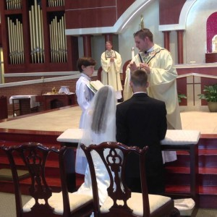
The Office for Music and Liturgy is committed to assisting couples with the planning and selection of music for their ceremony. Couples are strongly encouraged to contact the music office immediately after the initial meeting with the priest or deacon that is doing the marriage preparation in order to discuss the procedures for securing musicians and making liturgical music selections. Please read the parish music policies below and download the parish Marriage Preparation Guide, Wedding Music List, and Wedding Music Planning Form (add links to downloads).
The Office for Music and Liturgy
Mr. Tim Lewicki , Director of Music and Coordinator of Liturgical Ministries
(703) 393-2146
tlewicki@allsaintsva.org

All Saints Parish Wedding Music Policy
The music for your celebration should be carefully chosen, keeping in mind the solemnity of the occasion and the Church’s guidelines for music in the sacred liturgy. The music must be suitable for use in the Catholic Church, and priority must be given to the assembly’s sung prayer. The sung liturgical music must invite the participation of all present and not merely entertain. Therefore, no secular music may be used. It is your responsibility to contact the Director of Music before the wedding to arrange a music planning session. All Saints will provide a staff organist for your wedding. The stipend the organist receives helps to support his livelihood and organists from outside the parish are generally not permitted, except under extraordinary circumstances. In the event an outside organist is used, a bench fee of $150 must be paid to the Director of Music and the couple must still arrange a meeting for approval of all music and outside musicians.
Parish Cantor
A parish cantor is required for wedding liturgies to lead the assembly in those parts of the Liturgy that call for communal singing, and to serve as vocal soloist for selected solo vocal literature. Cantors from other parishes may be permitted with the approval of the Director of Music. In this case, cantors must be practicing Catholics, have proper vocal training, as well as experience with the Catholic liturgy. If the couple wishes to have a friend or relative sing for their wedding, and the singer possesses the requisite vocal training but not the necessary experience as a cantor, a parish cantor would still be required, but the invited singer may perform a prelude vocal solo and one piece during the wedding liturgy.
Instrumentation
While the organ and piano will be the primary instruments at your wedding, instrumentalists, such as harp, strings, flute or trumpet can enhance the music for your wedding liturgy. These instruments may be incorporated into your wedding as an addition to, but not in lieu of the organ and piano. Please do not hire any outside musicians before meeting with the Director of Music. It is strongly preferred that couples use professional instrumentalists affiliated with our parish music program, as they perform regularly here and know the requirements of the liturgy as well as our customary. All instrumentalists are subject to final approval of the Director of Music. Please note that the logistics surrounding multiple musicians such as arranging music, mailings, phone calls, e-mails and extra rehearsal time may incur extra stipends for all musicians involved. Many couples choose to make programs and worship aids for their guests, especially for those with non–Catholic guests. We encourage you to make a program for your wedding which will list the order of ceremony and the wedding party. Sample programs are available upon requests, and programs can be done through a professional printing company, on your own, or through the music office (for an additional fee).

Wedding Information and Planning Forms
Wedding Music List

Music Ministry
The Music Ministry at All Saints Church is a vibrant, volunteer-centered program that serves the parish community in all aspects of liturgical life. The choral and handbell choirs maintain an active rehearsal and liturgy schedule, which seeks to provide music of the highest possible quality for our parish liturgies.
The Constitution on the Sacred Liturgy reminds us that, “The musical tradition of the universal Church is a treasure of inestimable value, greater even than that of any other art. The main reason for this pre-eminence is that, as sacred song united to the words, it forms a necessary or integral part of the solemn liturgy” (CSL, 112).
The liturgy is, in turn, at the heart of our Catholic Faith. The members of our music ministry participate in the program in service to the parish through the spirit of Christian Stewardship: Time, Talent and Treasure.
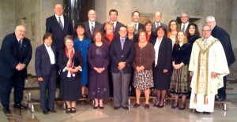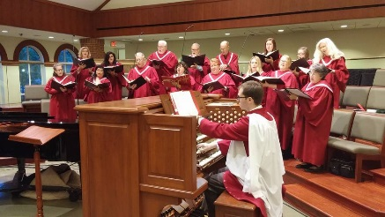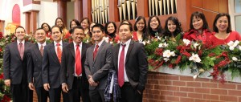
The following list contains information about each of our parish choirs and ensembles, including contact information for the corresponding directors.

Parish Choir
The Parish Choir sings at the 11:30 a.m. Mass each Sunday, Christmas Midnight Mass, the Great Easter Vigil, and other feast days and special liturgies throughout the year. The Choir’s repertoire covers the entire range of traditional Catholic liturgical music. At this time, we have openings for all voice parts. Contact director Tim Lewicki at (703) 393-2146 or tlewicki@allsaintsva.org for additional information. Rehearsals are Thursday evenings from 7:30-9:00 p.m.
Rehearsal and Liturgy schedule

Contemporary Choir
The Contemporary Choir sings on Saturdays at the 5:30 p.m. Mass and rehearses on Wednesdays from 7:30-9:00 p.m., September to June. Directed by Cathy Drummond, the Choir offers a mixture of contemporary Catholic styles with piano and guitar accompaniment. Contact Cathy Drummond at 703-335-1741 or cjsdrummond@gmail.com for more information. We welcome new musicians!

Young People’s Choir
Directed by Nichole Reynolds, the Young People’s Choir sings at the 9:30 a.m. Mass every 2nd and 4th Sunday from October to June. The choir rehearses from 5-6:00 p.m. two Wednesdays a month, and meets at 8:45 a.m. before each Mass they sing. Children in grades 3-8 from all schools as well as home-schooled are invited. For information on joining, please contact Nichole Reynolds at nreynolds@allsaintsva.org.

The Spanish Choirs
Los dos Coros Hispanos invitan cordialmente a todas las personas que desean cantar en español o que puedan tocar instrumentos musicales. Por favor vengan a hablar con el director del coro después de la misa de la 1:30 pm o de la 7:00 pm cada domingo.
All Saints’ two Spanish Choirs cordially invite all men and women who like to sing in Spanish or can play appropriate instruments. Please come to any Sunday 1:30 p.m. or 7:00 p.m. Mass and introduce yourself.

Teen Choir
The Teen Music Choir provides a mix of contemporary Christian worship songs and traditional Catholic liturgical music at the Sunday 5:30 p.m. Teen Mass during the youth group year. The music group practices at 4:30 p.m. in the Church before Mass. Those of high school age and above are welcome to join! Please contact director Laura Loker at 703-231-0398 or lauramloker@gmail.com.

Handbell Choir: Resounding Joy
Adults interested in this unique way of praising God and adding a special touch to our liturgies, please contact Kathryn Moore at (703) 346-0500 or kathrynmoore3@verizon.net. No musical experience needed. We will provide all the knowledge needed to participate. Rehearsals are held on Wednesday evenings from 7:30-9:00 p.m. The Handbell Choir plays once a month at Mass and on special occasions.

Cantors
Parish cantors are selected through a process of audition and interview with the Director of Music. Because this is a specialized ministry, music reading and voice training are highly recommended. For further information or to schedule an audition, please contact Tim Lewicki at (703) 393-2146 or tlewicki@allsaintsva.org.

Buy-a-Bell Campaign
The All Saints Handbell Choir cordially invites you to participate in our ongoing Buy-a-Bell Campaign. This is your opportunity to share in supporting the church community by sponsoring one of the bells used by the choir. Bells come in various sizes and price ranges. Please contact Kathryn Moore at (703) 346-0500 for further information.
Parish Music Leadership
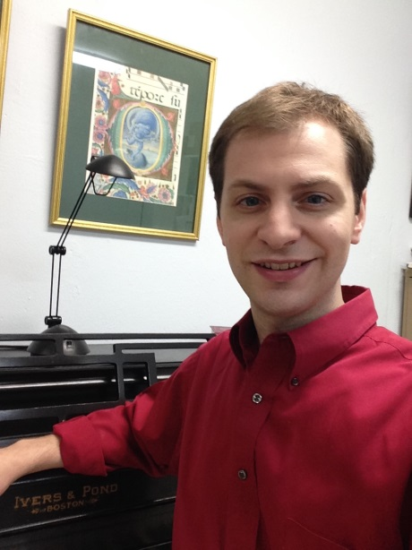
Tim Lewicki is a graduate of the Catholic University of America, earning a master’s degree in sacred music in October 2013. As a student at Westminster Choir College, he had the opportunity to perform with major conductors and orchestras, including Michael Tilson Thomas and the San Francisco Symphony and Daniel Harding and the Dresden Staakstapelle. As a member of the Westminster Concert Bell Choir, Mr. Lewicki performed with Josh Groban at the Rockefeller Center Christmas Tree Lighting, and toured with the choir through the mid-West. He studied organ with Ken Cowan and Alan Morrison. After receiving his Bachelor of Music in Sacred Music, magna cum laude, in May 2011 from Westminster Choir College of Rider University, Mr. Lewicki began graduate studies at the Catholic University of America in Washington, DC. As a graduate student he studied choral and sacred music with Dr. Leo Nestor and pursued liturgical and theological studies with Rev. Dominic Serra and Rev. Michael Witczak.
An active member of the National Association of Pastoral Musicians, Mr. Lewicki current serves as Newsletter Editor on the Arlington Chapter Board, and has served on the Advisory Board of the Trenton, NJ, local chapter. He is a member of the American Guild of Organists (AGO), Northern Virginia Chapter.
Mr. Lewicki is the recipient of scholarship awards from academic and professional organizations, including the MAGI Foundation at the Catholic University of America (2011), the National Association of Pastoral Musicians’ Koinonia Scholarship (2010) and the Steven Warner Scholarship (2012). He has held church music positions in New Jersey and Virginia. Tim currently serves as Director of Music and Coordinator of Liturgical Ministries at All Saints Catholic Church in Manassas, VA, where he oversees a vibrant music program including several singing ensembles and one handbell choir involving parishioners of all ages. He and his wife reside in Alexandria, VA.

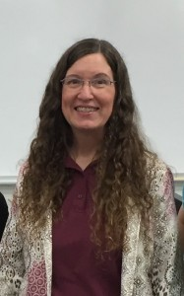
Cathy Drummond, Contemporary Choir Director, started her involvement in church music by playing guitar in the folk masses at St. Bernadette Catholic Church in Springfield, VA after being self-taught on the instrument in sixth grade. She holds a degree in Music Therapy from the University of Minneapolis, MN, where she studied under Dr. Judith Jellison. During college, she was an active member in the music ministry at the Newman Center. She also studied under Dr. Helen Bonny at The Catholic University of America in Washington, D.C. Her internship was completed at the University Hospital Schools in Iowa City, IA. Cathy holds National Board certification in Music Therapy as well as a Virginia Professional Teaching certificate in Music Education for Pre-K through grade 12. Hal Leonard Corporation has named her a Music Express Star Teacher, and in this capacity she has traveled the Mid-Atlantic region giving teacher workshops.
Joining the All Saints Catholic Church community in 1987, she has continued to serve in many ways; as the Music Teacher for All Saints Catholic School, as the Director of the Young People’s Choir, as a founding teacher for the Special Education program for Religious Education, as the substitute for the Contemporary Choir Director, and as an active member of the Contemporary Choir playing guitar, flute and voice. In the summer, she has been the involved with the Upper Room Theatre Ministry for 13 years, and as the Music Director and Conductor for the Orchestra for the past 10 of those years. She is the Director and Singing Instructor for Camp Broadway, a Musical Theater summer camp, which has expanded to three locations. Currently the Music Teacher at Round Elementary School in Manassas, she was selected as Teacher of the Year for 2014, and is currently a nominee for the Grammy Music Educator Award.

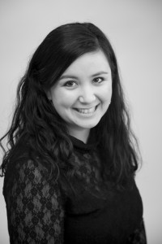
Nichole Reynolds is no stranger to music ministry at All Saints. At age eight, she joined the parish Young People’s Choir, and is now delighted to be the director of the same choir where it all began! Nichole also founded and directed the Life Teen Music Ministry at All Saints. She served as the All Saints Catholic School music teacher for many years teaching music to grades K-8, where she served as the director of the school choir (Schola).
Nichole graduated Magna Cum Laude with a Bachelor of Music in Vocal Performance from George Mason University in 2007, and a Master of Music in Vocal Performance in 2011. While at GMU, Nichole enjoyed many solo/ensemble performance opportunities with the GMU Opera Theater, GMU University Singers, and Soundcheque Vocal Jazz Ensemble and traveled with the University to sing in Cologne, Germany, and Moscow, Russia. She was also involved in the Catholic Campus Ministry at GMU, where she served as Student Campus Minister for two years, and volunteered her time with the music ministry. Nichole has also been involved with Upper Room Theater Ministry’s annual musical productions. You may remember her as Maria in The Sound of Music or as Catherine in Pippin. In addition to performing on stage with the Upper Room Theatre Ministry, she has also worked as Assistant Director, Music Director, and accompanist for various musicals and Winter Cabaret performances.

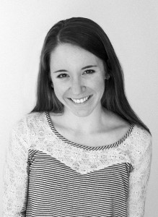
Laura Loker, Teen Choir Director, has been involved in liturgical music since she herself was a teen, beginning as an accompanist at St. Philip’s in 2007. She played at St. Robert Bellarmine Chapel at George Mason University in Fairfax, VA for all four years she attended the school, and upon graduating returned to play at St. Philip’s. Outside of Sunday Masses, she also plays for weddings, orchestra pits (including Upper Room Theatre Ministry’s production of Peter Pan), auditions, and other liturgical services.
Laura graduated from George Mason University in 2013 with a Bachelor of Science in economics and minors in English and computer science. During her time at Mason, she published a paper on the origin of perfect pitch, for which she was awarded a scholarship from the university and that she later presented at a Virginia research conference. Heavily involved in Mason’s Catholic Campus Ministry, she led a ministry team of 50 students, the pro-life ministry, and her own small group Bible study. Following graduation, she co-taught St. Philip’s RCIA class with several other volunteers. Laura lives in Arlington with her husband, Kevin, and is a parishioner of St. Charles Borromeo.

Sacred Music at All Saints – Concert Series
About the Concert Series
Sacred Music at All Saints Concert Series was founded in 2013 as a community outreach program of the parish Music Ministry. The annual series presents five events each season that showcase local and national performers and ensembles that specialize in classical and sacred music.

Current Season:

Sacred Music at All Saints Concert Series Flier
All events are free, with a free-will offering taken at the door. Proceeds will go to support future programming for this annual series. Visit our parish website for updated information and future concerts.

All Saints Catholic Church
The Office for Music and Liturgy
9300 Stonewall Rd., Manassas, VA 20110
(703) 368-4500 www.allsaintsvachurch.org

Friends of the All Saints Concert Series
Support for this program is provided by individuals who make annual donations to the series. We invite you to help us grow through your attendance and support of these special events for our parish and local community! To join our mailing list and/or to make a donation to the series, please complete the form below or contact the Office for Music and Liturgy at (703) 393-2146. Thank you for your support, prayers and generosity!
Friends of the All Saints Concert Series Donation Form

Performing on the Series
The Office for Music and Liturgy accepts proposals for potential events for future series. Interested solo performers and ensembles are requested to submit a written proposal via e-mail containing the following information:
- Name and bio of the performer or group
- A brief description of the program to be presented, including music titles
- Requested honorarium
- Contact information
- Audio samples
References and previous concert materials are also helpful, but not required.
E-mail proposals can be sent to: Mr. Tim Lewicki, Director of Music and Coordinator of Liturgical Ministries, at tlewicki@allsaintsva.org. No phone calls, please.

Parish Choir Music Lists
The Second Vatican Council stated emphatically that, “choirs must be diligently promoted while ensuring that the whole body of the faithful may be able to contribute that active participation which is rightly theirs.” The choir must not minimize the musical participation of the faithful. The congregation commonly sings unison melodies, which are more suitable for generally unrehearsed community singing. This is the primary song of the Liturgy. Choirs and ensembles, on the other hand, comprise persons drawn from the community who possess the requisite musical skills and a commitment to the established schedule of rehearsals and Liturgies. Thus, they are able to enrich the celebration by adding musical elements beyond the capabilities of the congregation alone.
The choir may draw on the treasury of sacred music, singing compositions by composers of various periods and in various musical styles, as well as music that expresses the faith of the various cultures that enrich the Church. The music of the choir must always be appropriate to the Liturgy, either by being a proper liturgical text or by expressing themes appropriate to the Liturgy.
Sing to the Lord: Music in Divine Worship, §28-30, Issued by USCCB, November 14, 2007

Listen to our choir:
E’en So Lord Jesus Quickly Come – Manz
If Ye Love Me – Tallis

Annual Music Lists:
Parish Choir Music List and Schedule 2017-2019
Sunday Worship Aid
Choir Pilgramage
On Sunday, November 4, 2012, the choirs of All Saints Church and St. Veronica Church embarked on a ten-day pilgrimage to Italy. The photos from the pilgrimage can be found here.
We began in the north of Italy, visiting Padua and Venice, traveled to Tuscany with stops in Florence and Orvieto, and ended our journey in Rome and Vatican City. As you will see from our pictures, we were blessed with beautiful weather throughout the trip. Our combined choir sang for Masses in the Basilica of San Marco in Venice, the Basilica of St. Francis in Assisi, the Basilica of St. Peter at the Vatican, and the Basilica of St. John Lateran in Rome.
Special thanks to all who supported our pilgrimage by way of donations and participation in fundraising events. Prayer requests were taken with us on pilgrimage, and were placed at the altars of every basilica in which Mass was celebrated.

Church Organ
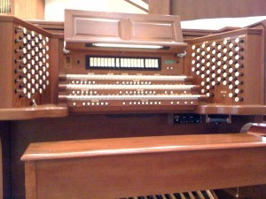
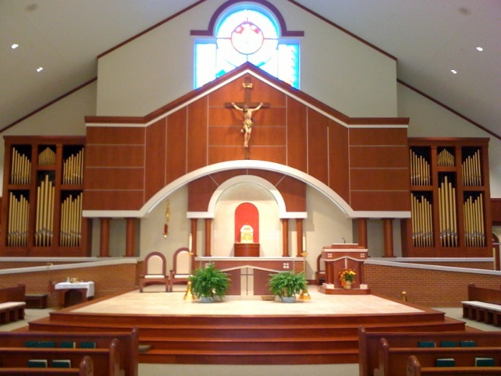
All Saints Catholic Church in Manassas, VA is privileged and blessed to have a new church building, and a newly-renovated pipe organ. Approximately 13 years ago, the original Opus 6376 was purchased from the Wicks Organ Company of Highland, IL, with the intention of one day moving it into a new church.
The organ is a hybrid instrument, comprised of pipework, and digital voices. The pipework, and console were built by Wicks, and the digital voices are a product of the Walker Technical Company of Zionsville, PA.
During the design period for our new church, every attempt was made to ensure that we retained as much of the current organ as possible. In the fall of 2008, All Saints entered into a contract with the Wicks Organ Company for a redesign and expansion of the current instrument for the new church.

The Organ Design
All of the pipework in the existing organ was kept, and the console (keyboards, pedal board, stops) were also retained and enlarged. The wood case of the original organ did not match the woodwork of the new church, nor could it be fitted to accommodate the new space. Two new identical pipe towers were built, which match the wood stain of the altar area and fit in the space on either side of the altar. Within these towers contain the re-voiced pipework, ten additional ranks of pipes, upgraded digital voices, and an array of new digital voices.
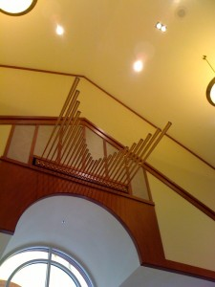
The enlarged stoplist features a wide range of voices in different tonal colors that are used to accompany the choir and the congregation, as well as to play solo organ literature. Full MIDI features are included, as well as solid-state memory and a play-back system. Mounted high above the baptismal font on the back wall of the sanctuary is a horizontal fanfare trumpet. Additionally, the bell tower carillon by the Verdin Bell Company is also controllable from the organ console.

Supporting Our Music Ministry
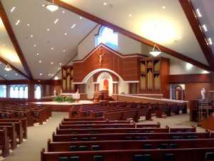
The renovated organ was delivered and installed by Wicks in July 2010, and was completed for the Dedication Mass on August 14. Together, this updated and expanded version of our organ gloriously adorns the liturgical life of our vibrant parish community. In addition to the main organ, a Wicks digital organ was also installed at All Saints.
This two-keyboard organ was installed in our Blessed Sacrament Chapel where it is used for smaller liturgies. The organ was formally dedicated in a recital on June 23, 2011 by Dr. Jeremy Filsell, artist-in-residence at the Washington National Cathedral.
Dr. William Atwood
Director of Music and Coordinator of Liturgical Ministries (2008-2015)
All Saints Catholic Church
Manassas, VA
Organ Dedication Recital Program and Stop List
Organ Audio Samples
Bill Atwood, organist
Carillon-Sortie – Henri Mulet
Improvisation on Victime paschali laudes – Timothy Lewicki
Jail Ministry
Through its Prison Ministry, All Saints offers spiritual and emotional assistance to inmates and their families with a belief in God’s healing grace and mercy. Fr. Mauricio serves as Priest-Moderator and Deacon Jim Van de Voorde as Ministry Coordinator of our Prison Ministry.
All Saints’ Jail Ministry provides the following services:
- Weekend Communion services led by Extraordinary Ministers of Holy Communion
- Religious materials for inmates and Liturgy Guide documents that can be downloaded
- Weekday evening religious education classes and R.C.I.A. Program
- Former Inmate Re-entry Support
Resources:
VA Catholic Conference
United States Catholic Catechism for Adults ministry Link
Dismas Catholic Jail Ministry webpage

Prayer Groups
- Apóstoles de la Palabra (Evangelization Ministry)
Coordinador: Angel Silva
Horario de reuniones: Martes 8-9:30 p.m.
- Comité Vocacional (Vocation Ministry)
Coordinador: Susy Segura
Horario de reuniones: Hora Santa por las Vocaciones viernes 10-11 pm

- Filipino American Ministry
- Grupo de Oración Amor de Dios (prayer group)
Coordinador: Fidel Gonzalez
Horario de reuniones: Viernes a las 7:30 pm
- Legion of Mary (English)
Coordinator: Gwen Anthony
Meeting Time: Tuesdays at 7:00 p.m., St. Joseph Room - PAC
- Legión de María (Español)
Coordinador: Jenny Herrera Gaspar
Horario de reuniones: Lunes a las 7:00 p.m.
- Mensajeros de Jesús (Prayer Group)
Coordinador: Guillermo Navarro
Horario de reuniones: Sábados 7:00pm-10:30 p.m.
- Movimiento de Cursillos de Cristiandad (Cursillos)
Coordinador/Coordinator: Pepe Briceño
Horario de reuniones: Lunes a las 7:30 p.m.
- Pastoral Familiar (Family Apostolate)
Coordinador(a): Gabriel Flores y Lupe Covarrubias
Horario de reuniones: 1er sábado Lectio Divina / 3er sábado reunión equipo
- Secular Franciscan Order
Coordinator: Peggy Gregory
Meeting Time: Monthly, Third Saturday

Secular Franciscan Order

Learning
Adult Faith Formation
Formed.org
Formed.org is a vibrant Adult Faith Formation resource. New programs, movies, audio talks and e-books are continuously being added, so please visit Formed.org and see what’s new. There are now over 40 movies on the site, perfect for family movie night. Don’t miss these fabulous, Catholic resources that are being provided for you by our parish subscription. You can view these over streaming internet at http://www.formed.org. Our parish access code is 16e125. Use this to set up your login credential of a User ID and password.

Marriage Apostolate

All Saints Catholic School (drop-down menu with direct link to www.allsaintsvaschool.org)

Religious Education Program (drop-down menu with direct link to www.allsaintsreligiouseducation.org)

R.C.I.A. / R.C.I.C.
In the Catholic Church, those who are interested in becoming Catholic, or need to complete their sacraments of initiation (Baptism, Confirmation, and Eucharist), or were baptized into another Christian faith and wish to become Catholic, join a program called the R.C.I.A.
R.C.I.A. stands for Rite of Christian Initiation for Adults (or children). This program is a journey through which you learn more about the Catholic faith and specifically, the sacraments.
Learn more about Becoming Catholic and R.C.I.A.

Parish Religious Library
Discover the treasure that is the All Saints Parish Library!
Located just inside the church, on the side leading to the Activities Center, the library collection of over 5,000 books, DVDs and CDs offers an opportunity for parents and children to learn more about the Catholic faith, scripture, the saints, and more. In addition to a wide selection of children’s books and children’s DVDs, the library has an extensive children’s collection of books about the saints. This is an excellent resource for students preparing for the Sacrament of Confirmation. The library is a free resource for parishioners and non-parishioners and is available to all eighth grade students.

Hours of operation:
- Wednesday 5:00-8:00 p.m.
- Saturday morning 8:30-10:00 a.m.
- Saturday after the 5:30 p.m. Mass
- Sunday after the 7:30 a.m., 9:30 a.m., 11:30 a.m., 1:30 p.m. and 5:30 p.m. Masses.
- The Parish Religious Library offers a children’s story time once a month after the 9:30 a.m. Mass.
- The library is closed during each Mass.

Come and share this beautiful resource with your family!Youth Ministry (drop-down menu with direct link to www.allsaintsyouthministry.org)

Prayer Groups
(See previous listing under Worship section.)
Young Adult Ministry (drop-down menu with direct link to www.allsaintsyoungadultministry.org)

Homeschoolers M.A.R.C.H.
Men’s Faith Formation (That Man Is You)
That Man is You (TMIY) addresses the pressures and temptations that men face in our modern culture, especially those relating to their roles as husbands and fathers. The program harmonizes current social and medical science with the teachings of the Church and the wisdom of the saints to develop the vision of man fully alive. It is particularly indebted to the teachings of the Second Vatican Council and Pope John Paul II.
Our new year starts each September and is designed for those wishing to take the next step and learn how to discern the will of God in their lives. This series will provide concrete steps which men can adopt to make progress in their spiritual lives.
“Spiritual formation” is deeper than just learning and more profound than just training. It allows the participants to understand more fully the life to which God is calling them and to kindle the desire for that life. It prepares one’s heart for transformation by practicing new skills in their spiritual life and understanding deeply the reasons that those practices were established in faith.

Vacation Bible School
Each summer, All Saints’ Religious Education Program offers Vacation Bible School (VBS). Our five-day program, which features a new engaging theme each year, is designed for rising kindergartners through rising fifth grade students.
Vacation Bible School provides a wonderful opportunity for children to get to know more about Jesus and their Catholic faith through Bible stories, crafts, games, saint presentations, and skits!
See All Saints’ Religious Education website for details and to register.

Living
Social Outreach
- Bethany Food Pantry (Despensa de Comida Betania) – (703) 366-1655
All Saints’ Bethany Food Pantry is open for distribution on Tuesdays from 5:00 – 8:00 p.m. and Fridays from 9:00 – 11:30 a.m. Donations can be brought to Mass or placed in the bin in the vestibule of the church.
- St. Vincent de Paul Society (Sociedad de San Vincente de Paul)
(703) 368-2429 (English) | (703) 393-1483 (en Espanol)
For over 170 years, the Society of St. Vincent de Paul has offered tangible assistance to those in need on a person-to-person basis and assumes a role of advocacy for those who are defenseless or voiceless. Aid may take the form of intervention, consultation, or direct dollar or in-kind service. The Society’s 160,000 trained volunteers in the United States provided 11.6 million hours of volunteer service in 2015, helping more than 14 million people through visits to homes, prisons and hospitals at a value of nearly $1 billion dollars.
- Jail Ministry
Pastoral Care Services
For information on any of the following services, please contact Gillian Quintana, All Saints’ Pastoral Care, at (703) 393-1411 or gquintana@allsaintsva.org.
- Bus Driving Ministry: Ambulatory parishioners are picked up and taken to the All Saints Sunday 9:30 a.m. Mass from local nursing homes and assisted living facilities. The buses do not pick up from private homes. If you would like to drive and be involved in this ministry, please contact Gillian Quintana (see above).
- Golden Agers: During the school year, September thru June, seniors gather in the Parish Activity Center on the second Tuesday of the month. Rosary begins at 11:30 a.m. A hot lunch is served at noon. Entertainment is provided at 12:45 p.m. All senior parishioners 55 years of age and over are invited. If Prince William County Schools are closed due to inclement weather we do not meet; if Prince William County Schools announce a delayed opening, we still meet as planned.
- Bereavement Support
An adult bereavement support group is offered twice a year, in the fall and spring. The group meets on Friday evenings for six weeks. To attend, please register with the Pastoral Care Office (see above).
- Cancer and Prayer Support
This group, which provides support for cancer victims and caregivers, meets on the 4th Monday of each month in the church library from 1:00-2:00 p.m.
- WOW – Widows or Widowers
WOW is a group to socialize with, to help overcome the loneliness, to share experiences and form new friendships. Come and meet with those who have walked a similar path as you.
- Sick and Home Bound: Volunteers and Eucharistic Ministers visit the home bound once we are notified of a need. Volunteers are needed to help provide respite for family caregivers by shopping, sitting with a family member, driving to local doctor appointments or to provide an occasional meal.
Respect Life
- Gabriel Project
Are you a new or expectant mother looking for help during this joyful and sometimes apprehensive time? Our mentors are available to assist you during this time of transition utilizing their experience in raising children and in living a life firmly rooted in Christ. So, whether you’re a brand new mom or a mom looking for support because you are new to the area, contact Gabriel Project at (703) 841-3810 or at GabrielProject@arlingtondiocese.org.
- Pro-Life
All Saints’ Pro-Life activities promote the defense and celebration of the sanctity of all human life from conception to natural death. Its active leadership role in the parish finds a special concern for the most vulnerable human life, the child in the womb longing to be born. Its scope reaches out to all life issues including abortion, health care, euthanasia, assisted suicide, capital punishment, prison reform, and stem cell research on human embryos.

Parish Life
Community
- Parish Festival – the parish festival will take place on Saturday, April 29, 2017.
- Five-Car Raffle – Share in the fun and excitement of All Saints’ popular 5-Car Raffle which raffles five new vehicles and cash prizes. The drawings take place each year at the parish festival. Tickets are just $5.00 and make the purchaser eligible to win any of our prizes.

Activities
- Boy Scouts
- Catholic Youth Organization (CYO)
- Adult Volleyball
- Men’s Basketball
Partners
- Knights of Columbus - http://www.georgebrent.net/
- Special Needs Family Services

Giving
Financial Giving
All Saints is a parish richly blessed with parishioners who give generously to support the many ministries and programs of our active parish. Your monetary gifts make a necessary and meaningful impact, while contributing to the vibrancy and spirit of our community. Your support—no matter the amount—is vital to continue the work of our parish and its ministries.
- Parishioners may wish to donate money online.
- Opportunities are also available for directed giving and planned giving.
- All Saints also gratefully accepts gifts of stock and mutual funds. All such donations are handled by the Catholic Diocese of Arlington’s Finance Office. Click here for more information about donating shares of stock and mutual funds.
We give in all these ways so that together, seeking to fulfill our stated mission as a parish, we accept, nourish and send all to do God’s work.



Online Parish Giving

What Is It?
Online giving enables you to have your weekly offering automatically debited from your checking account or credit card. You choose how much to give, how often to give, and what method of payment to use. You can also make special offertory donations for second collections, capital campaigns, and special events.

Why Choose Online Giving?
- Simplicity – You will appreciate the simplicity of the system and the ability to make updates, changes and one-time donations.
- Convenience – No more searching for the checkbook or Sunday morning stops at the ATM.
- Efficiency - Helps All Saints reduce administrative costs and is more environmentally-friendly.
It’s Fast, Simple and Secure
- To get started, please visit the Parish Giving website’s registration page.
- After completing registration, select from the various contributions. Some contributions are recurring, while others are processed only once. All contributions are processed once a month.
- When finished, please select the preferred billing method and billing date.
- You can access your account at any time with the user name and password you created at registration. You can view your contribution history, edit upcoming contributions and change your billing date and/or billing method as necessary.
Protecting Your Security
Parish Giving adheres to the strictest guidelines regarding the security of the financial information you provide. Parish Giving utilizes the strongest SSL encryption technology available, the same technologies employed by financial and banking institutions. This service is PCI compliant and safeguarded with advanced firewall, thorough anti-virus, and aggressive anti-hacking technologies.
- Directed Giving
What Is It?
Directed Giving focuses on the special occasions that arise in the life of our parish that call us to give beyond our ordinary contribution to help the community realize an especially important goal. Gifts provide for special furnishings or support particular ministries and are important enhancements to the life and mission of All Saints. Such gifts may be dedicated in memory or in honor of loved ones.
If you are considering a directed gift, please contact one of our priests or the parish finance office (finance@allsaintsva.org). From time to time, identified needs are noted in our parish publications as are special appeals to aid victims of crises.
- Planned Giving
What Is It?
Planned Giving is a wonderful way to share the blessings of a lifetime. It is the opportunity to leave a planned gift that constitutes both a legacy to generations yet unborn and a final witness to those you hold most dear. The parish finance office (finance@allsaintsva.org) will gladly direct you to financial advisors with expertise in a wide range of planned giving opportunities.

Volunteer Opportunities
All Saints is a large, vibrant parish offering many opportunities for you to get involved in the life of our community. We invite you to prayerfully consider how you can share your time and talents to assist us in building God’s kingdom.
Liturgical Ministry
Altar Servers
Eucharistic Ministers
Lectors
Ushers
Perpetual Adoration
Music Ministry
- Parish Choir – sings for the 11:30AM Mass each Sunday, Christmas Midnight Mass, the Easter Vigil, and other feast days and special liturgies. The Choirs Repertoire covers the entire range of Catholic sacred music. Rehearsals are on Thursday evenings, 7:30-9:00PM.
Contact: Tim Lewicki, tlewicki@allsaintsva.org
- Contemporary Choir – sings on Saturday evenings at the 5:30PM Mass, for Christmas, Good Friday, Easter, and other feast days. The Choir offers a mixture of contemporary Catholic styles with piano and guitar accompaniment. Rehearsals are on Wednesday evenings, 7:30-9:00PM.
Contact: Cathy Drummond, cjsdrummond@gmail.com
- Young People’s Choir – sings for the 9:30AM Mass every 2nd and 4th Sunday from October to June, for Christmas, Easter, and other liturgical feasts. Children in grades 3-8 from all schools, as well as home schooled students, are welcome. The Choir rehearses from 5:00-6:00PM two Wednesdays a month, and meets at 8:45AM before each Mass they sing.
Contact: Nichole Reynolds, nreynolds@allsaintsva.org
- Teen Choir – The Life Teen Music Group provides a mix of contemporary Christian worship songs and traditional Catholic liturgical music at the Sunday 5:30PM Teen Mass during the youth group year. Those of high school age and above are welcome to join. Rehearsals are Sunday afternoons at 4:30PM.
Contact: Laura Loker, lauramloker@gmail.com
- Handbell Choir: Resounding Joy – Adults interested in this unique way of praising God and adding a special touch to our liturgies are invited to consider ringing with us! No musical experience is needed; we will give you all the knowledge you need to participate. Resounding Joy rings at Mass once a month, for Christmas, Easter, and other special liturgies. Rehearsals are Wednesday evenings, 7:30-9:00PM.
Contact: Kathyrn Moore, kathrynmoore3@verizon.net
- Coros Hispanos – Los dos Coros Hispanos invitan cordialmente a todas las personas que desean cantar en español o que puedan tocar instrumentos musicales. Por favor vengan a hablar con el director del coro después de la misa de la 1:30PM o de la 7:00PM cada domingo.
Religious Education
- English and Spanish speaking catechists – Samantha Welsh at swelsh@allsaintsva.org
- Classroom assistants – Samantha Welsh at swelsh@allsaintsva.org
- Office volunteers during RE classes – Samantha Welsh at swelsh@allsaintsva.org
Youth Ministry
- High School Ministry opportunities – Rob Tessier at rtessier@allsaintsva.org
- Middle School Ministry opportunities – Mary Lambert at mlambert@allsaintsva.org
- Youth Ministry support roles – Candy Benitez at cbenitez@allsaintsva.org
Parish Festival
Jail Ministry
- We are in need of Catechists and Eucharistic Ministers
Contact: Deacon Jim Van de Voorde, jvandevoorde@allsaintsva.org
Note: Volunteers who work with children or youth need to meet the requirements of the Protection of God’s Children program requirements (link to Protection of God’s Children page).

News & Events
Blog

Calendar of Events

Contact
Contact Information/Social Media
Mailing Address:
9300 Stonewall Road
Manassas, Virginia 20110
Phone: (703) 368-4500 or (703) 368-2066
Parish Staff Contact Information (link to Staff page)
Contact Form
Directions
From the North and East
Exit onto Rt. 66 West from Rt. 495 (Washington Beltway). Travel approximately 15 miles to South Rt 28. Proceed 10 miles traveling through Old Town Manassas to All Saints Church on right at Stonewall Road.
From the West
On Rt 66 take exit 44 for Rt. 234 S/Prince William Parkway. Travel about 4.7 miles. Take exit VA 28-N ontoNokesville Road. Travel about 1.8 miles. Once you cross the railroad overpass, take second left at stoplight ontoBrinkley Lane.
From the South
There are two different ways to go from the south, please choose the best one for you.
- Travel Rt. 28 North to Brinkley Lane turn left. The church faces Center Street.
- From I-95 N take Exit 152B to merge onto VA-234 N/Dumfries Road toward Manassas. Travel approximately 17.6 miles. Take exit VA 28-N onto Nokesville Road. Travel about 1.8 miles. Once you cross the railroad overpass, take second left at stoplight onto Brinkley Lane.

GOOGLE MAP GOES HERE
View Larger Map