Punchlist Items for ASCC Website 2018

- Pale background color behind the body of the inside pages. We want this to be white. Right now images put on the pages show white squares around them and that will be a nightmare moving forward.
Examples: http://allsaintsdunwoody.diocesanweb.com/2017/12/28/chrp-weekends/; http://allsaintsdunwoody.diocesanweb.com/education/edge/

- Preschool subpages do not show on this page http://allsaintsdunwoody.diocesanweb.com/education/preschool-at-all-saints/ ; however, they do show on this page http://allsaintsdunwoody.diocesanweb.com/education/preschool-at-all-saints/our-environment/ . Why don’t the subpages show up from the main Preschool page?

- Also, under Preschool. Why don’t the related pages show up in the order I have them on the Pages section of the admin side? http://allsaintsdunwoody.diocesanweb.com/education/preschool-at-all-saints/our-philosophy-curriculum/

- The calendars I am setting up don’t seem to be showing on the main page. I might need a refresher on this.

- How are related pages generated? I think this is a widget. Is there a way we can access this or manually influence what pages appear in this column?

- I’d like to change the font in the body of the web pages to be slightly larger and darker in color. It’s not as easy to read as it could be.

- Can we create a hidden web page that streams the main Google calendar and has a metaslide? v6i8jbgd9hf6es1ft888s3ll7c@group.calendar.google.com https://calendar.google.com/calendar/embed?src=v6i8jbgd9hf6es1ft888s3ll7c%40group.calendar.google.com&ctz=America%2FNew_York
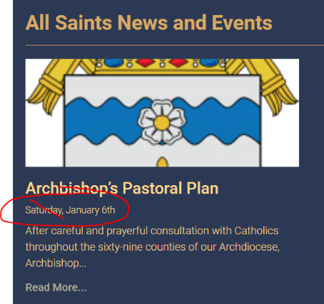
- Requested previously to have dates removed from posts

- myParish App Message still show future messages that have been scheduled, but not published. If we can’t fix this, then let’s remove that from the main web page. It could be included on the communications page.

